St Boniface Catholic Primary School

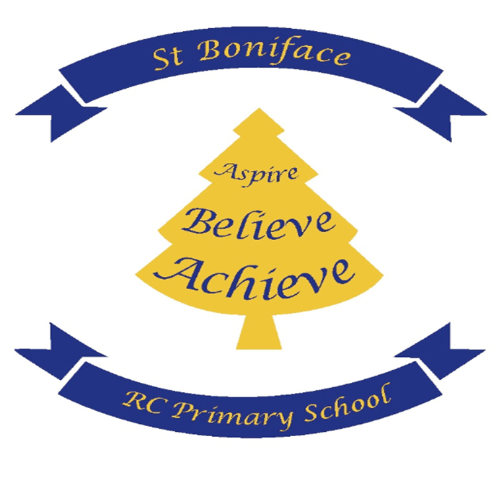

PE /Sport Premium Funding Impact Report

PE and sport premium funding impact report

Swimming and water safety
Meeting the swimming and water safety national curriculum requirements
What percentage of Year 6 pupils can swim competently, confidently and proficiently over a distance of at least 25 metres? | 80 %
What percentage of Year 6 pupils can use a range of strokes effectively, for example, front crawl, backstroke and breaststroke? | 80 %
What percentage of Year 6 pupils can perform safe self-rescue in different water-based situations? | 65 %
Has the PE and sport premium been used to provide additional provision for swimming activities over and above the national curriculum requirements? | No
If you answered yes to the above question, use this space to provide further details:

Spending Plan Impact report for 2023
Funding received
Number of eligible pupils: 235 | Total amount received: £17,750
Funding rate: The funding rate for 2023/2024 is as follows: for schools with 17 or more pupils, £16,000 plus £10 per pupil. For schools with 16 or fewer pupils, £1,000 per pupil.
Objectives
- Increasing engagement of all pupils in regular physical activity
- Raising the profile of PE and sport across the school as a tool for whole-school improvement
- Increasing staff members’ confidence, knowledge and skills in teaching PE and sport
- Offering pupils a broader range of sports and activities
- Increasing pupils’ participation in competitive sport

Objective 1: Increasing engagement of all pupils in regular physical activity |  |  |  | Percentage of total spending
 |  |  |  | 26%
Actions taken |  | Funding spent | Evidence and impact | Sustainability and suggested next steps
1 | To pay for our entry to the Salford Schools’ Sports Partnership and the All Hallows family multi-sports SLA (Priority1, 2,3,4 and 5) | £ 4750 | Access to resources and networking opportunities with the All Hallows family of schools and all Salford Primary Schools.  Entry into numerous sporting events and competitions throughout the year  Coaching in a variety of sports during and after the school day  Impact- all children have access to high quality physical activity weekly | Continue to pay into the school partnership.
Objective 2: Raising the profile of PE and sport across the school as a tool for whole-school improvement |  |  |  | Percentage of total spending
 |  |  |  | %
Actions taken |  | Funding spent | Evidence and impact | Sustainability and suggested next steps
1 | To pay for the installation of an orienteering course within school that can be adapted for curriculum use as well as sporting skills, | £ 2,400 | All classes to access the course as a half termly project to support orienteering skills, and to develop cross curricular use- impact all pupils will take part in active learning to embed cores skills in literacy and maths as well developing map reading and problem solving skills. | Course to be sustained and maintained  Resources built by individual teachers  Orienteering challenge
2 | To pay for a Forest Schools Practitioner to deliver targeted sessions. | £ £2,400 | Four class to access half term project-impact- pupils will have the opportunity to experience outdoor and active learning building skills such as resilience and problem solving and collaboration | Train own staff to deliver Forest schools  Purchase further equipment
3 | Purchase resources for Forest Schools | £ 1,000 | Pupils will have the opportunity to experience outdoor and active learning building skills such as resilience and problem solving and collaboration
Objective 3: Increasing staff members’ confidence, knowledge and skills in teaching PE and sport |  |  |  | Percentage of total spending
 |  |  |  | 50%
Actions taken |  | Funding spent | Evidence and impact | Sustainability and suggested next steps
1 | To deliver high quality continuous professional development in PE for teachers. | £ contribution to cost of sports coach £ 13,300 | The specialist PE coach works with every class in school whilst providing focussed CPD for class teachers. Impact- This allows teachers to develop their own skills in delivering engaging and effective PE lessons | Employ sports coach one day per week  Staff to deliver PE lessons based on training received.
Objective 4: Offering pupils a broader range of sports and activities |  |  |  | Percentage of total spending
 |  |  |  | %
Actions taken |  | Funding spent | Evidence and impact | Sustainability and suggested next steps
1 | Dhrum workshop | £ 425.00 | Pupils accessed active learning combining music and movement  Wellbeing of pupils, physical health | Repeat activity
2 | Quidditch workshop | £ 885.60 | Pupils accessed a new sport  Engagement in learning, collaboration, competition | Repeat activity
3 | Sports Bury Demonstration | £ 0 | Pupils accessed two sports- hockey and glow in the dark dodgeball  New opportunities, raised awareness of other sports | Liaise with the company around sports provision continuing
4 | Active Kids involvement | £ 0 | Raised awareness of sports of all through work of a Paralympian.  Engagement in sport, collaboration. Awareness of diversity | Repeat
Objective 5: Increasing pupils’ participation in competitive sport |  |  |  | Percentage of total spending
 |  |  |  | %
Actions taken |  | Funding spent | Evidence and impact | Sustainability and suggested next steps
1 | To pay for our entry to the Salford Schools’ Sports Partnership and the All Hallows family multi-sports SLA (Priority1, 2,3,4 and 5) | £ 4750 | Access to resources and networking opportunities with the All Hallows family of schools and all Salford Primary Schools.  Entry into numerous sporting events and competitions throughout the year  Coaching in a variety of sports during and after the school day  Impact- all children have access to high quality physical activity weekly | Continue

Impact summary
Impact area | Summary
What has been the impact on pupils’ participation? | All pupils engage in PE and sports clubs  All sports clubs were oversubscribed. Pupils who were targeted for lunch-time clubs were fully engaged.  Pupils who might not otherwise have accessed competitions have been able to compete and achieve.  Awareness of and participation in a wider range of sports has become embedded.
What has been the impact on pupils’ attainment? | There is an Increased enthusiasm for school and attendance has improved which in turn impacts upon attainment  Through forest school pupils feel able to express themselves emotionally and have the capacity to develop their well being and self regulate which in turns supports attainment  Key learning skills such as collaboration, resilience and perseverance have been developed and are becoming embedded. As a result there are fewer incidence of children expressing social and emotional emergency needs.
How will the school sustain the improvements? | School will review the provision and take into consideration pupil voice when planning which areas to develop further and the strategies to keep.
Key achievements to date |  | Areas for further improvement
Developing a sports council  All children participating in outside activities regularly  Teachers are actively involved in planning and delivering PE lessons  PE curriculum is varied  Sports Day reinstated |  | Develop the role of the sports council  Further develop teaching subject knowledge  Secure the PE curriculum  Improve the KS2 outdoor area with wider variety of sports equipment.

PE and sport premium action plan for 2023- 2024

Objective 1: Increasing engagement of all pupils in regular physical activity |  |  |  | Percentage of total spending
 |  |  |  | 50%
Planned actions |  | Funding allocated | Expected impact | Sustainability and suggested next steps
1 | Whole-school survey to be conducted to identify and target children who still do not take part in any physical activity outside of school | £ 0 | Clarity of understanding around children’s needs and wishes | Sports council to report back on a half termly basis,
2 | Employment of a sports coach one day per week | £ 8,000 | Every child will access high quality PE at least twice per week in school and have the opportunity to access extra-curricular activities
3 | Develop the delivery of orienteering and forest schools in school | £1,000 | Every child will access outdoor learning throughout the year.
Objective 2: Raising the profile of PE and sport across the school as a tool for whole-school improvement |  |  |  | Percentage of total spending
 |  |  |  | 1%
Planned actions |  | Funding allocated | Expected impact | Sustainability and suggested next steps
1 | PE leader and champions established | £ 0
2 | Develop the delivery of orienteering and forest schools in school | £ 1000(duplicated from other cost centre)
Objective 3: Increasing staff members’ confidence, knowledge and skills in teaching PE and sport |  |  |  | Percentage of total spending
 |  |  |  | n/a%
Planned actions |  | Funding allocated | Expected impact | Sustainability and suggested next steps
1 | Staff to access CPD via the sports coach through professional development meetings and team teaching exercises. | £ 10,000  (duplicated from other cost centre) | Staff will have the skills to provide high quality teaching in all disciplines | Source new sports coach
2 | Development of a cohesive PE curriculum | £ 0 | Children will access a wide range of sports  Staff will have resources to provide high quality teaching in all disciplines. | PE leads to have leadership time to plan curriculum
Objective 4: Offering pupils a broader range of sports and activities |  |  |  | Percentage of total spending
 |  |  |  | 30%
Planned actions |  | Funding allocated | Expected impact | Sustainability and suggested next steps
1 | Quidditch day | £ 900 | Sports Week activity. Opportunities for children to engage in team building games and unique sports. | To deliver the same experience next sport week.
2 | Rock Kidz workshop | £ 450 | Sport Week activity. Using music, exercise and fun we provided children with an unforgettable experience that encouraged them to be the best version of themselves. | To deliver the same experience next sport week.
3 | Installation of basketball nets | £ contribution to cost fo £10,000 | To deliver high quality basketball lesson following the National Curriculum for PE and School Sport. | To deliver high quality PE and afterschool club sessions and allow children free use during playtime and dinnertime to enhance skills.
4 | Range of sports activities after school through sports coach | £ 10,000  duplicated from other cost centre) | Providing children with opportunities to partake in extra-curricular activities. | To deliver consistent PE provision.
Objective 5: Increasing pupils’ participation in competitive sport |  |  |  | Percentage of total spending
 |  |  |  | 25%
Planned actions |  | Funding allocated | Expected impact | Sustainability and suggested next steps
1 | To pay for our entry to the Salford Schools’ Sports Partnership and the All Hallows family multi-sports SLA (Priority1, 2,3,4 and | £ 4000 | Access to resources and networking opportunities with the All Hallows family of schools and all Salford Primary Schools.  Entry into numerous sporting events and competitions throughout the year  Coaching in a variety of sports during and after the school day  Impact- all children have access to high quality physical activity weekly | Continue our partnership with SSSP providing children the opportunity to take part in competitions and represent the school.

