St Boniface Catholic Primary School

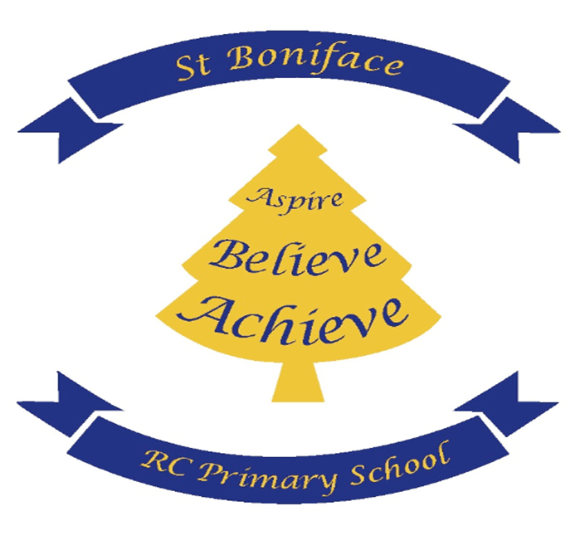

PE /Sport Premium Funding Impact Report

PE and sport premium funding impact report

Swimming and water safety
Meeting the swimming and water safety national curriculum requirements
What percentage of Year 6 pupils can swim competently, confidently and proficiently over a distance of at least 25 metres? | 80 %
What percentage of Year 6 pupils can use a range of strokes effectively, for example, front crawl, backstroke and breaststroke? | 80 %
What percentage of Year 6 pupils can perform safe self-rescue in different water-based situations? | 65 %
Has the PE and sport premium been used to provide additional provision for swimming activities over and above the national curriculum requirements? | No
If you answered yes to the above question, use this space to provide further details:

Spending Plan Impact report for 2024
Funding received
Number of eligible pupils: 235 | Total amount received: £17,750
Funding rate: The funding rate for 2023/2024 is as follows: for schools with 17 or more pupils, £16,000 plus £10 per pupil. For schools with 16 or fewer pupils, £1,000 per pupil.
Objectives
- Increasing engagement of all pupils in regular physical activity
- Raising the profile of PE and sport across the school as a tool for whole-school improvement
- Increasing staff members’ confidence, knowledge and skills in teaching PE and sport
- Offering pupils a broader range of sports and activities
- Increasing pupils’ participation in competitive sport

Objective 1: Increasing engagement of all pupils in regular physical activity |  |  |  | Percentage of total spending
 |  |  |  | 26%
Actions taken |  | Funding spent | Evidence and impact | Sustainability and suggested next steps
1 | To pay for our entry to the Salford Schools’ Sports Partnership and the All Hallows family multi-sports SLA (Priority1, 2,3,4 and 5) | £ 4750 | Access to resources and networking opportunities with the All Hallows family of schools and all Salford Primary Schools.  Entry into numerous sporting events and competitions throughout the year  Coaching in a variety of sports during and after the school day  Impact- all children have access to high quality physical activity weekly | Continue to pay into the school partnership.
Objective 2: Raising the profile of PE and sport across the school as a tool for whole-school improvement |  |  |  | Percentage of total spending
 |  |  |  | %
Actions taken |  | Funding spent | Evidence and impact | Sustainability and suggested next steps
1 | Yearly subscription for Get Set 4 PE | £ 700 | To provide teachers and teaching assistants with a comprehensive curriculum aligned lesson plans, teaching support and assessment tools. | Continue with subscription.
2 | To pay for a Forest Schools Practitioner to deliver targeted sessions. | £ £2,400 | Four class to access half term project-impact- pupils will have the opportunity to experience outdoor and active learning building skills such as resilience and problem solving and collaboration | Top up training for school staff to deliver Forest schools  Purchase further equipment
Objective 3: Increasing staff members’ confidence, knowledge and skills in teaching PE and sport |  |  |  | Percentage of total spending
 |  |  |  | 50%
Actions taken |  | Funding spent | Evidence and impact | Sustainability and suggested next steps
1 | Edstart | £ contribution to cost of sports coach £ 13,300 | The specialist PE coach works with every class in school whilst providing focussed CPD for class teachers. Impact- This allows teachers to develop their own skills in delivering engaging and effective PE lessons | Employ sports coach one day per week  Staff to deliver PE lessons based on training received.
Objective 4: Offering pupils a broader range of sports and activities |  |  |  | Percentage of total spending
 |  |  |  | %
Actions taken |  | Funding spent | Evidence and impact | Sustainability and suggested next steps
1 | Dhrum workshop | £ 425.00 | Pupils accessed active learning combining music and movement  Wellbeing of pupils, physical health | Repeat activity
2 | Rock Kids workshop | £ 1000 | Pupils accessed a new sport  Engagement in learning, collaboration and music and dance. | Repeat activity
3 | Yoga and Mindfulness | £ 500 | Pupils accessed two activities – Yoga for All, and importance of mindfulness activity.  New opportunities, raised awareness of other sports and wellbeing. | Liaise with the company around sports provision continuing
4 | Colour Run | £ 500 | Opportunity for children to participate in a run sponsored activity to raise awareness of keeping fit and staying active. | Repeat activity.
Objective 5: Increasing pupils’ participation in competitive sport |  |  |  | Percentage of total spending
 |  |  |  | %
Actions taken |  | Funding spent | Evidence and impact | Sustainability and suggested next steps
1 | To pay for our entry to the Salford Schools’ Sports Partnership and the All Hallows family multi-sports SLA (Priority1, 2,3,4 and 5) | £ 4750 | Access to resources and networking opportunities with the All Hallows family of schools and all Salford Primary Schools.  Entry into numerous sporting events and competitions throughout the year  Coaching in a variety of sports during and after the school day  Impact- all children have access to high quality physical activity weekly | Continue

Impact summary
Impact area | Summary
What has been the impact on pupils’ participation?
What has been the impact on pupils’ attainment?
How will the school sustain the improvements?
Key achievements to date |  | Areas for further improvement
Developing a sports council
All children participating in outside activities regularly
Teachers are actively involved in planning and delivering PE lessons
PE curriculum is varied
Sports Day reinstated
Renewed PE subscriptio

PE and sport premium action plan for 2023- 2024

Objective 1: Increasing engagement of all pupils in regular physical activity |  |  |  | Percentage of total spending
 |  |  |  | 50%
Planned actions |  | Funding allocated | Expected impact | Sustainability and suggested next steps
1 | Whole-school survey to be conducted to identify and target children who still do not take part in any physical activity outside of school | £ 0 | Clarity of understanding around children’s needs and wishes | Sports council to report back on a half termly basis,
2 | Edstart | £ 8,000 | Every child will access high quality PE at least twice per week in school and have the opportunity to access extra-curricular activities | Continue
3 | Develop the delivery of orienteering and forest schools in school | £1,000 | Every child will access outdoor learning throughout the year.
Objective 2: Raising the profile of PE and sport across the school as a tool for whole-school improvement |  |  |  | Percentage of total spending
 |  |  |  | 1%
Planned actions |  | Funding allocated | Expected impact | Sustainability and suggested next steps
1 | Select sports council to collect pupils voice. | £ 0 | Children having a voice in their sports curriculum | Collect pupil voice termly
2 | Order new sports equipment | £ 2000 | New resources to enhance the teaching of PE. | To deliver high quality PE provision
Objective 3: Increasing staff members’ confidence, knowledge and skills in teaching PE and sport |  |  |  | Percentage of total spending
 |  |  |  | n/a%
Planned actions |  | Funding allocated | Expected impact | Sustainability and suggested next steps
2 | Development of a cohesive PE curriculum | £ 0 | Children will access a wide range of sports  Staff will have resources to provide high quality teaching in all disciplines. | PE leads to have leadership time to plan curriculum
Objective 4: Offering pupils a broader range of sports and activities |  |  |  | Percentage of total spending
 |  |  |  | 30%
Planned actions |  | Funding allocated | Expected impact | Sustainability and suggested next steps
1 | Quidditch day | £ 900 | Sports Week activity. Opportunities for children to engage in team building games and unique sports. | To deliver the same experience next sport week.
2 | Rock Kidz workshop | £ 450 | Sport Week activity. Using music, exercise and fun we provided children with an unforgettable experience that encouraged them to be the best version of themselves. | To deliver the same experience next sport week.
3 | Yoga and Mindfulness | £500 | Pupils accessed two activities – Yoga for All, and importance of mindfulness activity.  New opportunities, raised awareness of other sports and wellbeing. | Liaise with the company around sports provision continuing
4 | Colour Run | £500 | Opportunity for children to participate in a run sponsored activity to raise awareness of keeping fit and staying active. | Repeat
Objective 5: Increasing pupils’ participation in competitive sport |  |  |  | Percentage of total spending
 |  |  |  | 25%
Planned actions |  | Funding allocated | Expected impact | Sustainability and suggested next steps
1 | To pay for our entry to the Salford Schools’ Sports Partnership and the All Hallows family multi-sports SLA (Priority1, 2,3,4 and | £ 4000 | Access to resources and networking opportunities with the All Hallows family of schools and all Salford Primary Schools.  Entry into numerous sporting events and competitions throughout the year  Coaching in a variety of sports during and after the school day  Impact- all children have access to high quality physical activity weekly | Continue our partnership with SSSP providing children the opportunity to take part in competitions and represent the school.

