Protection of Children’s Biometric Information Policy
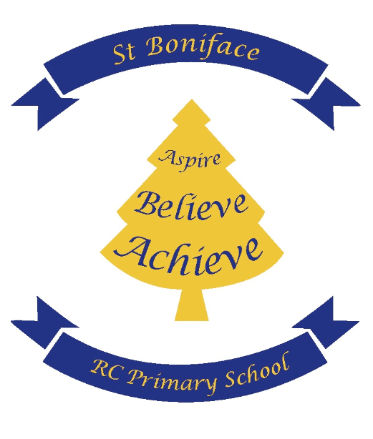
St Boniface RC Primary School
With Jesus in our hearts, we can reach our full potential

Adopted Date: November 2023 | Headteacher signature:
Review Date: November 2024 | Governor signature:
At St Boniface RC Primary School, we strive to make the lives of our pupils easier by enabling quick and easy access to a number of school systems and services. We aim to give them security over their own user identity when accessing school services.
In some settings, biometric information is collected and stored. Biometrics are physical or behavioural human characteristics that can be used to digitally identify a person to grant access to systems, devices or data. Examples of biometric identifiers are fingerprints, facial patterns or voice.
Each of the identifiers is considered unique to the individual, and can be used in combination to ensure greater accuracy of identification.
Currently, St Boniface RC Primary, does not collect, store and process any biometric data for any pupils.
If the school were to do so, we would ensure that the collection and storage of all pupil data abides by the principles of the General Data Protection Regulation and The Protection of Freedoms Act 2012. Any pupil biometric data collected would be stored securely for the purposes of identification only. Pupil biometric data would only be processed for the purposes for which it was obtained, and following notification to pupils' parents/carers. It would not be unlawfully disclosed to third parties.
In accordance with The Protection of Freedoms Act 2012, St Boniface RC Primary, in the event of using biometric information, would notify every pupil's parents/carers of its practice of collecting and processing pupils' biometric data as part of an automated biometric recognition system, and obtain written or online parental consent to that use from at least one parent/carer.
Parents/carers would be able to withdraw their consent in writing or online at any time. Pupils could also opt out of the use of their own biometric information at any time.
Any notification sent to parents/carers would inform them fully of St Boniface RC Primary’s reason for collecting and processing pupils' biometric data and include full details of the biometric data to be collected, its intended use, and parents/carers and pupils' right to opt out of the school's biometric recognition system. Those who opt out would be provided with details of alternative arrangements to access the relevant school services.
Any pupil biometric data would be deleted when the pupil leaves the school, or if for some other reason he/she ceases to use the biometric system.
If parents/carers or pupils have any questions about the school's collection and use of biometric information, they are welcome to contact the School’s Data Protection Manager via the school office.

