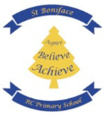

Helping your child read a word:
• Which letter phonemes (sounds) do you recognise?
Can you blend them together?
• Does the word make sense? Read the sentence again to check.
• Is there another word that would make sense?
• Is it a word you know?
• Have you read the word before? Is it on another page?
• Are there any bits of the word you recognise?
• Miss out the word, say ‘mmmm’, finish the sentence. Then go back and work out what the word was.
• In a rhyming book, think of a word that rhymes.
• Use the first 1 or 2 sounds with another strategy
• Always go back and read the sentence again!
As the child becomes a more confident reader:
It is still important to read with your child even when they have become a more confident reader.
CONTINUING TO SUPPORT AND GUIDE YOUR CHILD:
Do not worry if your child's reading is not word perfect. If they are making sense of the text, this does not matter e.g."house" instead of "home", "Good dog, Spot" instead of "Good boy, Spot". It would matter, however, if they read: "He got on his house and rode away", as this would have changed the meaning. Always be ready to takeover if your child is struggling. With your help they will succeed and will want to read more and more as a result. You can try “I read you read” as a shared reading activity.
Supporting the confident reader:
Confident readers have reached the stage where they no longer wish to read to an adult and want to read silently to themselves. The interaction between the parent and child changes at this stage. To ensure that the child's reading development continues to move forward, we would encourage parents to question the child about what they are reading, at an appropriate time, to extend their reading and share their enjoyment of the book Please pick 1-2 questions from each section.
Questions to ask:
• What is the title of the book?
• What kind of book is it? (Fiction, non-fiction, poetry, short story etc)
• Who is the author/illustrator?
• Have you read any other books by the same author?
• What made you choose this book? (Author, cover, illustration, recommendation etc)
• Did you read the blurb before selecting the book?
• Could you tell anything about the book before you started reading it? What were the clues?
• Have you read this book before? Why have you chosen it again?
Questions to ask before your child begins, resumes or during their book...
• What has happened so far?
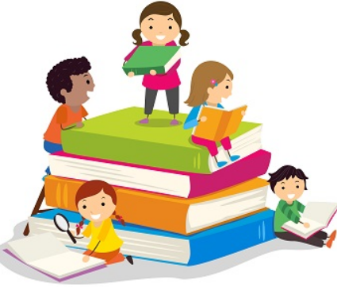
• What do you think will happen next?
• What do you think about…?
• What do you think that word means?
• What are the clues that make you think this?
• How would you like the story to end?
• Are you involved in the story? Why?
• Where is the story set? Is there a description?
• When is the story set? (Past, present, future)
• Who are the characters in the story? Who do you like/dislike? and Why?
• Do you feel similar to any of the characters? Tell me what is similar?
Questions to ask when your child has finished their book...
• Was the book as you expected?
• Was there anything you disliked about the story?
• At what point did you decide you liked/disliked the story?
• If you have read this book before, did you enjoy it more this time?
• Did you notice anything special about the way language is used in this book? (dialect, descriptive writing etc)
• If you had written this book, how would you have made it better?
• Has anything that happens in this book ever happened to you?
• Can you describe an exciting moment or favourite part of the story?
• Is the story straightforward? Is there more than one story happening at the same time?
• Who was telling the story?
• Was this the most important character in the story?
•Do we get to know the characters quickly or do they build up slowly through the book?
• Was the ending as you expected? Did you like the way the story ended?
• Do you like the illustrations? Do you have a favourite?
• Would you recommend this book to your friends? Tell me what you would say to a friend?

