St Boniface RC Primary – Y1 writing overview
Autumn 1 | Autumn 2 | Spring 1 | Spring 2 | Summer 1 | Summer 2
Core text:  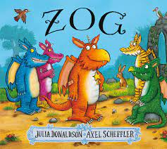 | Core texts:  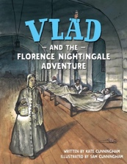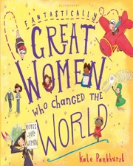 | Core texts:  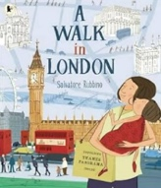  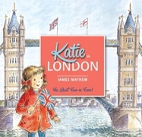 | Core text:  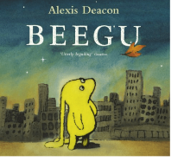 | Core texts:  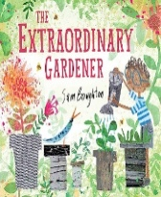  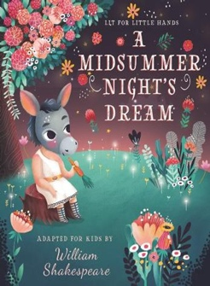 | Core text:  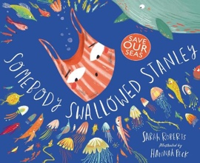
Key concepts:  N/A | Key concepts:  Migration, Legacy | Key concepts:  Cultural identity, Democracy | Key concept:  Migration | Key concepts:  Legacy, Sustainability | Key concept:  Sustainability
Lists | Narrative - retell as Vlad | Labels and captions | Character profile | Labels | Instructions - linked to the environment
Labels and captions | Diary | Postcard | Poetry - rhyming | Letters | Letters
Recount | Fact files | Fact files | Narrative (retell) | Instructions – growing plants | Narrative (retell with some innovation)
Character profile | Recount (link to real-life) | Recount in role or real life | Diary | Narrative (retell with some innovation) | Poetry - lists

