St Boniface RC Primary – Y2 writing overview
Autumn 1 | Autumn 2 | Spring 1 | Spring 2 | Summer 1 | Summer 2
Core text:  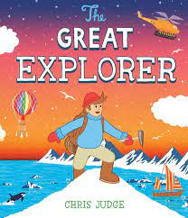  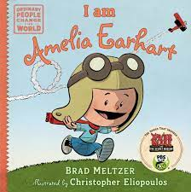 | Core texts:  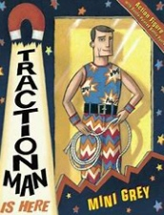 | Core text:  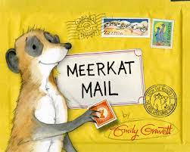 | Core text:  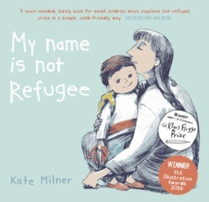 | Core text:  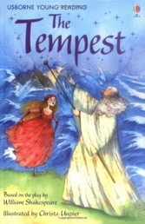 | Core text:  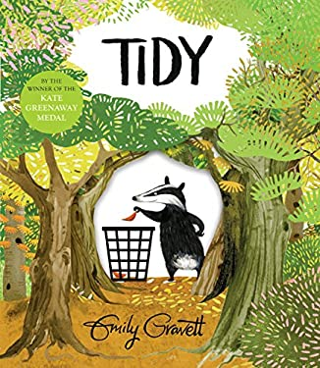
Key concepts:  Legacy, Cultural Identity | Key concept:  Cultural Identity | Key concept:  Cultural Identity | Key concepts:  Migration, Diversity, Cultural Identity | Key concept:  Legacy | Key concept:  Sustainability
Narrative – setting description  Write a description of the North Pole in first person | Diary entry  Write in role as Traction Man from a key point in the story | Narrative - character description  Write a missing poster for Sunny | Diary entry  Write in role as the boy from a key point in the story | Narrative – setting description  Describe a fierce storm in first person | Letters  Write a letter as one of the animals to Pete
Narrative – adventure story  Retell the story in first person | Narrative - character description  Create your own superhero and write a character profile | Letters  Write a postcard in role as Sunny | Letters  Write a letter for a new member of your class | Instructions  Write instructions, in role as Prospero, about how to create a storm | Narrative – woodland story  Retell the story with some innovation
Instructions  Write how to make the journey to the North Pole | Narrative – adventure story  Retell a section of Traction Man in third person (with some innovation) | Non-chronological reports  Write a report about meerkats after their visit to school | Poetry  Write a list poem linked to a theme in the book, such as new and different foods | Diary entry  Write in role from a key point of the story | Poetry  Write an acrostic poem linked to a forest/woodland
Fact file  Write a fact file about an explorer such as Amelia Earhart | Free Write  Produce a piece of writing based upon children’s interests | Free Write  Produce a piece of writing based upon children’s interests | Review  Write a review of the book | Free Write  Produce a piece of writing based upon children’s interests | Non-chronological reports  Write a fact file about an animal’s conditions for survival (link to science)

