St Boniface RC Primary – Y3 writing overview
Autumn 1 | Autumn 2 | Spring 1 | Spring 2 | Summer 1 | Summer 2
Core text:  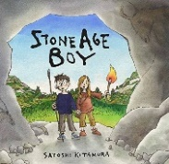  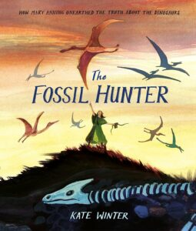 | Core texts:  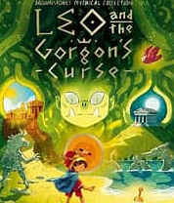  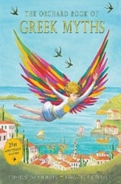 | Core text:  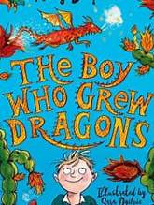 | Core text:  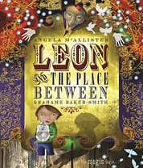 | 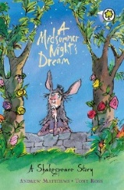  Core text: | 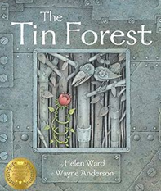  Core text:
Key concepts:  Cultural identity, Legacy | Key concepts:  Migration, Legacy | Key concept:  Cultural identity | Key concept:  Cultural Identity | Key concept:  Legacy | Key concept:  Sustainability
Letter to Inform  In character as Om writing to his parents | Narrative – character description  Write a description of a key character from Leo and the Gorgon’s curse | Narrative – character description  Design your own dragon and write a description | Narrative – setting description  In third person, describe ‘The Place Between’ | Narrative – setting description  In first person to describe a magical woodland setting | Persuasive letter  Write to a local MP about an environmental topic
Narrative – time travel  Retell of Stone Age Boy (with innovation for GDS) | Letter to inform  In character, write as Leo to a friend, explaining his quest | Narrative – adventure with dialogue  Write the next chapter from a key point in the story | Diary entry  Write in role as a character from a key point of the story | Diary entry  Write in role as a character from a key point of the story | Narrative – fantasy with dialogue  Retell of the story with some innovation
Diary entry  Write in role as Mary  Anning | Narrative – historical adventure with dialogue  Write the next chapter of Leo’s epic adventure | Non-chronological report  Write a non-chronological report about your dragon | Instructions/explanation  Write a piece linked to a theme such as ‘how to perform a magic trick’ | Narrative – playscripts  Retell a small section of the story as a playscript | Instructions/ explanation  How the old man can look after his environment
Biography  Write a factfile about Mary Anning | Non-chronological report  Based on Ancient Greek Gods/ Goddesses or a mythical creature | Poetry – calligrams  Write a calligram poem based upon the dragon | Persuasive poster  Design a poster explaining why people should visit the Peak District – link to geography | Poetry – Haiku  Write a haiku based upon a key character, such as one of the Fairies | Free Write  Produce a piece of writing based upon children’s interests

- Description (character and setting)
- Story
- Poetry
- Diary entries x 2
- Recount
- Letters
- Non-chronological reports
- Instructions/
explanations
- Biography
- Adverts
- Letter

