St Boniface RC Primary – Y4 writing overview
Autumn 1 | Autumn 2 | Spring 1 | Spring 2 | Summer 1 | Summer 2
Core text:  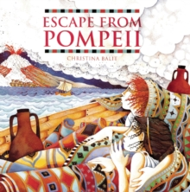 | Core texts:  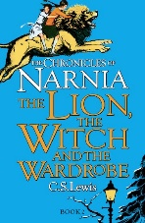 | Core text:  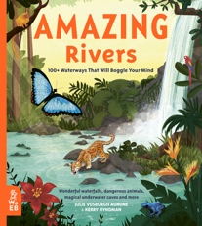 | 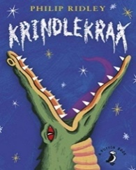  Core text: | Core text:  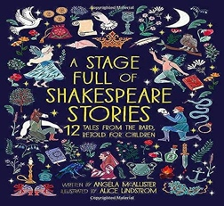 | Core text:  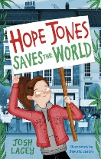
Key concepts:  Empire, Democracy | Key concepts:  Democracy, Law and Order | Key concepts:  Cultural identify, Diversity, Legacy | Key concept:  Cultural Identity | Key concepts:  Legacy, Democracy, Empire | Key concepts:  Sustainability
Narrative – setting description  Write a vivid description of the eruption (third person) | Narrative – character description  Write a description of one of the key characters, such as Mr Tumnus or the Queen | Recount - diary  Write a diary entry as one of the animals in the text | Narrative- character description  Write a description of Ruskin Splinter | Recount - diary  Write a diary entry as a character, such as Julius Caesar, in role | Narrative – alternative ending  Continue the story from a key point with dialogue
Letters - inform  Write a letter as a citizen describing the events and eruption | Persuasive letter  Write in role as the Queen, asking people to join her in battle | Non-chronological report  Produce a factfile about the Amazon Basin | Narrative – setting description  Write a vivid description of a setting, such as Lizard Street (third person) | Biography  Write a biography about Shakespeare | Biography/fact file  Write a biography about Hope Jones
Narrative – historical (including dialogue)  Retell of Escape from Pompeii (with innovation for GDS) | Narrative – adventure (including dialogue)  Retell the story in first person as a character of your choice | Poetry – kennings  Write a kennings poem based upon a river | Persuasive letter  Write in role to persuade Mr Lace that you are the best person to be in the play | Narrative – playscripts  Retell a section of the story as a playscript | Recount  Write a recount of our trip to Formby Beach
Instructions  Write a set of instructions linked to Roman unit | Non-chronological report  Write a report linked to Romans/Salford history unit | Explanations  Write how rivers are formed | Poetry – haiku  Write a haiku linked to crocodiles | Free Write  Produce a piece of writing based upon children’s interests | Explanations/instructions  Write a report about how we can look after our beaches and rivers (link to geography)

