St Boniface RC Primary - Y5 writing overview
Autumn 1 | Autumn 2 | Spring 1 | Spring 2 | Summer 1 | Summer 2
Core text:  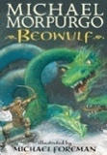 | 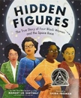  Core texts:  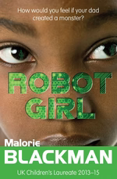 | Core text:  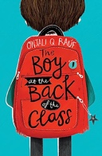 | 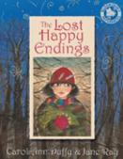  Core text: | Core text:  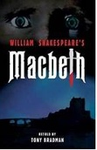 | Core text:  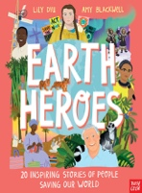
Key concepts:  Legacy | Key concepts:  Diversity, Legacy, Cultural Identity | Key concepts:  Migration, Cultural Identity, Diversity | Key concept:  Cultural Identity | Key concepts:  Legacy, Law and Order | Key concepts:  Sustainability, Cultural Identity, Trade
Speech - persuasive  Write a draft speech in role as King Hrothgar, pleading for help | Narrative – setting description  Describe a scene from Robot Girl | Diary entry  Write a diary entry as Ahmet from a key point in the story | Narrative- character description  Describe Jub or the witch using the text as inspiration | Narrative – setting description  Describe the heathland where the witches meet | Persuasive letter  Write about a topic linked to the environment, such as global warming
Narrative – historical adventure  Retell the story with innovation (including dialogue) | Instructions/explanation  Write a set of instructions linked to the creation of AI-E | Non-chronological Report  Write a report about our school environment for new arrivals | Diary entry  Write a diary entry in role as one of the key characters | Letter to inform  Write as Macbeth to Lady Macbeth about the witches | Biography  Write a biography about one of the 20 people in the book
Poetry – ballads  Retell a section of the story through a ballad | Biography  Write a short biography about one of the Hidden Figures | Narrative- character description  Describe one of the key characters | Review  Write a review of the book for a familiar website such as BBC Newsround | Narrative – playscripts  Retell a key section of the story as a playscript | Persuasive speech  Write a speech to deliver in school about an environmental issue
Non-chronological report  Produce a non-fiction report about Viking warriors (link to history) | Persuasion – balanced argument  Write a balanced argument linked to space, such as ‘should humans return to the moon again?’ | Narrative – contemporary  Continue the story from the end of a key chapter (including dialogue) | Instructions/Explanation  Write a piece linked to geography topic (earthquakes) | Review  Write a magazine article, counting down the top 3 most villainous characters in Macbeth | Poetry – cinquain  Write a cinquain about the environment

