St Boniface RC Primary – Y6 writing overview
Autumn 1 | Autumn 2 | Spring 1 | Spring 2 | Summer 1 | Summer 2
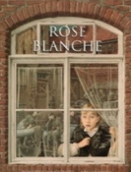  Core text: | Core text:  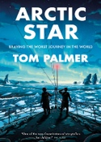 | Core text:  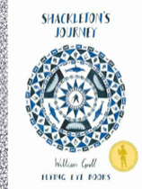 | Core texts:  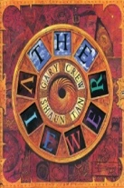  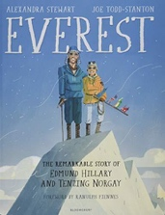 | Core text:  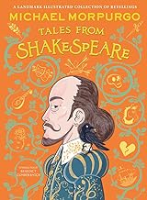 | Core text:  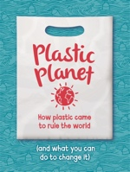
Key concepts:  Legacy, Democracy, Migration | Key concepts:  Democracy, Legacy | Key concept:  Cultural Identity | Key concepts:  Cultural Identity, Diversity, Sustainability | Key concepts:  Legacy, Law and Order | Key concepts:  Sustainability, Trade
Narrative – setting description  Describe a scene that Rose encounters | Report – formal  Write a formal report in role for the Royal Navy, outlining your experiences | Speech - formal  Write the speech as Shackleton to describe the journey | Narrative – mystery with dialogue  Write a story in the style of The Viewer, based upon finding a magic object | Narrative – formal letter  Write in role as Friar Lawrence, explaining the plan to Romeo | Persuasive letter – formal  Write to a food company or MP about reducing our use of plastic
Diary entry  Write in role as Rose | Narrative – historical adventure with dialogue  Write the next chapter of the boys’ epic adventure | Report – informal  Write a magazine interview with Shackleton | Non-chronological report  Write a non-chronological report about mountains (link to geography) | Narrative – playscripts  Retell a section of Romeo and Juliet as a playscript | Instructions/explanation  How we can reduce the use of plastic in everyday life
Narrative – informal letter  Write to a friend in another town, describing what is happening | Review - informal  Write a review of Arctic Star for a KS2 magazine | Poetry – Narrative  Write a narrative poem based upon Shackleton’s journey | Balanced argument  Linked to a theme such as ‘should explorers stop climbing Everest?’ | Biography  Write about a person of your choice | Narrative – setting description  Write a vivid description of the shop in Alma  Literacy Shed)

