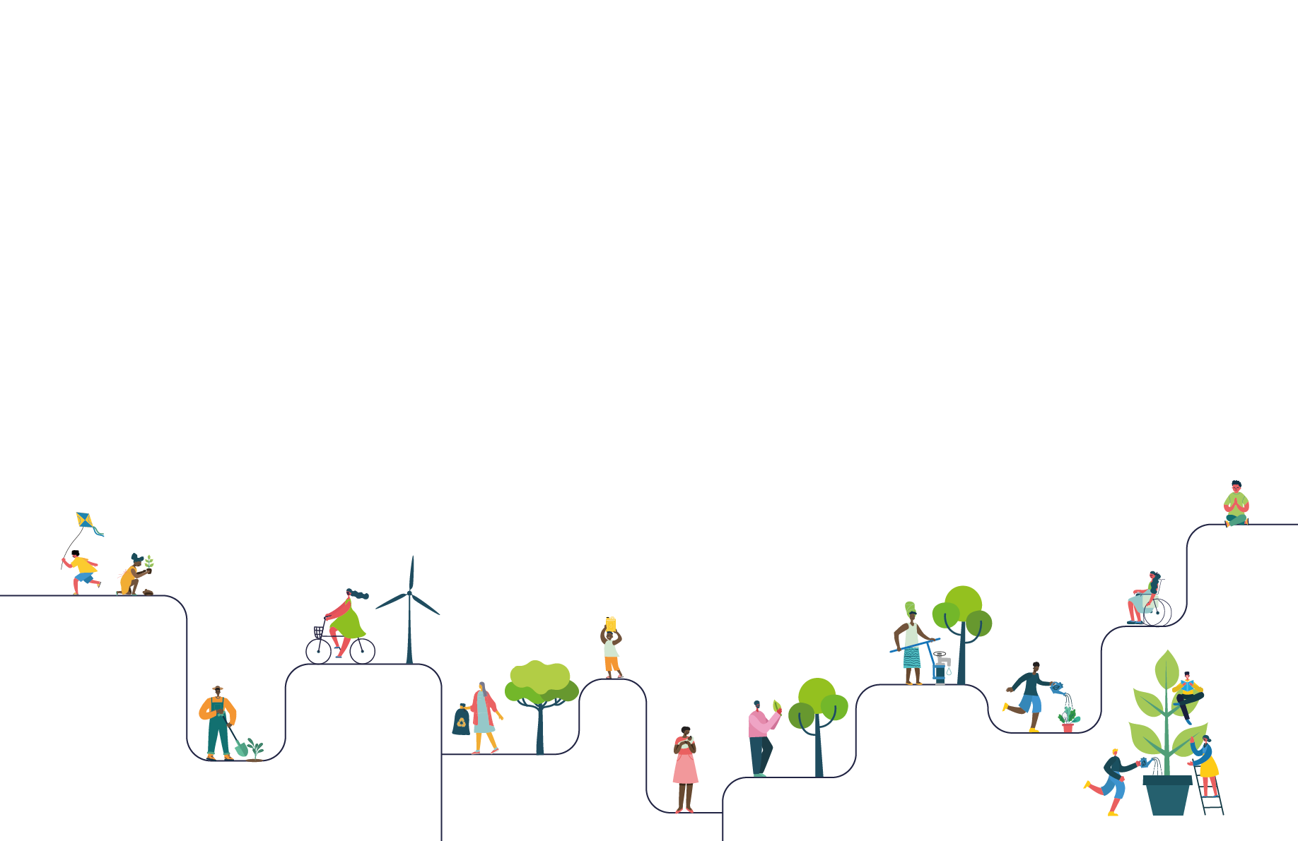



SCHOOL NAME: St Boniface RC Primary School

Thank you for registering your LiveSimply action plan.
The details you entered online are listed below.
Should you have any queries, please visit cafod.org.uk/LiveSimplySchools for the FAQs


Your LiveSimply action plan Libby a3RQ2000001VNfhMAG
Global Actions
Action 1 Living in Solidarity main action
1A) ___ We will take part in the CAFOD Big Lent Walk. The whole school will take part in a sponsored walk to raise funds for, and awareness of, CAFOD's work in supporting our global family. (Living in Solidarity)
Global Faith element 1
Links to the CST of Solidarity and standing together with those in need globally. As it is during the time of lent we will include prayers led by the children for our global family.
Global Learning element 1
During lent Children will take part and fundraise to support CAFOD and people living in poverty. Children will deliver an assembly to explain what the walk is and the challenges that many living in poverty face. All children in the school will learn about CAFOD's global mission. The children will understand how their fundraising will contribute to change.

How will you involve the wider community taking part in this action i.e. governors/families/parishioners/local people?
The fund raising will be advertised to families and they will be encouraged to take part with the children for example by walking to/from school. Governors will be invited to take part and will be invited to come to assemblies and join us for prayer and reflection.

Would you like a CAFOD visitor to deliver an assembly/workshop to support your CAFOD fundraising action? Yes we would like a CAFOD visitor

Action 2
2C) ___ We will engage with Fairtrade and introduce actions to support it (e.g. hold a Fairtrade stall, switch to Fairtrade products in the tuck shop, ask each family to swap at least one item for a Fairtrade product). (Living in Solidarity)
Global Faith element 2
This action will link to the CST of solidarity, we are one globally family and our actions can add to injustices or help to ensure that justice is upheld.
Pope Francis reminded us that 'every economic decision has a moral consequence'
Children can live out their faith by making daily choices that respect human dignity (CST)
Children will reflect and pray before completing activities for Fairtrade.
Link to teachings of fairness and respect for labour.
Global Learning element 2
Pupils will learn where their food comes from and how this can sometimes be unjust or unfair. Children will learn how theirs and their families small choices will promote a fairer and more just system globally.
https://schools.fairtrade.org.uk/
We will hold an assembly led by our eco-ambassadors to explain the importance of our choices and how our small actions can still have an impact.
Children will then participate in activities and take their learning home and explore a product that they could swap to a fairtrade product.
We will take part in Fairtrade Fortnight in 2026.
Children will be able to recognise the fairtrade symbol and explain its importance and understand why choosing to swap to a product with this symbol is upholding justice and representing their faith.

Action 3
3A) ___ We will take part in International Day of Peace or World Day of Peace. Included within our actions for this day, pupils will write prayers for our global family impacted by war and conflict. (Living Simply)
Global Faith element 3
Links to the CST of peace and the common good.
https://cafod.org.uk/pray/world-day-of-peace
World Day of peace messages to be shared with the children before time for reflection and prayer as a whole school.
Global Learning element 3
Children will learn about the importance of peace and forgiveness. Assembly on the significance of peace and what it means https://cafod.org.uk/education/primary-teaching-resources/peace-liturgy Children will take part in activities linked to peace such as peace rocks and prayers. Children will share these with each other and with our school community and spread the message to their families.
Local Actions
Action 1
1A) ___ We will create/maintain a link with a local care home, enabling our younger and older generations to share time together (e.g. talking, playing games such as dominos, learning more about the life of our older community, hearing top tips, singing to/with them, sending cards/letters). (Living Simply)
Local Faith element 1
Links to the CST of human dignity and every person being important no matter their age.
Links to Pope Francis' message to value the wisdom of the elderly. Prayer with the care home and for them when we are back in school.
Local Learning element 1
Children will be able to develop their respect, empathy and listening skills. Children will understand how the generosity of their time and kindness will have a big impact on the well being of those in the care home. Pupils will understand the importance of community and maintaining links within the community.

Action 2
2A) ___ Inspired by Laudato Si' pupils will organise a litter pick in the community to protect wildlife and keep the local area tidy. Where possible, litter picked will be recycled appropriately. (You may wish to start your litter pick with a prayer.) (Living sustainably)
Local Faith element 2
CST of caring for God's gifts and being stewards to look after the world that he created. before each litter pick we will begin with a prayer and reflection of why our actions are important to care and protect God's creation. Links with Laudato Si' and being protectors of God's work.
Local Learning element 2
Led by our Laudato Si' ambassadors we will arrange litter picks of the local area every half-term. The children will understand how their help in keeping the local area tidy will protect wild life and care for God's creation. Children will learn to think about their actions outside of school with regards to litter and encourage their families to do the same and explain why they are also having an impact by their actions.

Action 3
3C) ___ We will support our local homeless shelter. Pupils will find out what the shelter needs and then raise funds or gather the items required. (Living in Solidarity)
Local Faith element 3
CST link to human dignity emphasising that everyone was made in the image of God and deserves to be cared for and respected.
Link to solidarity and standing together with our local community to support those in need.
Local Learning element 3
Pupils will learn about poverty and how this is even present in our local community. We will continue to maintain links with Loaves and Fishes Salford and donate food and items in exchange for non-uniform days at school at different points in the year such as harvest. Children will learn and understand how their donations and spreading of the word about homelessness can have a big impact on our local community.

School Actions
Action 1 – Living Simply main action
1B) ___ We will hold a whole school art or photography competition, celebrating awe and wonder of God's creations. Depending on the age group we will either provide quotations from scripture to inspire the pupils, or they will choose one themselves to go with their art/photo. (Living simply)
School Faith element 1
Links to the story of Creation from Genesis and the CST of Caring for God's gifts and us being Stewards of the World. Links with Laudato Si' to spread the message and remember the importance of our actions in protecting the wonder of God's creations.
School Learning element 1
Children will retrieve their prior learning on Creation and remember the beautiful world that God created for us and how we have a duty to protect it. They will chare their learning with their families and remind them of the actions that they can take to protect the Wonder of God's creations. Children will learn that Creation is a gift from God.

How will you involve the wider community taking part in this action i.e. governors/families/parishioners/local people?
We will add a digital gallery onto the website of the art to share with the local community. School governors and other members of the community will be invited in to judge the competition. Pieces of art will be shared with our local churches to celebrate Creation.

Action 2 – Living Sustainably main action
2C) ___ We will take action to Rethink, Refuse, Reduce, Reuse, Repair, Regift, Recycle. Pupils will be involved in implementing, raising awareness, and taking part in actions. (Living Sustainably)
School Faith element 2
Links to CST of caring for God's creation and stewardship for creation. Links with Laudato Si'. Encouraging children to use their faith and learning about creation to influence their decision making in day to day life.
School Learning element 2
Children will learn to lead more sustainable lives and understand the moral implications of waste and their choices. Children will see how their collective small changes can lead to having a positive impact.
https://www.ecoschools.global/lesson-plans-for-teachers

How will you involve the wider community taking part in this action i.e. governors/families/parishioners/local people?
Families will be encouraged to continue the practices that we will be implementing into school at home. We will share eco tips with families and encourage them to donate products that could be upcycled or reused to school. We will organise an exchange event for the local community to attend and swap any items.

Action 3
3B) ___ We will use our school grounds to live more sustainably (e.g. growing produce, planting wildflowers and pollinator friendly plants, planting trees). (Living Sustainably)
School Faith element 3
Link to Laudato Si' - call to live in harmony with nature
Links to CST of caring for God's creation
School Learning element 3
https://cafod.org.uk/education
https://www.rhs.org.uk/education-learning/school-gardening
Children will learn about different eco systems, biodiversity and the growth of food. Children will be the main part of this action and will be able to take their learning home and explain how their actions within school will positively impact on the environment.

Main Actions

Living Simply
1B) ___ We will hold a whole school art or photography competition, celebrating awe and wonder of God's creations. Depending on the age group we will either provide quotations from scripture to inspire the pupils, or they will choose one themselves to go with their art/photo. (Living simply)

Living Sustainably
2C) ___ We will take action to Rethink, Refuse, Reduce, Reuse, Repair, Regift, Recycle. Pupils will be involved in implementing, raising awareness, and taking part in actions. (Living Sustainably)

Living in Solidarity
1A) ___ We will take part in the CAFOD Big Lent Walk. The whole school will take part in a sponsored walk to raise funds for, and awareness of, CAFOD's work in supporting our global family. (Living in Solidarity)

School/Contact Details

Name of School
St Boniface RC Primary School

Address
Yew Street
Salford
M7 2HL

Phone
01617925659

Contact Name
Libby Calvert (Miss)

Email Address
libby.calvert@stbonifacesalford.co.uk

Any queries please view our FAQ on www.cafod.org.uk/LiveSimplySchools or email schools@cafod.org.uk

