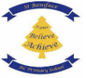
St Boniface RC Primary School
Long – Term Overview 2025

Areas of Learning | NC Links | Autumn 1 | Autumn 2 | Spring 1 | Spring 2 | Summer 1 | Summer 2
 |  | All about Me! | How do we celebrate? | What is it like in space? | What helps us Grow? | People Who Help Us | Under the Sea
 |  | Getting to Know Me  My Family  My senses  My Body  My Feelings  Celebrating Me | Birthdays  Bonfire Night  Remembrance Day  Diwali  Celebrations around the world  Weddings | Day & Night  Space Travel  Planets & Stars  Moon & Sun  Astronauts | Plants around us  Seeds and bulbs  Life Cycles  Healthy Grows  Animals  Celebrating Growth | Introducing helpers  Police  Firefighters  Doctors & Nurses  Teachers  People in the community  Celebrating People who help us. | Sea Creatures  Rock pools  Boats  Cx  Seaside Safety  The Beach  Sun Safety
Physical development | Physical development is about both gross and fine motor skills, as well as healthy self-care habits. Children will have daily opportunities to move freely and develop coordination, balance, and control through climbing, running, jumping, and other large movements. Alongside this, fine motor skills—such as holding a pencil, using scissors, fastening buttons, and pouring—are nurtured to prepare children for writing and self-care. There is also an emphasis on healthy choices, such as the importance of being active, eating well and learning independence with dressing and toileting. These skills are closely linked to children’s confidence and readiness for more formal learning.
 | PE | N –  Introduction to PE Unit 1 | Fundamentals  Unit 1 | Ball Skills: Unit 1 | Gymnastics: Unit 1 | Dance: Unit 1 | Games: Unit 1
 |  | R –  Introduction to PE Unit 2 | Fundamentals  Unit 2 | Ball Skills: Unit 2 | Gymnastics: Unit 1 | Dance: Unit 1 | Games: Unit 1
Communication, Language & Literacy. | Children’s spoken language, listening, and understanding skills form the foundation of all learning. In the early years, children will be immersed in language-rich environments where conversations, storytelling, songs, and role-play encourage them to develop a wide and varied vocabulary. Practitioners will model new words in context, encourage children to articulate their thoughts, and give them opportunities to listen carefully to others. The focus is on enabling children to express themselves clearly and confidently, while also building the ability to follow instructions and engage in meaningful back-and-forth conversations
 | Core Text: | N  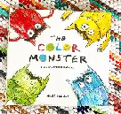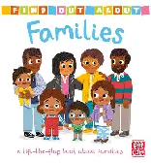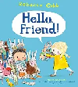 | 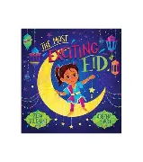  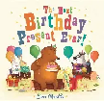  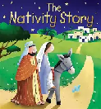 | 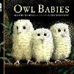  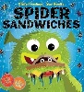  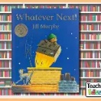 | 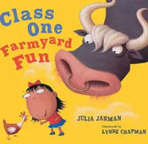  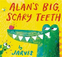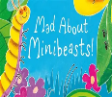 | 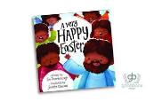  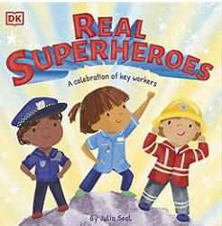 | 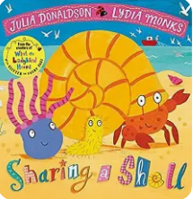  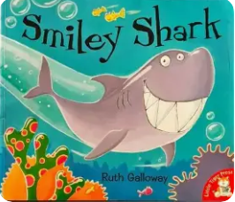  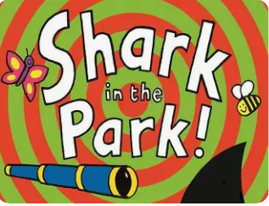
 |  | R  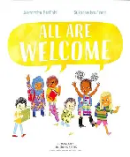  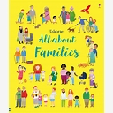  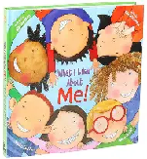 | 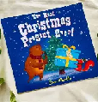   | 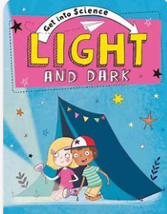  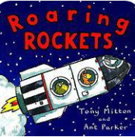  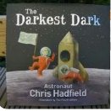 | 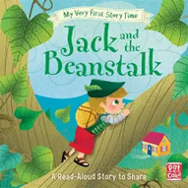  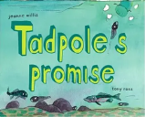  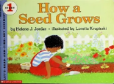 | 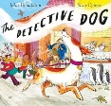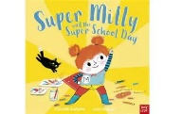 | 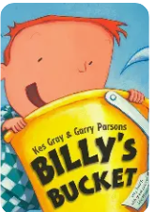  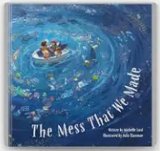  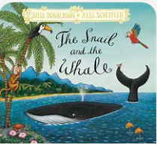
Literacy  Little Wandle  SSP | Literacy learning in the early years is focused on fostering a love of stories, books, and writing. Children will engage in daily story sharing, nursery rhymes, and songs to build early comprehension skills and awareness of rhythm and rhyme. They will begin to link sounds and letters through phonics and develop the ability to recognise familiar words. Mark-making activities—whether drawing, painting, or writing their names—support early writing development. By the end of the early years, children will be encouraged to write simple sentences and use their knowledge of sounds to spell words, while also being able to understand and talk about what they have read.
 | English | N- Rhyme Time | Rhyme Time | Foundations for a Love of Reading. | Foundations for a Love of Reading. | Foundations for a Love of Reading. | Foundations for a Love of Reading.
 |  | R – Apply and recognise Phase 2 graphemes in reading and writing | Apply and recognise Phase 2 graphemes in reading and writing | Apply and recognise Phase 3 graphemes in reading and writing | Apply and recognise Phase 3 graphemes in reading and writing | Apply and recognise Phase 4 graphemes in reading and writing | Apply and recognise Phase 4 graphemes in reading and writing
Understanding the World | This area introduces children to the wider world around them, encouraging curiosity and respect for different people, places, and environments. They will learn about the past and present by talking about their own families, events, and stories from history. Diversity and community are celebrated through learning about different cultures, beliefs, and traditions. Children will also explore the natural world—observing plants, animals, weather, and seasonal changes—building an early understanding of science. Hands-on exploration, such as gardening, nature walks, and using simple technology, helps children make sense of the world and their place within it.
 | History | N  Talk about when I was a baby. | Continue to develop positive attitudes about the differences between people. | Discussions of journey’s children have embarked on. | CTo recognise plants grow from a seed. | To look at home Emergency helpers and their equipment has changed over the years. | To Talk about special day’s, I have enjoyed.
 |  | R  How have I changed? |  |  | Create a timeline of a school day in Reception.
 | Geography | N  Families – My Own Home is in Lower Broughton | Celebrations  Discuss how celebrations all over the world maybe different to our own. | Draw a map of our playground drawing what we see along the way. | Past & Present  Look at pictures of the local area and discuss how they have changed. | To recognise people have different jobs, look at a variety of jobs within our local community. | Early Geographers  Compare how living in Lower Broughton is different to living in a hot country.
 |  | R  Families – My school community | Celebrations | Special People | Past and Present | Significant People | Early Geographers.
 | Science | N  Our Bodies | Freezing and Melting | Light and Dark | Planting flowers | What’s changed – Ourselves | Floating and sinking
 |  | R  Our bodies | Freezing and Melting | Light and Dark | Planting Vegetables | What’s changed – Natural environments? | Floating and sinking.
 | RE  EYFS | 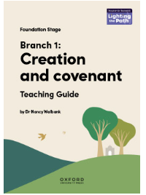 | 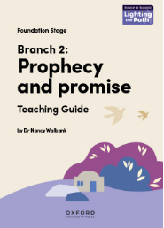
Personal, Social & Emotional Development | This area supports children in understanding themselves and others, managing their feelings, and developing positive relationships. Children will learn to share, take turns, and resolve simple conflicts with guidance. They will be encouraged to talk about their emotions, understand how their actions affect others, and develop resilience in the face of challenges. Independence is fostered through managing self-care, making choices, and taking responsibility for tasks. PSED also lays the foundation for empathy, respect, and appreciation of diversity—helping children build secure attachments and a strong sense of belonging in their community.
 | PHSE  RSE | N  Think Equal level 1 weeks 1-5 | Think Equal level 1 weeks 5-10 | Think Equal level 1 weeks 10-15 | Think Equal level 1 weeks 15-20 | Think Equal level 1 weeks 20-25 | Think Equal level 1 weeks 25 - 30
 |  | R  Think Equal level 2 weeks 1-5 | Think Equal level 2 weeks 5- 10 | Think Equal level 2 weeks 10-15 | Think Equal level 2 weeks 15 - 20 | Think Equal level 2 weeks 20 -25 | Think Equal level 2 weeks 25 -30

Mathematics | Early maths is taught through play, problem solving, and exploration of the world around children. The focus is on developing a strong sense of number—recognising numerals, counting objects, comparing quantities, and understanding the concept of more or fewer. Children will explore numerical patterns, such as odd and even numbers, doubling, and sequences. While shape, space, and measures are no longer a separate Early Learning Goal, they remain embedded in practice through activities like building with blocks, cooking, and exploring capacity with sand and water. The aim is for children to see maths as practical, enjoyable, and relevant to everyday life.
 | Maths | N  More than, fewer than, same  Explore and build with shapes and objects  Explore repeats  Hear & say number names | Begin to order number names  I see 1,2,3  Join in with repeats  Explore position and space | Show me 1,2,3  Move and label 1,2,3  Shape, Space & Explore position and routes  Explore pattern | Take and give 1,2,2  Shape, Space & Match, talk, push and pull  Talk about dots  Compare and sort collections | Lead on own repeats  Start to puzzle  Make patterns together  Make games and actions | Show me 5  My own pattern  Stop at 1,2,3,4,5  Match, sort, compare
 |  | R –  Getting to know you  Match, Sort & Compare | Getting to know you  Match, Sort & Compare  Shapes with 4 sides | Alive in 5  Mass and Capacity  Growing 6,7, 8 | Length, Height & Time  Building 9 & 10  Explore 3D Shapes | To 20 and beyond  How many now?  Manipulate, compose and decompose | Sharing and Grouping Visualise, Build and map
Expressive Art & Design | Creativity and imagination flourish in this area, as children are given opportunities to experiment with different materials, tools, and techniques. They will explore colour, texture, shape, and sound through art, music, movement, and role-play. Children are encouraged to create their own artwork, models, and performances, as well as to express their ideas through storytelling and pretend play. This area will support developing children’s confidence, originality, and the joy of experimenting. Staff will support children to be imaginative and expressive to enhance children’s problem-solving skills, resilience, and ability to communicate their thoughts and feelings in a way that is unique to them individually.
 | Art  DT | N  Handprints  Self portraits  Building houses  Daily access to paint and tools to create and build. | N  Create a party Hat  Firework paintings  Bake a cake | N  Rocket Making  Moon surface paining  Alien collages | N  Handprint flower garden  Fruit and veg printing  Yoghurt pot cress heads | N  People who help us paper face painting  Design a doctors bag – cut and stick | N  Shell painting  Sand texture art  Using disks make a rainbow fish.
 |  | R  Self portraits  Create a ‘My favpurite things box. | R  Create a celebration card  Design an invitation  Make party foods from playdough  Create a Chinese lantern | R  Planet painting  Star constellation art  Design and make a space helmet. | R  Life Cycle seed to plants  Design a flowerpot | R  Design a super hero badge  Build an emergency vehicle using recycled products. | R  Under the sea collage  Building sandcastles  Design your own sea creature.
 | Music  Get Set 4 Music | EYFS  Traditional Tails | Whatever the Weather | Journey’s | Circus | Minibeast | Deep Blue Sea

