Science Policy

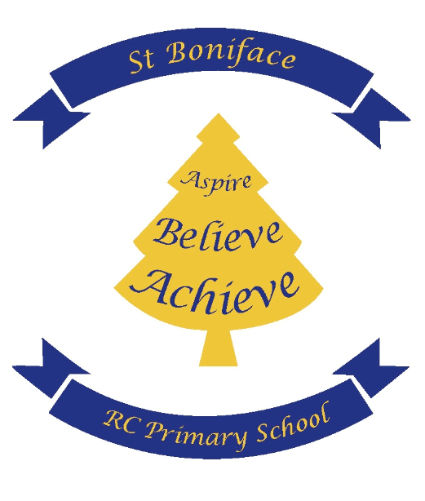
St Boniface RC Primary School

With Jesus in our hearts, we can reach our full potential

Date: September 2025 | Headteacher signature:
Review Date: September 2026 | Governor signature:

St Boniface R.C. Primary School Policy for Science
Mission Statement:
With Jesus in our hearts, we nurture each individual to reach their full potential. We aspire for every member of our school family: To learn and grow in a happy and safe place. To believe in themselves and be proud of who they are. To treat each other with respect, love and acceptance.
With Jesus in our hearts, we can reach our full potential.
At St Boniface RC, we aim to provide a high-quality science education that inspires curiosity, encourages questioning, and develops a deep understanding of the world around us. Our goal is to nurture pupils’ natural curiosity and equip them with the knowledge, skills, and vocabulary to explore, investigate, and explain scientific phenomena with confidence.
Intent
At St Boniface, we value science and scientific enquiry as essential parts of learning. Our curriculum develops children’s scientific knowledge and skills alongside our Catholic faith, encouraging them to care for our common home now and in the future.
We aim to deliver a fun, practical and engaging science curriculum that inspires curiosity and a lifelong love of learning. Following the national curriculum, we nurture children’s ability to ask questions, investigate, and think critically about the world around them.
Scientific investigation is at the heart of our teaching. Through hands-on, systematic enquiry, pupils gain key knowledge, skills, and positive attitudes that equip them for life. Working Scientifically skills are developed progressively so children grow confident in using equipment, conducting experiments, explaining ideas, and applying scientific vocabulary—always questioning and exploring their world with curiosity and understanding.
By the end of Key Stage 2, we aim for our children to:
- Develop a secure understanding of the key concepts and processes in biology, chemistry, and physics.
- Build curiosity and enthusiasm for exploring scientific ideas through hands-on investigations.
- Use scientific language confidently to explain and discuss their findings.
- Understand how science has shaped our world and continues to impact our lives
- Develop critical thinking, problem-solving, and enquiry skills that prepare them for further study and everyday life.
Implementation
How will we achieve our aim?
- We will continue to embed the new White Rose Science scheme across school
- Our curriculum has been recently reviewed to ensure that is it current and effective
- Teachers are supported and aided in their teaching of science by team teaching and modelling of good practice. Following the White Rose scheme ensures that teacher’s subject knowledge is supported, including how to address misconceptions.
- All staff are encouraged to raise questions, seek support and request further training if needed
- Whole school CPD on science teaching in school, with a particular focus on developing scientific enquiry and skills
- Staff and pupil voice audits to be completed mid-way through the year to monitor new scheme.
We will continually recap and revisit previous skills with a focus on children’s oracy:
- All lessons start with “Flashback 4” which is 4 questions about previous learning (from previous lessons, previous topics or previous year groups).
- Whole school focus (covered in CPD day) on embedding scientific vocabulary and strategies to ensure this is remembered and used.
- Children encouraged to use correct scientific language to verbally describe how they know and answered the questions
- Sentence stems displayed in class where appropriate and included in lessons
- Some topics are revisited throughout the year to further embed and build on prior learning (i.e. seasons, shadows etc.)
We will continue to develop scientific enquiry and skills:
- Whole school staff CPD focus
- White Rose Scheme planning highlights ways to work practically as well as how to develop enquiry and skills
- Children are encouraged to discuss their thoughts, ideas and questions throughout lessons but also at other times of the school day.
- Vocabulary and skills progression is mapped throughout the year for each science topic and strand.
- School trips, wider opportunities and workshop days in school add to and enrich our science curriculum.
Impact
How will we know that we have achieved our aims?
- Children understand the relevance and importance of what they are learning in relation to real world concepts
- Scientific enquiry and skills are taught well and are built upon effectively. Scientific vocabulary is used across school life and children’s oracy skills are developed
- Children have a positive view of science and see it is an exciting and enjoyable subject in which they can investigate and ask questions
- Children demonstrate a scientific mindset of observation, exploration, questioning, critical thinking and evaluation in other areas of their life and learning.
- Teaching is consistent and coverage of the curriculum is detailed. Prior learning is embedded and used to help acquire new learning.
- Assessment of both knowledge and skills is robust and secure. Assessment shows high levels of attainment and progression

Aims
Our science teaching aims to develop knowledge and understanding of:
- Important scientific concepts
- The nature, processes and methods of science through various types of enquiry promote creative thinking and ways of communicating ideas.
- The uses and implications of science, today and for the future.
- The awe and wonder that comes from appreciating God’s creation.
Knowledge and Conceptual Understanding
Children are encouraged to:
- Be curious and to explore the world around them using their senses.
- Use this experience to develop their understanding of key scientific ideas and to make links.
- Think about ways to model things they cannot directly experience.
- Investigate different scientific theories and explain reasons for their predictions.
- Try to think practically and critically about ideas.
The Nature, Processes and Methods of Science
‘Working Scientifically’ is embedded within science lessons where children are led to:
- Use a variety of approaches to ask and answer relevant scientific questions.
- Seek answers to questions through collecting, analysing and presenting data.
- Conduct different types of scientific enquiry at an ever advancing level including: observing over time; pattern seeking; identifying, classifying and grouping; comparative and fair testing (controlled investigations) and researching using secondary sources.
- Practise mathematical skills such as counting, measuring and drawing and interpreting graphs in real contexts.
- Develop language skills by talking about their work and using appropriate scientific and mathematical vocabulary.
The Role of the Science Coordinator
This is to:
- Be a role model and demonstrate good practice.
- Monitor and evaluate the success of science within the school.
- Keep the written policy document and scheme of work up to date and evaluate the content and method.
- Submit regular feedback on standards in Science to the SLT.
- Offer advice, support and organise in-service training for staff.
- Attend courses and use the knowledge gained to improve attainment in science.
- Ensure that resources are well managed.
- Be aware of national and local developments through reading relevant materials and attending courses.
Health and Safety
We implement the safety recommendations in the Be Safe publication as well as our own Health and Safety Policy. Pupils are taught about hazards, risks and how to control them.
Resources
- Practical resources are stored in the science cupboard near the staffroom
- Assessment resources and additional resources are stored on the Shared Drive in the ‘Science Curriculum’ folder.
Strategies for Assessing, Recording and Reporting
Both formative and summative assessment is carried out to help assess learning against the expectations stated in the National Curriculum.
Formative Assessment
Formative assessment is carried out through questioning and discussion as work is undertaken. We follow the White Rose Science scheme, which incorporates retrieval questions in each lesson to assess and recap prior knowledge. Retrieval tasks are also recorded regularly during written activities, allowing teachers to evaluate understanding of previous lessons and topics. At the start of each topic, children discuss “What do we already know?” which informs planning. At the end of each topic, children complete an end-of-unit test from the White Rose scheme, demonstrating progress and enabling teachers to assess understanding and development throughout the topic.
Summative Assessment
At the end of each topic, teachers will use Insight Assessment Tracker to record if each child has met the expectations for the topic that has been covered.
At the end of KS1 and KS2, teachers make an assessment of the children’s work in science. This assessment is reported to the Local Authority.
Pupils’ progress is reported verbally to parents on at least two occasions during the year and by way of a written report once a year. Attainment is reported at the end of each key stage.
Progression
Children are given the opportunity to progress from using everyday language to using increasingly precise scientific language. They move on from describing to explaining events and from an unstructured exploration to more systematic investigations of a question. In terms of recording, they progress from using simple drawings, diagrams and charts to represent and communicate scientific information to using more conventional diagrams and graphs.
Coverage
Teachers ensure all areas of Working Scientifically are being addressed throughout each topic. This ensures the objectives and skills are being practised and ensures the children are familiar with the scientific skills as well as the knowledge.
Science Ambassadors
The roles of the Science Ambassadors are to:
- Provide a pupil voice and opinion of science across the school.
- Monitor use of resources.
- Feedback any relevant information to the science coordinator.
- Offer assistance if and where needed across other classes.
Science Ambassadors are selected by their teachers across UKS2 after expressing an interest to the Science Coordinator. The aim of this is to raise the profile of science across the school and allow the pupils to have a voice in the types of investigations they would like to carry out. The roles of the Science Ambassadors develop as they move up the school and are monitored by regular meetings with the Subject Coordinator.
Equal Opportunities
All work is planned to ensure equal access and opportunity for children, regardless of race, gender, disability or learning difficulty. The view that scientists can be male or female and come from all areas of the world’s society is actively encouraged.

Signed: __________________________ Chair of Governors.
Date: _______________

Policy update: September 2025
Sarah Cassidy

