Scientist Studies KS1
AUTUMN | SPRING | SUMMER
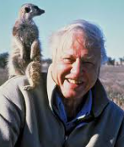  Sir David Attenborough | 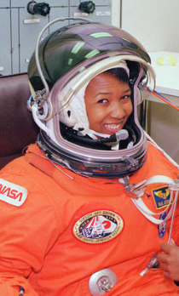  Mae Carol Jemison | 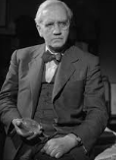  Alexander Fleming
St Boniface RC Primary School
Scientist Studies
As part of each topic of learning, we explore the work and achievements of a significant scientist linked to that area of science. This helps children to understand how scientific knowledge has developed over time and to recognise the real people whose ideas, discoveries, and innovations have shaped the world around us. By studying the lives and contributions of these scientists, pupils learn about the impact of their work, the challenges they faced, and the curiosity and perseverance that led to their success. This approach not only deepens pupils’ scientific understanding but also inspires them to think critically, ask questions, and see themselves as future scientists. Below are some of the scientists we focus on each term.

Scientist Studies LKS2
AUTUMN 1 | AUTUMN 2 | SPRING 1
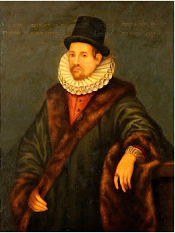  Forces: William Gilbert | 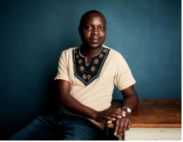  Electricity: William Kamkwamba | 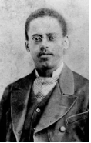  Light: Lewis Latimer
SPRING 2 | SUMMER
  Plants: Vanessa Nakate | 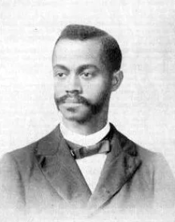  Living things and their habitats: Henry Turner
Scientist Studies UKS2
AUTUMN 1 | AUTUMN 2 | SPRING 1
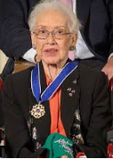  Earth and Space: Katherine Johnson | 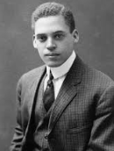  Animals including humans: Ernest Everett Just | 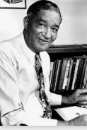  Materials: Frederick Mckinley Jones
SPRING 2 | SUMMER
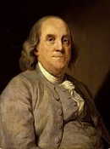  Electricity: Benjamin Franklin |   Evolution and Inheritance: Dr Estella Atekwana

