Remote Learning Policy

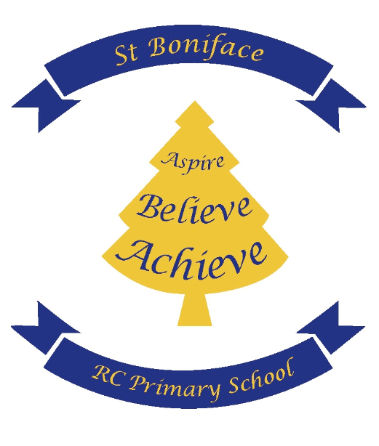
St Boniface RC Primary School

With Jesus in our hearts, we can reach our full potential

Adopted Date: November 2023 | Headteacher signature:
Review Date: November 2025 | Governor signature:

Intent
This policy will ensure consistency in the approach to home learning for pupils who are not in school as well as setting out expectations for all members of the school community with regards to home learning.

Implementation of home learning
We will use Google Classrooms to enable staff to post a range of teaching and learning presentations, stimuli, resources and activities for children to access from varying devices at home. This platform allows for staff to post sound files, videos and work documents and enables staff to view activities the children have completed, as well as answer any questions and provide feedback on the completed work submitted. This will be implemented in different ways, dependent upon the differing scenarios which require home learning.
In the event of a national lockdown, staff will use Google Classrooms to post a range of teaching and learning materials for their year group which will include videos and sound files to support learning. Staff will be able to answer questions and will respond to work submitted to the teacher.

Learning will be assigned to children at 8:00am each day.

What will children submit via Google Classrooms?
Children may be asked to upload documents or photographs or could be asked to complete work directly onto a Google Classroom document. Work should be submitted when completed throughout the day. Staff will be active in responding to work between 9am and 5pm. Work submitted after this time will be acknowledged the next day.

Home Learning Packs
Children will be issued with a Home Learning Pack with a Maths and English exercise book, stationery and wallet to keep these items together. These should only be used for school issued work and work within them should follow the school expectations for presentation and handwriting.

Responsibilities

Teachers need to ensure lesson materials and activities for children are saved in their Google Classroom class folders by 8.00am each morning. When creating a new activity on Google Classroom, the activity name should be the date, subject and title. All activities should have instructions to support the completion of the learning activity and tasks. Work allocated to children will be differentiated to reflect the usual provision in the classroom.
It has been agreed that the following will be provided in Year 1-6:
- English lesson
- Maths lesson
- Grammar 5-a-day and answers (over learning/ revision activity) or Phonics (KS1)
- Maths 5-a-day and answers (over learning/ revision activity)
- Reading – 2 comprehensions/reading activities per week and 3 sessions of reading for pleasure to be assigned.
- Topic lessons – e.g. Science/History/Geography/Art/DT/RE etc.– to reflect the class timetable as much as possible.
- Well-being/ PE to be allocated on the class usual PE day and a well-being activity.
- Picture book or story read to the class by a member of the staff team.

In the event of a school closure, teachers will also record a short video to welcome the children and introduce the timetable for the day.

It has been agreed that the home learning provision for Nursery will consist of
2 activities from the following:
- Phonics
- Maths
- Communication and language
- Story
- Understanding the World
- PSE
- Art and Design/mark making
- A play based activity
It has been agreed that the following will be provided in Reception:
- A writing activity
- A phonics activity
- A maths activity
- An activity linked to Understanding the World
- A play based activity
- Story read by a member of staff

EHCP Provision
Teachers need to ensure that bespoke provision for children with an EHCP is allocated to individual children where this is appropriate and based on the children’s EHCP Outcomes.
It may be necessary to provide paper learning packs for EHCP children to enable EHCP targets to be addressed.
The school SENCo and SEN team will support the class teacher with provision of work to EHCP children when necessary.
Live lessons
Live lessons will take place regularly on Google Meet. Teachers will deliver lessons to their whole class or to small groups depending on the topic or subject. These lessons will be set up and scheduled through Google Classroom. There will always be two members of staff on the live lesson.
Feedback
Teachers will provide feedback for English and Maths on an individual, group or whole class basis. Feedback will be age appropriate. In other subjects, feedback will be given as deemed necessary by the teacher. Staff will award Dojos for recognition of work. Staff will be active in responding to work between 9am and 5pm.
Homework
Teachers may post some or all of the year group’s weekly homework on Google Classroom to keep children familiar with using the platform. Clear instructions must be given to children and parents/carers so that homework can be completed as desired.

Teaching assistants
Teaching assistants may be asked to assist with home learning resources, support pupils who aren’t in school with home learning via use of the Google Classroom Platform or to make phone calls to children in their year group. Teaching assistants will also support teachers during live lessons.

Senior leaders
Alongside any teaching responsibilities, senior leaders are responsible for:
- Monitoring the effectiveness of home learning provision for the year groups in their phase
- Monitoring the security of remote learning systems, including data protection and safeguarding
- Responding to parents’ comments and concerns with 48 hours for children within their phase as required.

Designated Safeguarding Lead
The DSL is responsible for:
- Safeguarding concerns, including those related to remote learning.
- Maintaining contact with vulnerable children weekly.
- Collating, passing on information to the Deputy DSLs and class teachers as appropriate and responding to any concerns in a timely manner.
- To update the Child Protection and Safeguarding Policy as required by any new government guidance.

Subject Leaders
Alongside their teaching responsibilities, as outlined above, subject leaders are responsible for:
- Monitoring the work set by teachers in their subject as required.
- To offer guidance and support for staff in relation to their subject for our updated Backpack Curriculum.
- Ensure evidence for their subject is captured, particularly for those with class learning books.

Pupils
Staff can expect pupils to:
- Complete the work issued to them each day if they are well enough to do so throughout the day.
- To be contactable during the school day.
- To upload work as requested by teaching staff.
- Seek help from staff if needed via the use of Google Classroom.
- To ensure the safe and appropriate use of the Google Classroom Platform and when communicating with teaching staff.
- To keep all school issued equipment in learning packs safe and looked after.
- To follow instructions in relation to homework being posted on Google Classroom: which may be all homework or some homework as issued by the teacher.

Parents/Carers
Staff can expect parents to:
- Support children with accessing home learning as required.
- To support children with submitting and uploading of work and acting upon feedback given from teaching staff where needed.
- To communicate with school via the school email address; Google Classroom is not a means to contact teachers- it is for children only.
- To communicate appropriately with school staff in an acceptable manner.
- Where SALT takes place on a child’s provision timetable because it is written into their EHCP or because of an issued episode of care from the SALT team, it is the responsibility of the parent/carer who also has copies of targets and programmes of work, to deliver this when not in school.
- Ensure children keep login information safe and home learning resources issued by school are looked after.
- To ensure children complete any weekly homework which has been allocated to children on Google Classroom as communicated by the teacher.

Governing body
The governing body is responsible for:
- Monitoring the school’s approach to providing remote learning to ensure education remains as high quality as possible.
- Ensuring that the remote learning systems are appropriately secure, for both data protection and safeguarding reasons.

Data protection
Accessing personal data
- Staff members will have access to CPOMS to record any parent contact or concerns about children. This is accessed via a secure password.
- Staff will log out after use and not allow access to the site by any third party.
- Teachers are able to access parent contact details via a secure password issued Excel document from the school office. This will not be shared or printed.
- School laptops are the school’s preferred devices to be used when accessing any pupils’ personal information.
Keeping devices secure
All staff members will take appropriate steps to ensure their devices remain secure. This includes, but is not limited to:

- Keeping the device password-protected – strong passwords, with a combination which isn’t shared with any other household member.
- Making sure the device locks if left inactive for a period of time.
- Not sharing the device among family or friends.
- Keeping operating systems up to date – always install the latest updates.

Safeguarding
Please refer to the Child Protection and Safeguarding Policy.
Report any concerns to the DSL/Deputy DSLs.

Behaviour
Where the behaviour of children online and via communication with the teacher causes concern, this will be addressed with the children and the behaviour policy will be followed e.g. a verbal reminder about the expectations of behaviour.
Should behaviour after a warning continue, phase leaders will intervene and parents may be contacted to discuss any behaviour concerns and recorded in the behaviour log. Where behaviour is deemed concerning enough to be addressed by the Headteacher/Deputy Headteacher, they will speak to parents and hold a remote meeting via TEAMS or ZOOM.

Communication during a national lockdown
School staff will make telephone calls or video calls using Google Classroom to children every 3 weeks. They will do this during one day and so they may provide learning resources that do not require videos and allocate work which will not need to be submitted for marking on that day.

Vulnerable pupils will be called at least weekly by the DSL or Deputy DSL or phase leaders. EHCP children (not in school) will be called fortnightly by the SENCo or Headteacher.

Additionally, each week, class teachers in year groups 1-6, will host a pastoral contact session with members of their class on Google Meet. These provide an essential face to face contact with both staff and peers. The details of the meeting, such as the Meeting ID and Password will be allocated directly to children via Google Classroom. We ask that children read and adhere to our Pupil Agreement when using Google Meet. Please see Appendix 1 for the Google Meet Pupil Agreement.

The children in year 6 will also receive a daily live registration via Google Meet each morning at 9.20am. Details of the sessions will be issued directly to the children via Google Classroom.
Parents and carers are asked to email the school email address if they have any concerns or queries linked to home learning, where their concerns and queries can be directed to the relevant teacher. Teachers will aim to respond to these within 48 hours.

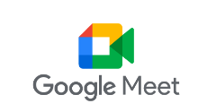

Contact Sessions Pupil Agreement

Be on time  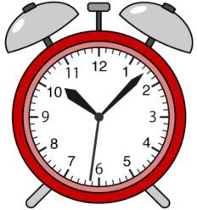 | Be respectful and polite to all  
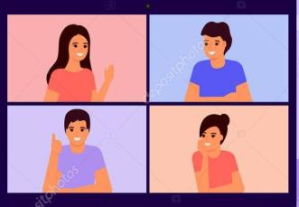    Dress appropriately (not in pyjamas) | Contribute when you are not muted  
Be in an appropriate location with no distractions.    If possible, we would prefer you not to be in your bedroom please. | Do not screen shot, share images or videos of the session.    It is important to respect everyone’s  privacy.
Do not change the username of any other member of the video call.  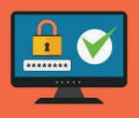 |   Raise your hand if you wish to speak.

