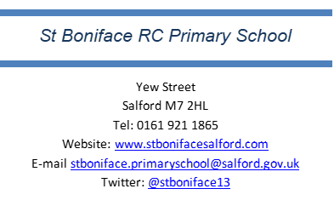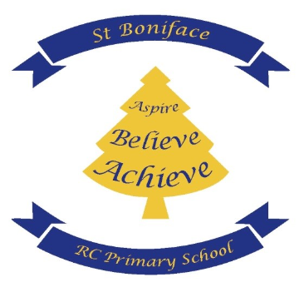
W.C Monday 13th April
Dear Reception Parents and Carers,
I am excited to continue this wonderful journey with both you and your children, filled with discovery, growth, and lots of fun. This year will continue to be full of new friendships, hands-on learning, and magical moments as your little ones take their first steps in exploring the world around them. Together, we will create a nurturing and inspiring environment where your child feels valued and supported. Please find below some important information going forward.

Reception Staff
Class Teacher: Miss Riley
Wednesday PM PPA cover: Mrs Casey
Teaching Assistants: Mrs Backhouse and Miss Richardson

PE Days- Children will have P.E each Monday afternoon. P.E kits should consist of a white t-shirt, black or navy shorts, and black pumps for PE. When appropriate, children can wear a plain black or navy jumper and pants for their winter PE kit. This half term, we are dancing! Please can pupils come into school each Monday in their P.E kit?

Water Bottles - Children are encouraged to bring a labelled water bottle to school each day! Staying hydrated helps keep our bodies and minds healthy, especially during busy days filled with fun activities and learning. By having their own water bottle, children can easily take a drink when they need it, and having it labelled makes sure no bottles get mixed up. Please ensure children bring only water into school.

Behaviour and Rewards - In school, we use the Dojo system to recognise and reward positive behaviour, good values, good manners and participation during learning in class. Dojo points can also be earned for activities such as reading at home and wearing the full school uniform. Stickers are given out frequently throughout the day. Each week, selected pupils will be selected for Star of the Week and Saint of the week. If you have not yet set up your child’s ClassDojo to view their progress, please speak to the school office for assistance.

Communication- Please feel free to speak with me at the beginning or end of the school day if you have any concerns about your child. Alternatively, you can contact me via Class Dojo by sending a message, and I will respond as soon as possible. Kindly note that messages should be sent between 8:00 a.m. and 5:00 p.m Monday - Friday. Please remember that absences must be reported by calling the school office, they should not be reported through Class Dojo.

SchoolGrid – Please ensure that dinners are ordered at home where possible, as ordering lunches in the morning takes time away from being with the children.

Home Learning – Homework and reading books will be set/sent home each Friday, please can reading books be returned by the following Thursday?

Other - This half term, pupils can look forward to a Stay and Pray session, as well as an exciting trip to the Manchester Science Museum as part of their topic How Do People Help Us?

Best wishes,

Miss Riley

