EAD – Early links to Art/DT
Create an underwater scene with tissue paper, paint, or coloured paper cut-outs of fish, seaweed, and shells.
Make fish using paper plates, paint, and glitter.
Craft a jellyfish using paper cups and streamers or ribbons.

Religious Education Branch 6
Dialogue and Encounter

Lesson 1 – Can children talk about Saint Peter?

Lesson 2 - Can children talk about Saint Paul (Saul)?
Lesson 3 – Can children talk about the work of a parish priest?

Lesson 4 - Can children talk about some of the things people do in a parish?
Lesson 5 - Can children retell the story of Creation in the correct sequence?
Lesson 6 - Can children remember some of the things used at Shabbat?
Lesson 7 - Can children talk about the things that might be used at Shabbat?
Lesson 8 - Can children remember some things about how Muslims might get ready to pray?
Lesson 9 – Can children remember some things about how and where Muslims might pray?
Lesson 10 - Can children talk about how they could help people to pray?

Music – Following Get Set 4 Music
Minibeasts

UTW - Early links to science:
Observe and test which materials float or sink and explore sea creatures/habitats.
Learning activities: Boat-building challenge; collect classroom objects to test floating/sinking; create simple fact-books about a chosen sea creature.
Skills: grouping & comparing, using simple non-standard measures (counts, scales), communicating findings.

Maths – Following WhiteRose:
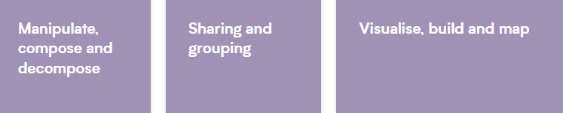

UTW – Early Links to Geography
Explore oceans and sea creatures.
Compare life in the UK to life in contrasting countries.
Talk about how we can protect our oceans and environment.

PE
Get Set 4 P.E
P.E Games Unit 2

English
Phonics
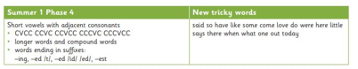
Text focuses: Sharing a Shell, The Singing Mermaid and What the Ladybird Heard at the Seaside.
Dictation will support sequencing and life cycle vocabulary. Children write short instructions or simple sentences linked to planting and growth (e.g. “Put the seed in soil”). There is increasing expectation for full sentences with capital letters, finger spaces and full stops. Adults provide shared writing first, then guided and independent dictation tasks to develop confidence and accuracy

What We Are Learning
Topic Focus: Under the Sea
Summer 2
Reception Miss Riley

UTW – Early Links to History
To talk about seaside holidays now and in the past using photos, artefacts, and stories.
Identify what has changed and what has stayed the same.
(Links to KS1: comparing ways of life in different periods; developing historical enquiry skills.)

