St Boniface R.C. Primary school follows a progressive scheme, based on the works of Martin Harvey, which contains consistent language and focuses on the four letter formation families. As our children begin to learn to form letters correctly, children are taught handwriting rhymes to support them with remembering the formation and the shape. These rhymes are used consistently across all lessons in EYFS and during any relevant sessions KS1 upwards e.g. Phase 3 phonics.
At the end of Year 2, the letter formation progresses onto joined handwriting. Handwriting is also used to support spelling work and vice versa. Handwriting is planned and taught on a daily basis or at least three times per week. Teachers provide individual correction and support for all pupils during lessons, including letter formation, correct posture and pencil/pen grip. All pupils will start handwriting lessons with a pencil, but will move onto a fine nib ink pen at the teachers’ discretion. There is no age related watershed for this – essentially, when the child is ready and skilled enough with a pencil, thought may be given to a pen.
Assessment of handwriting will be undertaken continuously in handwriting and other lessons on a one-to-one basis. Assessment of pencil grip is tracked within each year group or until a pupil has a desired pencil grip. Resources are used to support pupils in establishing the desired pencil grip.
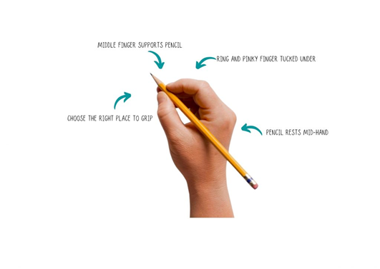

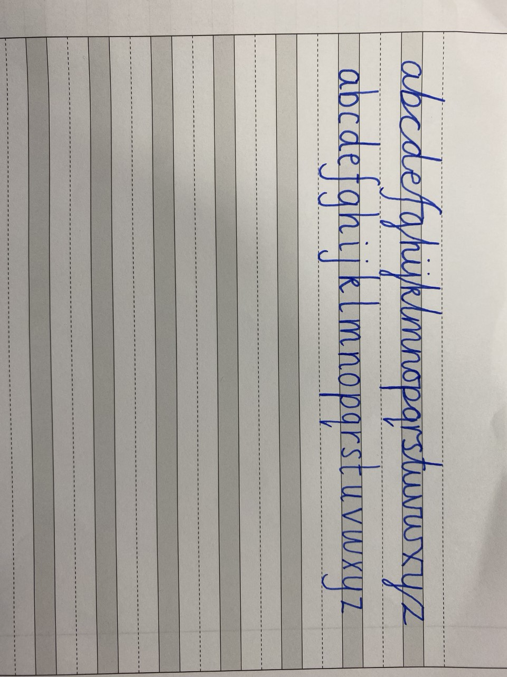
For all writing, handwriting lines are used. Wide lines are used predominantly in reception and Year 1, leading into narrow handwriting lines from Year 2 upwards. Where pupils have secured a strong, neat handwriting style, where clear ascenders and descenders are used, then movement onto normal lines will occur. The transition between the different lines is not specific to each year group as the various lines can be used for any pupil within the academy, dependent on their level of handwriting.



