Autumn 1 · Weeks 1–7 |  |  |  |  |  |  | Autumn 2 · Weeks 8–14
Week 1 | Week 2 | Week 3 | Week 4 | Week 5 | Week 6 | Week 7 | Week 8 | Week 9 | Week 10 | Week 11 | Week 12 | Week 13 | Week 14

Year 4 Autumn Term | Writing Root  Text |  | 2 weeks  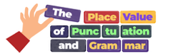  PVPG Sentence  Foundations | 3 weeks  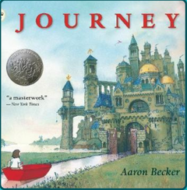  Journey | 2 weeks  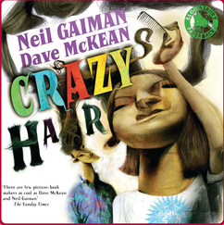  Crazy Hair | 2 weeks  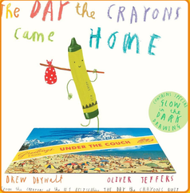  The Day the Crayons  Came Home | 3 weeks  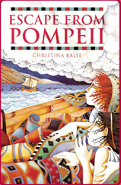  Escape from Pompeii | 1 week  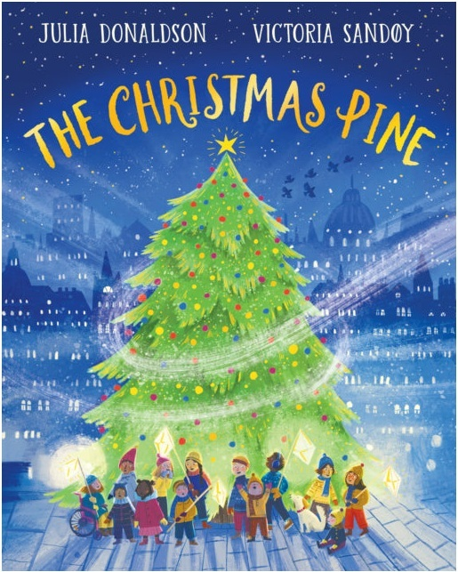  The Christmas Pine
Year 4 Autumn Term | Outcomes  Fiction  Non-fiction |  | Sentence practice  Clause work  Short compositions | Character descriptions  Setting descriptions  Narrative | List poems  Performance poetry  Character descriptions | Letters  Diary entries  Character viewpoints | Eyewitness accounts  Factual descriptions  Recounts | Analyse imagery and sound  Personify the pine  Vary line length and rhythm  Draft, edit and perform
Year 4 Autumn Term | Main outcome |  | Sentence-building  checkpoint | Narrative | Performance poem | Letter | Recount | Poetry
Year 4 Autumn Term | Audience /  Form |  | Accurate sentences for teacher and peers  Sentence-building checkpoint | An imagined quest for readers of adventure fiction  Narrative | A humorous poem for a live class audience  Performance poem | A first-person complaint addressed to Duncan  Letter | An eyewitness account for readers learning about Pompeii  Recount | An atmospheric poem tracing the pine's journey for a live Christmas audience  Free-verse performance poem
Year 4 Autumn Term | Purposes  covered |  | Inform  Rehearse | Entertain  Describe | Entertain  Perform | Inform  Reflect | Inform  Recount | Entertain  Describe  Reflect  Perform
Year 4 Autumn Term | Grammar coverage  * indicates coverage from a different year group  (these may be taught multiple times throughout the sequence) | Word | -ing suffix  un- prefix | word families *  forms of a or an * | -ing suffix  word families * | forms of a or an *  plural and possessive -s | plural and possessive -s  Standard English verb forms | word families *  precise verbs  figurative language  personification  alliteration
Year 4 Autumn Term |  | Sentence | combining words to make sentences  joining clauses using and  range of sentence types *  short sentences for effect  multi-clause sentences without a conjunction | expanded noun phrases *  noun phrases expanded with preposition phrases  fronted adverbials | expanded noun phrases *  range of sentence types * | conjunctions to express time and cause *  fronted adverbials | fronted adverbials  conjunctions to express time and cause * | expanded noun phrases *  fronted adverbials  varied sentence types *
Year 4 Autumn Term |  | Punctuation | capital letters *  full stops *  question marks *  exclamation marks * | inverted commas *  direct speech punctuation *  other speech punctuation | capital letters *  full stops *  question marks *  exclamation marks *  commas in lists * | apostrophes for contractions *  apostrophes for singular possession *  commas after fronted adverbials | commas after fronted adverbials  possessive apostrophes, inc. for plural nouns * | commas after fronted adverbials  punctuation to support meaning and performance
Year 4 Autumn Term |  | Text | sequencing sentences to form short narratives  tense consistency | paragraphs to organise around a theme  pronouns to avoid repetition | paragraphs to organise around a theme  tense consistency | paragraphs to organise around a theme  pronouns to avoid repetition  simple future tense | present perfect tense *  paragraphs to organise around a theme  pronouns to avoid repetition | stanzas organised around a theme  nouns and pronouns for cohesion  repetition for effect  edit vocabulary and grammar

Spring 1 · Weeks 1–6 |  |  |  |  |  | Spring 2 · Weeks 7–12
Week 1 | Week 2 | Week 3 | Week 4 | Week 5 | Week 6 | Week 7 | Week 8 | Week 9 | Week 10 | Week 11 | Week 12

Year 4 Spring Term | Writing Root  Text |  | 3 weeks    Jabberwocky | 3 weeks  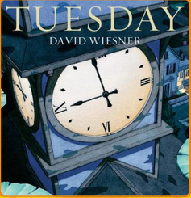  Tuesday | 2 weeks    The Present | 3 weeks  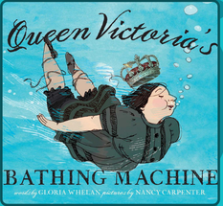  Queen Victoria's  Bathing Machine
Year 4 Spring Term | Outcomes  Fiction  Non-fiction |  | Invented vocabulary  Creature descriptions  Narrative | Witness statements  Headlines  News reports | Thought bubbles  Character viewpoints  Character descriptions | Factual descriptions  Process diagrams  Explanations
Year 4 Spring Term | Main outcome |  | Narrative | Newspaper report | Character description | Explanation
Year 4 Spring Term | Audience /  Form |  | A quest narrative inspired by Carroll's poem for readers of fantasy fiction  Narrative | A factual account of Tuesday night's unexplained events for newspaper readers  Newspaper report | A sensitive description revealing the boy's changing feelings for a film audience  Character description | An explanation of how the bathing machine worked for museum visitors  Explanation text
Year 4 Spring Term | Purposes  covered |  | Entertain  Describe | Inform  Recount | Describe  Reflect | Inform  Explain
Year 4 Spring Term | Grammar coverage  * indicates coverage from a different year group  (these may be taught multiple times throughout the sequence) | Word | nouns formed with prefixes  word families * | plural and possessive -s  Standard English verb forms | forms of a or an *  word families * | word families *  Standard English verb forms  abstract nouns  Standard English verb forms
Year 4 Spring Term |  | Sentence | noun phrases expanded with preposition phrases  fronted adverbials  conjunctions to express time and cause * | fronted adverbials  conjunctions to express time and cause * | expanded noun phrases *  noun phrases expanded with preposition phrases  fronted adverbials | conjunctions to express time and cause *  fronted adverbials
Year 4 Spring Term |  | Punctuation | inverted commas *  direct speech punctuation *  other speech punctuation  commas after fronted adverbials | commas after fronted adverbials  possessive apostrophes, inc. for plural nouns * | capital letters *  full stops *  question marks *  exclamation marks *  commas after fronted adverbials | commas after fronted adverbials  capital letters *  full stops *  question marks *  exclamation marks *
Year 4 Spring Term |  | Text | paragraphs to organise around a theme  pronouns to avoid repetition | paragraphs to organise around a theme  subheadings  present perfect tense * | paragraphs to organise around a theme  pronouns to avoid repetition | paragraphs to organise around a theme  subheadings  pronouns to avoid repetition

Summer 1 · Weeks 1–5 |  |  |  |  | Summer 2 · Weeks 6–12
Week 1 | Week 2 | Week 3 | Week 4 | Week 5 | Week 6 | Week 7 | Week 8 | Week 9 | Week 10 | Week 11 | Week 12

Year 4 Summer Term | Writing Root  Text |  | 2 weeks  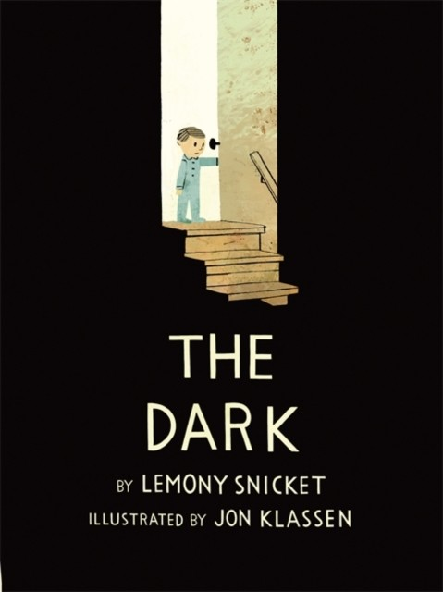  The Dark | 3 weeks  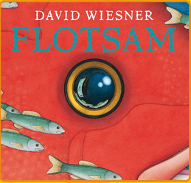  Flotsam | 3 weeks  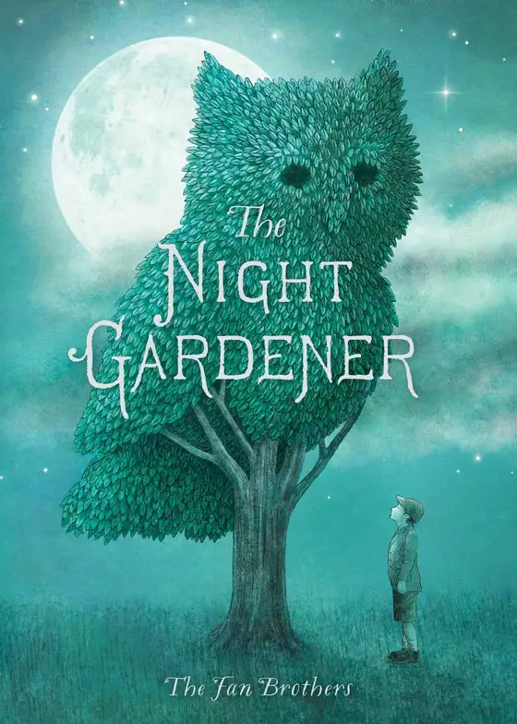  The Night Gardener | 2 weeks    The Pirate Cruncher | 2 weeks  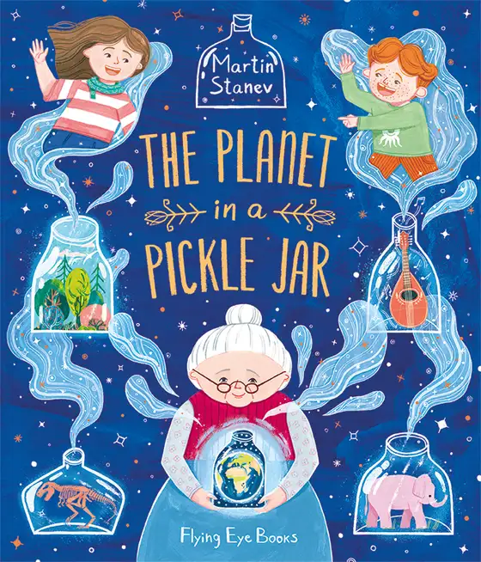  Planet in a  Pickle Jar
Year 4 Summer Term | Outcomes  Fiction  Non-fiction |  | Sensory descriptions  Thought bubbles  Setting descriptions | Image captions  Setting descriptions  Narrative | Campaign slogans  Formal letters  Persuasive speeches | Warning notices  Route guides  Instructions | Evidence notes  Viewpoint statements  Balanced discussions
Year 4 Summer Term | Main outcome |  | Setting description | Narrative | Persuasive speech | Instructions | Balanced discussion
Year 4 Summer Term | Audience /  Form |  | An atmospheric description of Laszlo's home for readers of suspense fiction  Setting description | A visual mystery developed into a story for readers of fantasy fiction  Narrative | A proposal to protect and improve a community space for local decision-makers  Persuasive speech | A safe route and survival guide for an inexperienced pirate crew  Instructional text | A balanced discussion of whether humans should intervene to protect habitats  Discussion text
Year 4 Summer Term | Purposes  covered |  | Describe  Entertain | Entertain  Describe | Persuade  Inform | Instruct  Inform | Discuss  Inform
Year 4 Summer Term | Grammar coverage  * indicates coverage from a different year group  (these may be taught multiple times throughout the sequence) | Word | forms of a or an *  word families * | plural and possessive -s  Standard English verb forms | forms of a or an *  word families * | word families *  Standard English verb forms | plural and possessive -s  Standard English verb forms
Year 4 Summer Term |  | Sentence | noun phrases expanded with preposition phrases  fronted adverbials | noun phrases expanded with preposition phrases  fronted adverbials  conjunctions to express time and cause * | expanded noun phrases *  fronted adverbials  conjunctions to express time and cause * | commands *  fronted adverbials  conjunctions to express time and cause * | noun phrases expanded with preposition phrases  fronted adverbials  conjunctions to express time and cause *
Year 4 Summer Term |  | Punctuation | commas after fronted adverbials  apostrophes for contractions *  apostrophes for singular possession * | inverted commas *  direct speech punctuation *  other speech punctuation  commas after fronted adverbials | commas after fronted adverbials  possessive apostrophes, inc. for plural nouns * | commas in lists *  commas after fronted adverbials | commas after fronted adverbials  possessive apostrophes, inc. for plural nouns *
Year 4 Summer Term |  | Text | paragraphs to organise around a theme  pronouns to avoid repetition | paragraphs to organise around a theme  pronouns to avoid repetition  present perfect tense * | paragraphs to organise around a theme  pronouns to avoid repetition | paragraphs to organise around a theme  subheadings  pronouns to avoid repetition | paragraphs to organise around a theme  pronouns to avoid repetition  tense consistency

