St Boniface R.C. Primary’s handwriting long term plan - Year 1
Handwriting is to be taught daily.
At the start of each handwriting session, ensure children are in the correct sitting position and that they are holding their pencil in the ‘tripod grip’ (see diagram at the end of this document).

Children should write one line in pencil and another line in purple pen.

Refer to the ‘Formation Guide’ for help on the formation of letters and numbers.
Autumn 1
Week 1 | Week 2 | Week 3 | Week 4 | Week 5 | Week 6 | Week 7
Introduction to the line guide.  Tall, short and tail soldiers  Focus on finger spaces. | Forming numbers on a line guide and on squared paper.  Introduction to numbers 0, 1, 2, 3, 4. | Forming numbers on a line guide and on squared paper.  Introduction to numbers 5, 6, 7, 8, 9. | Curly caterpillar family.  Introduction to the letters c, a, o.  Include capital letters C, A, O. | Curly caterpillar family.  Introduction to the letters d, g, q.  Include capital letters D, G, Q. | Curly caterpillar family.  Introduction to the letters e, s, f.  Include capital letters E, S, F. | RECAP week.
 |  |  | CEW to practise - a | CEW to practise – do, go | CEW to practise – of, off, as, so
Autumn 2
Week 1 | Week 2 | Week 3 | Week 4 | Week 5 | Week 6 | Week 7
Recap all curly caterpillar family letters (c, a, o, d, g, q, e, s, f).  Include all capital letters. | Bridge family.  Introduction to the letters r, n, m.  Include capital letters R, N, M. | Bridge family.  Introduction to the letters h, b, p, k.  Include capital letters H, B, P, K. | Bridge family.  Recap all bridge family letters (r, n, m, h, b, p, k).  Include capital letters. | Ladder family.  Introduction to the letters i, l, t.  Include capital letters I, L, T. | Ladder family.  Introduction to the letters j, u, y.  Include capital letters J, U, Y. | Ladder family.  Recap all ladder family letters (i, l, t, j, u, y).  Include capital letters.
CEW to practise - | CEW to practise – are, Mrs, no, once, me | CEW to practise – he, she, her, be | CEW to practise – Mr, come, one, make | CEW to practise – said, all, like, the, into | CEW to practise – to, little, out, you, by | CEW to practise – my,  they, there
Spring 1

Week 1 | Week 2 | Week 3 | Week 4 | Week 5 | Week 6 | Week 7
Recap all curly caterpillar family letters.  Include capital letters. | Recap all bridge family and ladder family letters. | Zig zag family.  Introduction to the letters v, w, z, x. | Recap all curly caterpillar family letters.  Include capital letters. | Recap all bridge family letters.  Include capital letters. | Recap all ladder family letters.  Include capital letters. | Recap all zig zag family letters.  Include capital letters.
 | Include capital letters.
 |  | Include capital letters V,  W, Z, X. | CEW to practise –  where, when, find | CEW to practise – were,  who, I’m, some | CEW to practise – why,  what, ask | CEW to practise – with,  down, today, eyes
 |  | CEW to practise – love, have, we, was
Spring 2
Week 1 | Week 2 | Week 3 | Week 4 | Week 5 | Week 6 | Week 7
Recap upper case and lower case letters  together in pairs. | Recap upper case and lower case letters  together in pairs. | Recap upper case and lower case letters  together in pairs. | Recap upper case and lower case letters  together in pairs. | Introduce writing the days of the week. | Introduce writing the days of the week. | Recap the days of the week.
Aa, Bb, Cc, Dd, Ee, Ff, Gg  Ensure explicit teaching of letter names is seen between upper and lower case letters. | Hh, Ii, Jj, Kk, Ll, Mm  Ensure explicit teaching of letter names is seen between upper and lower case letters. | Nn, Oo, Pp, Qq, Rr, Ss, Tt  Ensure explicit teaching of letter names is seen between upper and lower case letters. | Uu, Vv, Ww, Xx, Yy, Zz  Ensure explicit teaching of letter names is seen between upper and lower case letters. | Monday, Tuesday,  Wednesday, Thursday  Ensure explicit teaching of capital letter at start of words. | Friday, Saturday, Sunday  Ensure explicit teaching of capital letter at start of words.
Summer 1
Week 1 | Week 2 | Week 3 | Week 4 | Week 5 | Week 6 | Week 7
Practise groups of letter as digraphs. | Practise groups of letter as digraphs. | Practise groups of letter as digraphs. | Practise groups of letter as digraphs and  trigraphs. | Practise groups of letter as digraphs. | Introduce writing the months of the year. | Introduce writing the months of the year.
ss, ll, ff, ck, zz, qu, ch, sh  Suggested words-hiss, pass, sell, full, huff, bluff, kick, sock, buzz,  fizz, quick, quiz, chin, chat, ship, push. | ng, ing, th, ai, ee, igh,  oa, oo Suggested words –  CEW to practise – that, this, see, too, school | ar, er, ir, ur, or, oi, ow  Suggested words –  CEW to practise – water, down, now, for, oh | ear, air, ure, ie, ou, ea, au, aw  Suggested words – CEW to practise – friend,  saw, your | oy, ue, ew, ou, ay  Suggested words –  CEW to practise – house, today, day, says | January, February,  March, April, May, June  Ensure explicit teaching of capital letter at start of words. | July, August,  September, October, November, December  Ensure explicit teaching of capital letter at start of words.
CEW to practise – will,
pull, back, children,
push

Summer 2
Week 1 | Week 2 | Week 3 | Week 4 | Week 5 | Week 6 | Week 7
Recap writing the days of the week. | Recap writing the months of the year. | Introduce writing the number words. | Introduce writing the number words. | Practise writing these common exception  words. | Practise writing these common exception  words.
 |  | one, two, here, four,  five, six, seven, eight, nine, ten | eleven, twelve, thirteen,  fourteen, fifteen, sixteen, seventeen, eighteen, nineteen, twenty | people, the, could, out, can’t, called, here, very | looked, eyes, you, should, old, don’t, school, asked

Correct Sitting Position
h

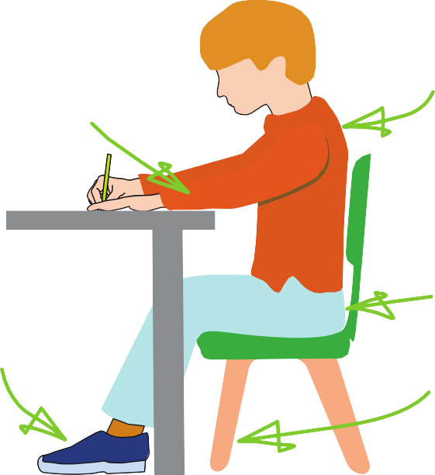





Sit with a
The table
reaches to below elbow eight
Keep feet flat
on the floor
straight back, not leaning over the p ge
a

Sit right back


in the s eat


Pull the chair
d
close in to the table

The Tripod Pencil Grip
Paper position for right han -ed children

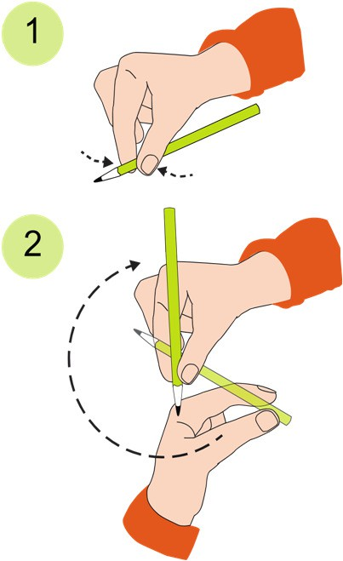
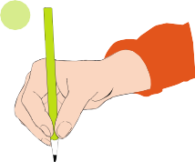
Both right and left handed children should be encouraged to use the tripod grip which allows the pen/pencil to be held securely whilst allowing controlled movements of the pen/pencil nib. Teachers should pay particular attention to pencil grip and sitting position.
3

- Grip the pencil with your index finger and thumb with the nib pointing away.
- With your free hand, spin the pencil from underneath.
- Use your middle finger to support the underside of the pencil.

If a child is not using the tripod pencil grip, ensure a pencil grip assessment has been done to put in appropriate interventions.

