St Boniface R.C. Primary’s handwriting long term plan - Year 2
Handwriting is to be taught daily.
At the start of each handwriting session, ensure children are in the correct sitting position and that they are holding their pencil in the ‘tripod grip’ (see diagram at the end of this document).

Children should write one line in pencil and another line in purple pen.

Refer to the ‘Formation Guide’ for help on the formation of letters and numbers.
Autumn 1
Week 1 | Week 2 | Week 3 | Week 4 | Week 5 | Week 6 | Week 7
Introduction to the line guide - Tall, short and tail soldiers  Forming numbers on a line guide and on squared paper.  0, 1, 2, 3, 4, 5 | Forming numbers on a line guide and on squared paper.  Introduction to numbers 5, 6, 7, 8, 9. | Curly caterpillar family.  Recap curly caterpillar family letters (c, a, o, d, g).  Include all capital letters. | Curly caterpillar/Bridge family.  Recap remaining curly caterpillar letters and bridge family letters (q, e, s, f, r).  Include capital letters. | Bridge family.  Recap all bridge family letters (n, m, h, b, p, k).  Include capital letters. | Ladder family.  Recap all ladder family letters (i, l, t, j, u, y).  Include capital letters. | Zig zag family.  Recap all zig zag family letters (v, w, z, x).  Include capital letters.
Autumn 2
Week 1 | Week 2 | Week 3 | Week 4 | Week 5 | Week 6 | Week 7
Recap upper case and lower case letters together in pairs.  Aa → Mm  Ensure explicit teaching of letter names is seen between upper and  lower case letters. | Recap upper case and lower case letters together in pairs.  Nn → Zz  Ensure explicit teaching of letter names is seen between upper and  lower case letters. | Recap writing the days of the week.  Ensure explicit teaching of capital letter at start of words.  Emphasise that upper case letters are not joined onto other  letters. | Recap writing the months of the year.  Ensure explicit teaching of capital letter at the start of words.  Emphasise that upper case letters are not joined onto other  letters. | Recap writing the number words.  one, two, three, four, five, six, seven, eight, nine, ten. | Recap writing the number words.  eleven, twelve, thirteen, fourteen, fifteen, sixteen, seventeen, eighteen, nineteen, twenty. | Practise teacher selection of year 1 common exception words.
Spring 1
Week 1 | Week 2 | Week 3 | Week 4 | Week 5 | Week 6 | Week 7
Practise common exception words: | Practise common exception words: | Practise common exception words: | Practise common exception words: | Practise common exception words: | Practise common exception words: | Recap teacher selection of common exception words.

door, floor, poor, because, who, any, many, water, again,  even | find, kind, mind, behind, child, children, wild, climb, clothes, people | most, only, both, old, told, hold, gold, cold, Mr, Mrs | every, everybody, great, break, steak, pretty, beautiful, whole, half | after, fast, past, past, father, class, path, bath, money, parents,  Christmas | hour, move, prove, improve, sure, sugar, eye, could, would,  should
Spring 2
Week 1 | Week 2 | Week 3 | Week 4 | Week 5 | Week 6 | Week 7
Introduction to joining onto letters (up, over, stop, reverse).  Join onto:  a, c, o, g, q, s, d  Suggested combinations:  og, da, ds, eq, ma, uc,  lo, ed | Introduction to joining onto letters (down, round, top dotted line).  Join onto: b, f, l, t, h, k  Suggested combinations:  mb, th, ch, nk, if, ab, al | Introduction to joining onto letters down, round, top solid line).  Join onto:  i, m, n, p, r, u, v, w, y, z, x, j  Suggested combinations:  kn, ai, up, aw, mp, er, du | Introduction to joining from letters (across the top).  Join from: v, w, o, f, r  Suggested combinations:  vi, va, vr, we, wh, wr, on,  of, oo, re, ry, rs | Introduction to joining from letters (do the loop).  Join from: g, y, j  Suggested combinations:  gl, go, gr, ye, yo, ya, ju,  je, ju | Introduction to joining from letters (along the bottom and up).  Join from: b, p, s  Suggested combinations:  bo, ba, bl, ph, pr, pu, sh,  st, sp | Recap examples of all join types.  Explicit teach of joining q onto u.
Summer 1
Week 1 | Week 2 | Week 3 | Week 4 | Week 5 | Week 6 | Week 7
Recap joining onto letters (up, over, stop, reverse).  Join onto:  a, c, o, g, q, s, d | Recap joining onto letters (down, round, top dotted line).  Join onto: b, f, l, t, h, k | Recap joining onto letters down, round, top solid line).  Join onto:  i, m, n, p, r, u, v, w, y, z,  x, j | Recap joining from letters (across the top).  Join from: v, w, o, f, r | Recap joining from letters (do the loop).  Join from: g, y, j | Recap joining from letters (along the bottom and up).  Join from: b, p, s | Recap examples of all join types.  Explicit teach of joining q onto u.
Summer 2
Week 1 | Week 2 | Week 3 | Week 4 | Week 5 | Week 6 | Week 7
Practise writing common exception words joined up:  door, floor, poor, because, who, any, many, water, again, even, find, kind, mind,  behind, child | Practise writing common exception words joined up:  children, wild, climb, clothes, people, most, only, both, old, told, hold | Practise writing common exception words joined up:  gold, cold, Mr, Mrs, every, everybody, great, break, steak, pretty | Practise writing common exception words joined up:  beautiful, whole, half, after, fast, past, past, father, class, path, bath, money, parents | Practise writing common exception words joined up:  Christmas, hour, move, prove, improve, sure, sugar, eye, could, would, should | Practise any joins that are causing misconceptions. | Practise any joins that are causing misconceptions.

Correct Sitting Position
h

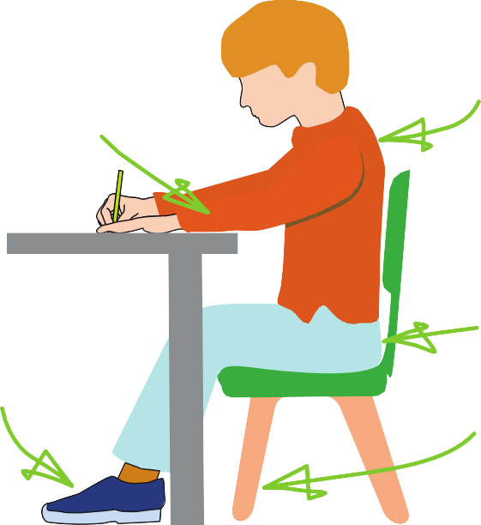





Sit with a
The table
reaches to below elbow eight
Keep feet flat
on the floor
straight back, not leaning over the p ge
a

Sit right back


in the s eat


Pull the chair
d
close in to the table

The Tripod Pencil Grip
Paper position for right han -ed children

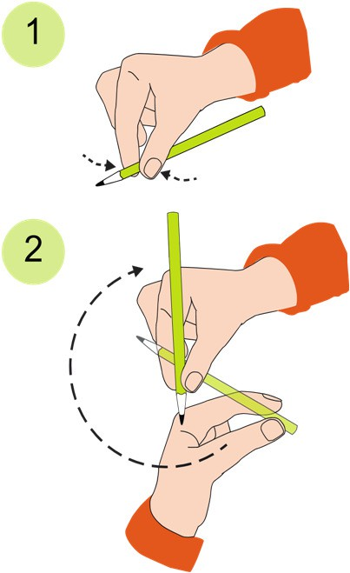
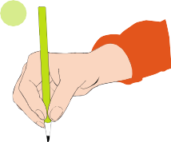
Both right and left handed children should be encouraged to use the tripod grip which allows the pen/pencil to be held securely whilst allowing controlled movements of the pen/pencil nib. Teachers should pay particular attention to pencil grip and sitting position.
3

- Grip the pencil with your index finger and thumb with the nib pointing away.
- With your free hand, spin the pencil from underneath.
- Use your middle finger to support the underside of the pencil.

If a child is not using the tripod pencil grip, ensure a pencil grip assessment has been done to put in appropriate interventions.

