St Boniface’s handwriting long term plan - Year 3
Handwriting is to be taught 3 times per week.
At the start of each handwriting session, ensure children are in the correct sitting position and that they are holding their pencil in the ‘tripod grip’ (see diagram at the end of this document).

Children should write one line in pencil and another line in purple pen.

Refer to the ‘Formation Guide’ for help on the formation of letters and numbers.
Autumn 1
Week 1 | Week 2 | Week 3 | Week 4 | Week 5 | Week 6 | Week 7
Recap joining onto | Recap joining onto | Recap joining onto | Recap joining from | Recap joining from | Recap joining from | Recap upper case and
letters (up, over, stop, | letters (down, round, | letters (down, round, | letters (across the top). | letters (do the loop). | letters (along the | lower case letters
reverse). | top dotted line). | top solid line). | Join from: | Join from: | bottom and up). | together in pairs.  Aa → Zz
Join onto: | Join onto: | Join onto: | v, w, o, f, r | g, y, j | Join from:
a, c, o, g, q, s, d | b, f, l, t, h, k | i, m, n, p, r, u, v, w, y, z, |  |  | b, p, s | Explicit teaching of
 |  | x, j | Suggested | Suggested |  | letter names.
Suggested | Suggested |  | combinations: | combinations: | Suggested
combinations: | combinations: | Suggested | vi, va, vr, we, wh, wr, on, | gl, go, gr, ye, yo, ya, ju, | combinations: | Emphasise that upper
og, da, ds, eq, ma, uc, | mb, th, ch, nk, if, ab, al | combinations: | of, oo, re, ry, rs | je, ju | bo, ba, bl, ph, pr, pu, sh, | case letters are not
lo, ed |  | kn, ai, up, aw, mp, er, du |  |  | st, sp | joined onto other
 |  |  |  |  |  | letters.
Autumn 2
Week 1 | Week 2 | Week 3 | Week 4 | Week 5 | Week 6 | Week 7
Practise writing the days of the week – joined | Practise writing the months of the year - joined | Practise writing number words - joined | Practise spelling words with /ow/ sound (spelled ‘ou’) - joined | Practise spelling words with /u/ sound (spelled ‘ou’) - joined | Practise spelling words with /i/ sound (spelled ‘y’) - joined | Practise spelling words with /ze/ sound - joined
Emphasise that upper  case letters are not joined onto other letters. | Emphasise that upper case letters are not joined onto other letters. |  | mouth, around, sprout, sound, spout, ouch, hound, trout, found, proud | double, trouble, country, touch, young, cousin, enough, encourage, flourish,  couple | gym, myth, Egypt, pyramid, mystery, symbol, synonym, lyrics, system, gymnastics | measure, treasure,  pleasure, enclosure, displeasure, composure, leisure, exposure, disclosure
Spring 1
Week 1 | Week 2 | Week 3 | Week 4 | Week 5 | Week 6 | Week 7

Practise spelling words with /ch/ sound – joined  creature, furniture, picture, nature, adventure, future, capture, mixture,  sculpture | Practise spelling common exception words – joined  actual, answer, bicycle, circle, earth, enough, fruit, island, often, popular | Practise spelling words with prefix ‘re’ – joined  redo, refresh, return, reappear, redecorate, revenge, review, replay, reaction | Practise spelling words with prefix ‘dis’ – joined  disagree, dislike, dishonest, disallow, distrust, disobey, discover, disown, dismiss | Practise spelling words with prefix ‘mis’ – joined  misuse, mislead, misbehave, misfire, mismatch, misplace, misread, miscount | Practise spelling common exception words – joined  centre, decide, disappear, early, heart, learn, minute, notice, regular, therefore | Practise spelling common exception words – joined  Teacher to choose words based on which joins need practising
Spring 2
Week 1 | Week 2 | Week 3 | Week 4 | Week 5 | Week 6 | Week 7
Practise spelling multisyllabic words (final consonant not  doubled) – joined | Practise spelling multisyllabic words (final consonant  doubled) – joined | Practise spelling words with the /a/ sound (spelled ‘ai’) – joined | Practise spelling words with the /a/ sound (spelled ‘ei’) – joined | Practise spelling words with the /a/ sound (spelled ‘ey’) – joined | Practise spelling words with the /l/ sound (spelled ‘al’) – joined | Practise spelling common exception words – joined
gardener, limited, developing, covered, listening, listened, footballer, brightening,  destroyed | forgotten, beginning, preferred, permitted, regretting, committed, forbidden, propelled,  equipped | straight, painter,  fainted, waist, strainer, chained, claimed, failure, waiter | vein, weigh, eight,  neighbour, sleigh, freight, reins, veil, eighteen | Obey, prey, convey,  survey, grey, disobey, they, surveyor, conveyor | arrival, burial, comical,  emotional, national, magical, personal, optional, survival, tropical | Teacher to choose  words based on which joins need practising
Summer 1
Week 1 | Week 2 | Week 3 | Week 4 | Week 5 | Week 6 | Week 7
Practise spelling words with the /l/ sound (spelled ‘le’) – joined | Practise spelling words with the suffix ‘ly’ (from ‘le’) – joined | Practise spelling words with the suffix ‘ally’ (from ‘ic’) – joined | Practise spelling words with the suffix ‘ly’ (exceptions) – joined | Practise spelling common exception words – joined | Practise spelling words ending in ‘er’ (where the root word ends in (t)ch)  – joined | Practise spelling common exception words – joined
battle, article, struggle,  possible, capable, settle, humble, terrible, example, adjustable | gently, simply, humbly,  terribly, incredibly, possibly, horribly, responsibly, wrinkly | basically, frantically,  dramatically, historically, nationally, emotionally, accidentally,  automatically | truly, publicly, daily,  slyly, shyly, happily, coyly, suddenly | address, arrive, certain,  experience, history, mention, occasionally, probably, reign, sentence | teacher, butcher, preacher, catcher, watcher, stretcher, dispatcher, scorcher | Teacher to choose  words based on which joins need practising
Summer 2
Week 1 | Week 2 | Week 3 | Week 4 | Week 5 | Week 6 | Week 7
Practise spelling words with the /k/ sound (spelled ‘ch’) – joined | Practise spelling words with the /g/ sound (spelled ‘gue’) and the  /k/ sound (spelled ‘que’)  – joined | Practise spelling words with the /s/ sound (spelled ‘sc’) – joined | Practise spelling common exception words – joined | Practise spelling common exception words – joined | Practise spelling common exception words – joined | Practise spelling common exception words – joined

scheme, chorus, |  | science, scene, | accidentally, breathe, | difficult, important, | build, describe, imagine, | Teacher to choose
chemist, echo, | vague, league, plague, | discipline, fascinate, | century, consider, eight, | length, perhaps, | library, natural, | words based on which
character, stomach, | tongue, antique, | crescent, scissors, | guard, heard, peculiar, | position, question, | ordinary, promise, | joins need practising
monarch, school, | unique, grotesque, | ascend, scented, | possible, quarter | strange, pressure, | recent, suppose, weight,
anchor, chaos | mosque, plague | scenery, descend |  | special, purpose

Correct Sitting Position
h

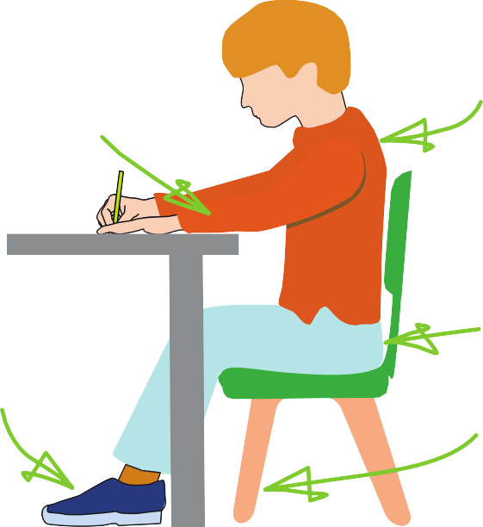





Sit with a
The table
reaches to below elbow eight
Keep feet flat
on the floor
straight back, not leaning over the p ge
a

Sit right back


in the s eat


Pull the chair
d
close in to the table

The Tripod Pencil Grip
Paper position for right han -ed children

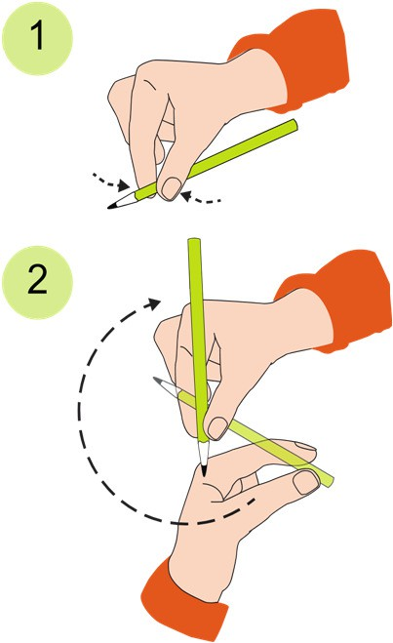
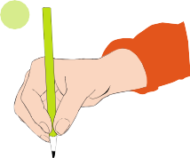
Both right and left handed children should be encouraged to use the tripod grip which allows the pen/pencil to be held securely whilst allowing controlled movements of the pen/pencil nib. Teachers should pay particular attention to pencil grip and sitting position.
3

- Grip the pencil with your index finger and thumb with the nib pointing away.
- With your free hand, spin the pencil from underneath.
- Use your middle finger to support the underside of the pencil.

If a child is not using the tripod pencil grip, ensure a pencil grip assessment has been done to put in appropriate interventions.

