St Boniface’s handwriting long term plan - Year 4
Handwriting is to be taught 3 times per week.
At the start of each handwriting session, ensure children are in the correct sitting position and that they are holding their pencil in the ‘tripod grip’ (see diagram at the end of this document).

Children should write one line in pencil and another line in purple pen.

Refer to the ‘Formation Guide’ for help on the formation of letters and numbers.
Autumn 1
Week 1 | Week 2 | Week 3 | Week 4 | Week 5 | Week 6 | Week 7
Recap joining onto | Recap joining onto | Recap joining onto | Recap joining from | Recap joining from | Recap joining from | Recap upper case and
letters (up, over, stop, | letters (down, round, | letters (down, round, | letters (across the top). | letters (do the loop). | letters (along the | lower case letters
reverse). | top dotted line). | top solid line). | Join from: | Join from: | bottom and up). | together in pairs.  Aa → Zz
Join onto: | Join onto: | Join onto: | v, w, o, f, r | g, y, j | Join from:
a, c, o, g, q, s, d | b, f, l, t, h, k | i, m, n, p, r, u, v, w, y, z, |  |  | b, p, s | Explicit teaching of
 |  | x, j | Suggested | Suggested |  | letter names.
Suggested | Suggested |  | combinations: | combinations: | Suggested
combinations: | combinations: | Suggested | vi, va, vr, we, wh, wr, on, | gl, go, gr, ye, yo, ya, ju, | combinations: | Emphasise that upper
og, da, ds, eq, ma, uc, | mb, th, ch, nk, if, ab, al | combinations: | of, oo, re, ry, rs | je, ju | bo, ba, bl, ph, pr, pu, sh, | case letters are not
lo, ed |  | kn, ai, up, aw, mp, er, du |  |  | st, sp | joined onto other
 |  |  |  |  |  | letters.
Autumn 2
Week 1 | Week 2 | Week 3 | Week 4 | Week 5 | Week 6 | Week 7
Practise writing the days of the week – joined | Practise writing the months of the year - joined | Practise spelling words with the prefix ‘in’ – joined | Practise spelling words with the prefix ‘il’, ‘ir’ and ‘im’– joined | Practise spelling words with the prefix ‘sub’ – joined | Practise spelling words with the prefix ‘inter’ – joined | Practise spelling common exception words – joined
Emphasise that upper  case letters are not joined onto other letters. | Emphasise that upper case letters are not joined onto other letters. | inactive, incorrect, invisible, insecure, inflexible, incurable, inability, inadequate | illegal, illegible, immature, impossible, impatient, imperfect, irregular, irrelevant, irresponsible | subtitle, submarine, submerge, subheading, submit, subtropical, subway, substandard | interact, international, interfere, interview, intercept, internet, intercity, interchange | calendar, appear, believe, grammar, increase, interest, opposite, straight, strength, women
Spring 1

Week 1 | Week 2 | Week 3 | Week 4 | Week 5 | Week 6 | Week 7
Practise spelling words with the suffix ‘ation’ – joined  information, preparation, vibration, decoration, observation, location, exploration, illustration | Practise spelling words with the ‘ly’ suffix (adding onto adverbs) – joined  sadly, completely, wildly, bravely, gently, proudly, horribly, happily, nervously | Practise spelling words with the ‘ly’ suffix (turning adjectives into adverbs) – joined  usually, finally, beautifully, thoughtfully, wonderfully, carefully, faithfully, peacefully,  generally | Practise spelling words with the /sh/ sound (spelled ‘ch’) – joined  chef, machine, brochure, parachute, chaperone, chandelier, crochet, quiche, chaperone | Practise spelling words with the suffix ‘ion’ (or ‘sion’) – joined  Expansion, comprehension, tension, suspension, exclusion, provision, explosion, erosion, invasion | Practise spelling common exception words – joined  complete, continue, experiment, famous, favourite, February, naughty, material, knowledge, remember | Practise writing number words - joined
Spring 2
Week 1 | Week 2 | Week 3 | Week 4 | Week 5 | Week 6 | Week 7
Practise spelling words with the suffix ‘ous’ – joined  poisonous, dangerous, marvellous, perilous, tremendous, enormous, jealous, precious, disastrous | Practise spelling words with the suffix ‘ous’ (if keeping the /g/ sound, ‘e’ is kept on the end) – joined  courageous, outrageous, nervous, famous, adventurous, carnivorous, ridiculous, torturous,  advantageous | Practise spelling words with the /ee/ sound (spelled ‘i’) – joined  happiness, plentiful, silliness, beautiful, prettiest, nastiness, merriment, plentiful | Practise spelling words with the suffix ‘ous’ - joined  serious, obvious, curious, hideous, spontaneous, courteous, furious, various, victorious | Practise spelling words with the ‘au’ digraph – joined  Naughty, caught, automatic, astronaut, cause, author, applaud, taught, audience | Practise spelling common exception words – joined  breath, business, caught, different, exercise, extreme, medicine, possession, although, thought | Practise spelling common exception words – joined  Teacher to choose words based on which joins need practising
Summer 1
Week 1 | Week 2 | Week 3 | Week 4 | Week 5 | Week 6 | Week 7
Practise spelling words with the suffix ‘ion’ (or ‘tion’) – joined  invention, injection, action, hesitation, completion, nomination, migration, conservation, selection | Practise spelling words with the suffix ‘ion’ (or ‘ssion’) – joined  expression, discussion, confession, permission, admission, impression, obsession, omission, concussion | Practise spelling words with the suffix ‘cian’ – joined  musician, magician, electrician, politician, technician, optician, beautician, physician, dietician | Practise spelling words with the suffix ‘ly’ (to create adverbs of manner) – joined  reluctantly, quickly, generously, unexpectedly, gently, curiously, furiously,  seriously, victoriously | Practise spelling homophones – joined  scene – seen whose – who’s affect – effect here – hear heel - heal | Practise spelling common exception words – joined  group, height, particular, potatoes, separate, surprise, through, various, though, woman | Practise spelling common exception words – joined  Teacher to choose words based on which joins need practising
Summer 2
Week 1 | Week 2 | Week 3 | Week 4 | Week 5 | Week 6 | Week 7

Practise spelling words with the /s/ sound (spelled ‘c’ before ‘i’ and ‘e’) – joined  circle, century, centaur, circus, princess, voice, medicine, celebrate, celery, pencil | Practise spelling words with the prefixes ‘super’, ‘anti’ and ‘auto’ – joined  supermarket, superman, superstar, superhuman, antiseptic, anticlockwise, antisocial, autobiography,  autograph, automatic | Practise spelling words with the prefix ‘bi’ – joined  bicycle, biplane, biped, bicentennial, biannual, bilingual, bicuspid, biceps, binoculars, bisect | Practise spelling words from the ‘sol’ word family and the ‘real word family’ – joined  solar, solution, soluble, insoluble, dissolve, real, reality, realistic, unreal, realisation | Practise spelling words from the ‘phon word family’ and the ‘sign word family’ – joined  phone, telephone, phonics, microphone, phonograph, sign, signature, assign, designer, signaller | Practise spelling common exception words – joined  Teacher to choose words based on which joins need practising | Practise spelling common exception words – joined  Teacher to choose words based on which joins need practising

Correct Sitting Position
h

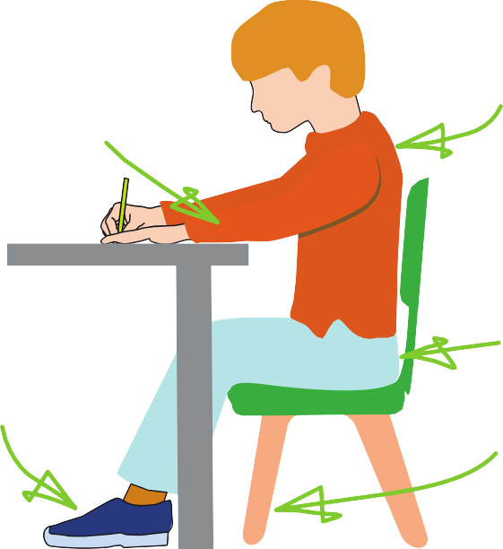





Sit with a
The table
reaches to below elbow eight
Keep feet flat
on the floor
straight back, not leaning over the p ge
a

Sit right back


in the s eat


Pull the chair
d
close in to the table

The Tripod Pencil Grip
Paper position for right han -ed children

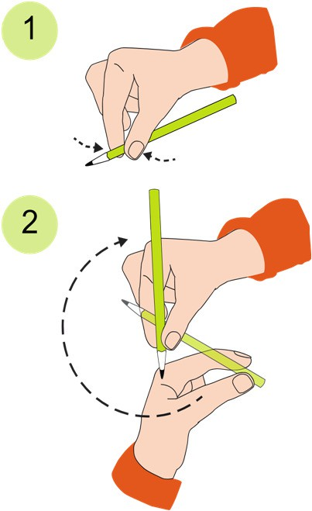
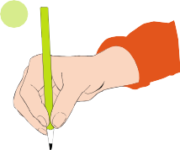
Both right and left handed children should be encouraged to use the tripod grip which allows the pen/pencil to be held securely whilst allowing controlled movements of the pen/pencil nib. Teachers should pay particular attention to pencil grip and sitting position.
3

- Grip the pencil with your index finger and thumb with the nib pointing away.
- With your free hand, spin the pencil from underneath.
- Use your middle finger to support the underside of the pencil.

If a child is not using the tripod pencil grip, ensure a pencil grip assessment has been done to put in appropriate interventions.

