St Boniface’s handwriting long term plan - Year 5
Handwriting is to be taught 3 times per week.

At the start of each handwriting session, ensure children are in the correct sitting position and that they are holding their pencil in the ‘tripod grip’ (see diagram at the end of this document).

Children should write one line in pencil and another line in purple pen.

Refer to the ‘Formation Guide’ for help on the formation of letters and numbers.
All letters should be joined (unless uppercase) – Speed and legibility is the focus, children should decide which letters are best left with no join if this improves speed and legibility.
Autumn 1
Week 1 | Week 2 | Week 3 | Week 4 | Week 5 | Week 6 | Week 7
Recap joining onto | Recap joining onto | Recap joining onto | Recap joining from | Recap joining from | Recap joining from | Recap upper case and
letters (up, over, stop, | letters (down, round, | letters (down, round, | letters (across the top). | letters (do the loop). | letters (along the | lower case letters together
reverse). | top dotted line). | top solid line). | Join from: | Join from: | bottom and up). | in pairs.  Aa → Zz
Join onto: | Join onto: | Join onto: | v, w, o, f, r | g, y, j | Join from:
a, c, o, g, q, s, d | b, f, l, t, h, k | i, m, n, p, r, u, v, w, y, z, |  |  | b, p, s | Explicit teaching of letter
 |  | x, j | Suggested | Suggested |  | names.
Suggested | Suggested |  | combinations: | combinations: | Suggested
combinations: | combinations: | Suggested | vi, va, vr, we, wh, wr, on, | gl, go, gr, ye, yo, ya, ju, | combinations: | Emphasise that upper
og, da, ds, eq, ma, uc, | mb, th, ch, nk, if, ab, al | combinations: | of, oo, re, ry, rs | je, ju | bo, ba, bl, ph, pr, pu, sh, | case letters are not joined
lo, ed |  | kn, ai, up, aw, mp, er, du |  |  | st, sp | onto other letters.
Autumn 2
Week 1 | Week 2 | Week 3 | Week 4 | Week 5 | Week 6 | Week 7
Practise writing the days of the week – joined | Practise writing the months of the year - joined | Practise spelling words ending in ‘ious’ – joined | Practise spelling words ending in ‘cious’ – joined | Practise spelling words ending in ‘cial’ and ‘tial’ – joined | Practise spelling words ending in ‘cial’ and ‘tial’ (exceptions) – joined | Practise spelling common exception words – joined
Emphasise that upper  case letters are not joined onto other letters. | Emphasise that upper case letters are not joined onto other letters. | ambitious, infectious,  fictitious, nutritious, repetitious, amphibious, curious, devious, obvious | delicious, atrocious, conscious, ferocious, gracious, malicious, precious, spacious,  suspicious | official, special, artificial, crucial, glacial, facial, potential, essential, confidential | financial, commercial, initial, spatial, controversial, provincial, palatial | appreciate, cemetery,  conscious, convenience, environment, immediately, language, sufficient, thorough,  vegetable
Spring 1

Week 1 | Week 2 | Week 3 | Week 4 | Week 5 | Week 6 | Week 7
Practise spelling words ending in ‘ant’ – joined  abundant, brilliant, constant, distant, dominant, elegant, fragrant, ignorant, tolerant | Practise spelling words ending in ‘ance’ – joined  abundance, brilliance, elegance, extravagance, tolerance, relevance, hesitance, fragrance, ignorance | Practise spelling words ending in ‘ent’ and ‘ence’ (after soft c, soft g and qu) – joined  innocent, innocence, frequent, confident, confidence, transparent, violent, violence,  competence | Practise spelling words ending in ‘able’ and ‘ible’ – joined  dependable, forgivable, enjoyable, comfortable, incredible reliable, possible, horrible, terrible | Practise spelling words ending in ‘ably’ and ‘ibly’ – joined  reliably, dependably, comfortably, possibly, horribly, terribly, visibly, sensibly, incredibly | Practise spelling common exception words – joined  accommodate, available, controversy, dictionary, twelfth, marvellous, suggest, opportunity, secretary,  sincerely | Practise spelling common exception words – joined  Teacher to choose words based on which joins need practising
Spring 2
Week 1 | Week 2 | Week 3 | Week 4 | Week 5 | Week 6 | Week 7
Practise spelling words ending in ‘able’ (words ending in ‘ce’ or ‘ge’) – joined  changeable, manageable, noticeable, knowledgeable, replaceable, microwaveable, rechargeable, irreplaceable,  salvageable | Practise spelling temporal adverbs – joined  afterwards, immediately, earlier, eventually, previously, finally, recently, yesterday, tomorrow | Practise spelling words with vowel suffixes on words ending in ‘fer’ – joined  referring, preferred, transferring, reference, referee, preference, difference, inference, conferring | Practise spelling words with ‘silent’ letters at the start – joined  knight, wreckage, writer, knowledgeable, knuckle, wreath, pterodactyl, mnemonic, knife | Practise spelling words with ‘silent’ letters throughout – joined  doubt, island, lamb, solemn, thistle, autumn, build, receipt, ascend | Practise spelling common exception words – joined  amateur, ancient, awkward, criticise, excellent, foreign, pronunciation, symbol, yacht, equipment | Practise spelling common exception words – joined  Teacher to choose words based on which joins need practising
Summer 1
Week 1 | Week 2 | Week 3 | Week 4 | Week 5 | Week 6 | Week 7
Pracctise spelling words with ‘ie’ after ‘c’ – joined  ancient, science, species, efficient, deficient, glacier, scientists, sufficient, emergencies | Practise spelling words with the /ee/ sound (spelled ‘ei’ after ‘c’) – joined  deceive, conceive, receive, perceive, receipt, protein, caffeine, either, neither | Practise spelling words with the /aw/ sound (spelled ‘ough’) – joined  bought, fought, thought, ought, sought, brought, wrought, thoughtful, afterthought | Practise spelling words with the sounds /oa/ and /ow/ (spelled ‘ough’) – joined  though, although, dough, doughnut, plough, drought | Practise spelling modal verbs – joined  definitely, possibly, probably, frequently, occasionally, rarely, certainly, obviously, often | Practise spelling common exception words – joined  accompany, communicate, conscience, desperate, disastrous, interfere, nuisance, queue,  restaurant, rhythm | Practise spelling common exception words – joined  Teacher to choose words based on which joins need practising
Summer 2

Week 1 | Week 2 | Week 3 | Week 4 | Week 5 | Week 6 | Week 7
Practise spelling homophones – joined  advice – advise device – devise license – licence practise – practice prophecy - prophesy | Practise spelling homophones – joined  aisle – isle aloud – allowed altar – alter ascent – assent farther - father | Practise spelling homophones – joined  guessed – guest heard – herd morning – mourning past – passed  bridal - bridle | Practise spelling homophones – joined  cereal – serial complement – compliment principal – principle  stationary – stationery wary - weary | Practise spelling homophones – joined  affect – effect precede – proceed draft – draught dessert – desert whose – who’s | Practise spelling common exception words – joined  achieve, apparent, bargain, bruise, community, mischievous, muscle, necessary, vehicle,  system | Practise spelling common exception words – joined  Teacher to choose words based on which joins need practising

Correct Sitting Position
h

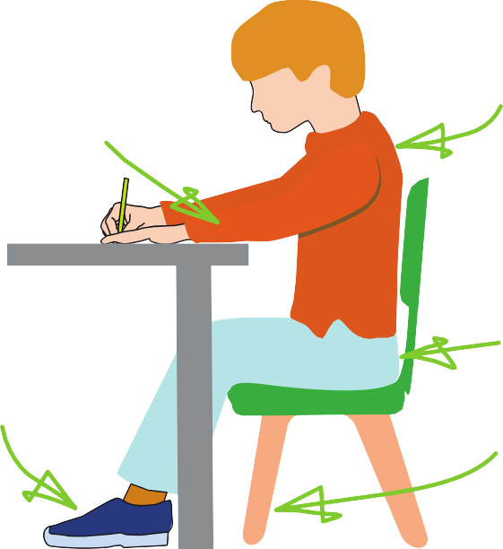





Sit with a
The table
reaches to below elbow eight
Keep feet flat
on the floor
straight back, not leaning over the p ge
a

Sit right back


in the s eat


Pull the chair
d
close in to the table

The Tripod Pencil Grip
Paper position for right han -ed children

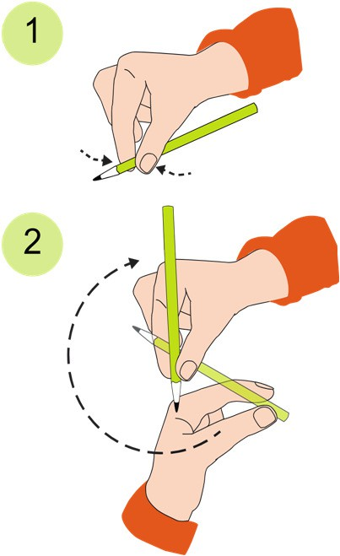
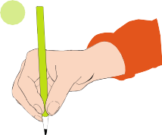
Both right and left handed children should be encouraged to use the tripod grip which allows the pen/pencil to be held securely whilst allowing controlled movements of the pen/pencil nib. Teachers should pay particular attention to pencil grip and sitting position.
3

- Grip the pencil with your index finger and thumb with the nib pointing away.
- With your free hand, spin the pencil from underneath.
- Use your middle finger to support the underside of the pencil.

If a child is not using the tripod pencil grip, ensure a pencil grip assessment has been done to put in appropriate interventions.

