St Boniface’s handwriting long term plan - Year 6
Handwriting is to be taught 3 times per week.

At the start of each handwriting session, ensure children are in the correct sitting position and that they are holding their pencil in the ‘tripod grip’ (see diagram at the end of this document).

Children should write one line in pencil and another line in purple pen.

Refer to the ‘Formation Guide’ for help on the formation of letters and numbers.
All letters should be joined (unless uppercase) – Speed and legibility is the focus, children should decide which letters are best left with no join if this improves speed and legibility.
Autumn 1
Week 1 | Week 2 | Week 3 | Week 4 | Week 5 | Week 6 | Week 7
Recap joining onto | Recap joining onto | Recap joining onto | Recap joining from | Recap joining from | Recap joining from | Recap upper case and
letters (up, over, stop, | letters (down, round, | letters (down, round, | letters (across the top). | letters (do the loop). | letters (along the | lower case letters together
reverse). | top dotted line). | top solid line). | Join from: | Join from: | bottom and up). | in pairs.  Aa → Zz
Join onto: | Join onto: | Join onto: | v, w, o, f, r | g, y, j | Join from:
a, c, o, g, q, s, d | b, f, l, t, h, k | i, m, n, p, r, u, v, w, y, z, |  |  | b, p, s | Explicit teaching of letter
 |  | x, j | Suggested | Suggested |  | names.
Suggested | Suggested |  | combinations: | combinations: | Suggested
combinations: | combinations: | Suggested | vi, va, vr, we, wh, wr, on, | gl, go, gr, ye, yo, ya, ju, | combinations: | Emphasise that upper
og, da, ds, eq, ma, uc, | mb, th, ch, nk, if, ab, al | combinations: | of, oo, re, ry, rs | je, ju | bo, ba, bl, ph, pr, pu, sh, | case letters are not joined
lo, ed |  | kn, ai, up, aw, mp, er, du |  |  | st, sp | onto other letters.
Autumn 2
Week 1 | Week 2 | Week 3 | Week 4 | Week 5 | Week 6 | Week 7
Practise writing the days of the week and months of the year – joined | Practise spelling common exception words – joined | Practise spelling common exception words – joined | Practise spelling common exception words – joined | Practise spelling common exception words – joined | Practise spelling common exception words – joined | Practise spelling common exception words – joined
Emphasise that upper case letters are not joined onto other letters. | muscle, prejudice, available, determined, rhyme, identity, accommodate, suggest, competition, existence | accompany, average, conscience, develop, explanation, immediately, necessary, privilege, category,  occur | according, awkward, dictionary, familiar, individual, neighbour, profession, sacrifice, system, correspond | achieve, controversy, disastrous, frequently, interfere, nuisance, programme, secretary, temperature, variety | aggressive, convenience, embarrass, forty, interrupt, occupy, pronunciation, shoulder,  signature, thorough | amateur, environment,  language, queue, twelfth, equipped, government, leisure, recognise, sincerely

Spring 1
Week 1 | Week 2 | Week 3 | Week 4 | Week 5 | Week 6 | Week 7
Practise spelling words with the /i/ sound (spelled ‘y’) – joined  rhythm, system, physical, symbol, mystery, lyrics, oxygen, typical, symptom | Practise spelling words with the /igh/ sound (spelled ‘y’) – joined  rhyme, occupy, apply, hygiene, supply, identify, multiply, recycle, python | Practise spelling words with the prefix ‘over’ – joined  overthrow, overturned, overcoat, overslept, overcook, overpaid, overreact, overtired, overlooked | Practise spelling word with the suffix ‘ful’ – joined  merciful, plentiful, beautiful, fearful, faithful, doubtful, thankful, pitiful, fanciful | Practise spelling words with the /s/ sound (spelled ‘ce’) – joined  prejudice, nuisance, hindrance, sacrifice, cemetery, certificate, celebrate, December, necessary | Practise spelling common exception words – joined  committee, curiosity, definite, especially, exaggerate, guarantee, lightning, parliament, recommend, soldier | Practise spelling common exception words – joined  Teacher to choose words based on which joins need practising
Spring 2
Week 1 | Week 2 | Week 3 | Week 4 | Week 5 | Week 6 | Week 7
Practise spelling words with the prefixes ‘dis’, ‘un’, ‘over’ and ‘im’ – joined  disappointed, dissimilar, unsure, unnecessary, overseas, overrule, overreact, impatient,  immature | Practise spelling words with the /f/ sound (spelled ‘ph’) – joined  graph, pheasant, phone, photo, physical, alphabet, dolphin, elephant, sphere | Practise spelling words ending in /shul/ (after a vowel) – joined  antisocial, official, superficial, special, artificial, crucial, social, facial, beneficial | Practise spelling words ending in /shul/ (after a consonant) – joined  influential, spatial, partial, confidential, essential, substantial, potential, sequential, torrential | Practise spelling words starting with ‘acc’ – joined  accompany, accommodate, access, accuse, accost, accuracy, accomplish, accumulate, accentuate | Practise spelling common exception words – joined  attached, harass, hindrance, mischievous, persuade, physical, relevant, stomach, vehicle, yacht | Practise spelling common exception words – joined  Teacher to choose words based on which joins need practising
Summer 1
Week 1 | Week 2 | Week 3 | Week 4 | Week 5 | Week 6 | Week 7
Practise spelling words ending in ‘ably’ – joined  changeably, noticeably, dependably, comfortably, reasonably, adorably, believably,  considerably, tolerably | Practise spelling words ending in ‘ible’ – joined  reversible, incredible, possible, horrible, terrible, responsible, legible, sensible, visible | Practise spelling words with the suffix ‘ibly’ (to make adverbs) – joined  reversibly, responsibly, possibly, horribly, terribly, visibly, incredibly, sensibly,  legibly | Practise spelling words where ‘ent’ changes to ‘ence’ – joined  excellent, excellence, silent, silence, evident, evidence, convenient, convenience, difference | Practise spelling words ending in ‘er’, ‘or’ and ‘ar’ – joined  computer, superior, customer, soldier, shoulder, interior, calendar, popular,  particular | Practise spelling common exception words – joined  Teacher to choose words based on which joins need practising | Practise spelling common exception words – joined  Teacher to choose words based on which joins need practising
Summer 2
Week 1 | Week 2 | Week 3 | Week 4 | Week 5 | Week 6 | Week 7

Practise spelling descriptive adjectives (setting) – joined  picturesque, magnificent, regal, tranquil, sinister, unsightly, spectacular,  majestic, bustling | Practise spelling descriptive adjectives (feelings) – joined  euphoric, delighted, despondent, terrified, apprehensive, jittery, optimistic, positive,  sanguine | Practise spelling descriptive adjectives (character)– joined  amiable, obnoxious, disagreeable, grotesque, exquisite, courageous, gargantuan, valiant,  delightful | Practise spelling grammar vocabulary – joined  subject, synonym, antonym, punctuation, comma, colon, adverb, clause, relative | Practise spelling maths vocabulary – joined  addition, subtraction, multiplication, division, horizontal, vertical, circumference, diameter, calculation | Practise spelling common exception words – joined  Teacher to choose words based on which joins need practising | Practise spelling common exception words – joined  Teacher to choose words based on which joins need practising

Correct Sitting Position
h

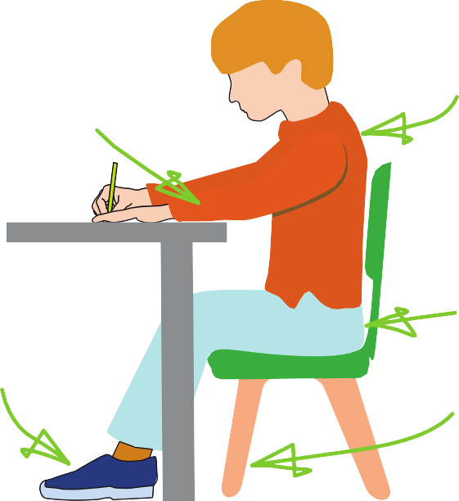





Sit with a
The table
reaches to below elbow eight
Keep feet flat
on the floor
straight back, not leaning over the p ge
a

Sit right back


in the s eat


Pull the chair
d
close in to the table

The Tripod Pencil Grip
Paper position for right han -ed children

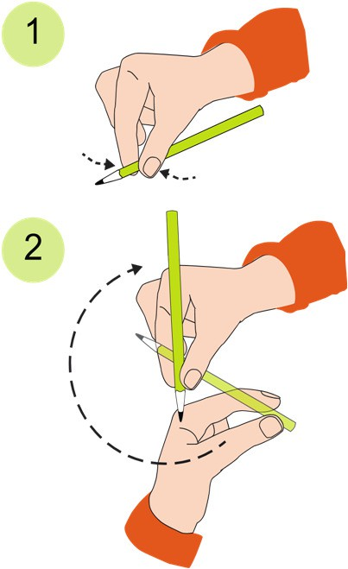
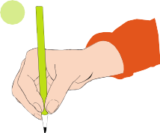
Both right and left handed children should be encouraged to use the tripod grip which allows the pen/pencil to be held securely whilst allowing controlled movements of the pen/pencil nib. Teachers should pay particular attention to pencil grip and sitting position.
3

- Grip the pencil with your index finger and thumb with the nib pointing away.
- With your free hand, spin the pencil from underneath.
- Use your middle finger to support the underside of the pencil.

If a child is not using the tripod pencil grip, ensure a pencil grip assessment has been done to put in appropriate interventions.

