Maths – Following Mastery of Number
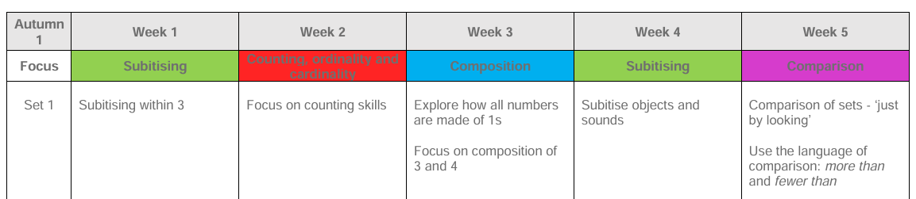

EAD – Early links to Art/DT
Develop creativity through art, music, movement, role play and imaginative play.
- Explore colour, colour mixing, texture, pattern, line and shape.
- Create self-portraits and representations of people and emotions.
- Explore the work of Pablo Picasso and use portraits as inspiration.
- Use a range of materials and tools including paint, collage, loose parts and natural materials.
- Develop imaginative play through families, people who help us and traditional tales.
- Explore beat, rhythm, pitch, loud/quiet and fast/slow.
- Sing familiar songs and rhymes and develop a repertoire of new songs.
- Explore instruments and use music and movement to represent characters and stories.
- Create transient art using natural and loose parts.

PE- Following Get Set 4 P.E
Introduction to P.E Unit 2

UTW - Early links to science:
To explore the natural world and develop an understanding of people, plants, animals, seasons and materials.
Big ideas:
- Use our senses to explore and describe the world around us.
- Observe changes in the natural environment during Autumn.
- Identify signs of seasonal change including leaves, weather, daylight and temperature.
- Explore natural materials and describe their similarities and differences.
- Explore how plants grow and what they need to survive.
- Talk about animals, including nocturnal animals and animals found in different environments.
- Develop understanding of caring for plants, animals and the natural environment.

UTW – Early Links to Geography
Explore the school grounds and identify important features.
Create simple maps of the classroom and school.
Use simple positional and directional language.
Identify familiar buildings and places in the local community.
Explore different types of homes and environments. Locate countries and continents on a world map. Talk about where children and their families come from and celebrate diversity.
UTW – Early Links to History
Talk about how we have grown and changed over time.
Explore changes within living memory through:
- Baby photographs and photographs from home.
- Comparing toys from the past with toys we use today.
- Discussing what children could do as babies and what they can do now.
- Exploring bedtime and school routines – then and now.
- Talking about important people and occupations in our local community.
Music – Following Get Set 4 Music
Traditional Tales

What We Are Learning
Topic Focus: All About Me
Autumn 1
Reception Miss Riley
Religious Education
Branch 1 Creation and Covenant
Big Question: Who made me?
LO : Can I recognise that the story of Creation describes how God made the world?
LO: Can I understand that everything in the world comes from God, our Father, who made heaven and Earth?
LO: Can I learn that God wants us to look after the world and everyone in it to show love for Him and others?
LO: Can I recognise that Prayer is a way of drawing closer to God?
LO: Can I think about the ‘Our Father’ and how it helps us feel close to God?
English

Children will develop their communication, language and early literacy skills through stories, rhymes, songs, discussion and purposeful play.
Pupils will be developing their early literacy skills following Little Wandle:
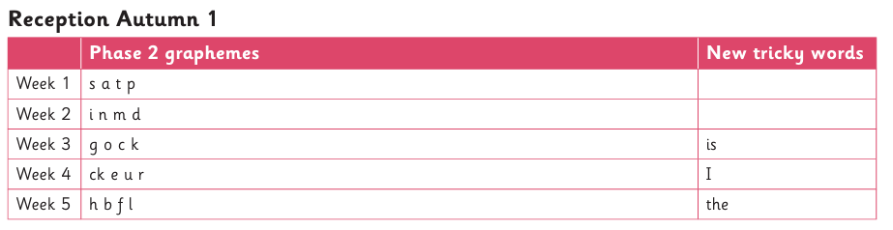
Text focuses: All About Families, My Five Senses and The Colour Monster

