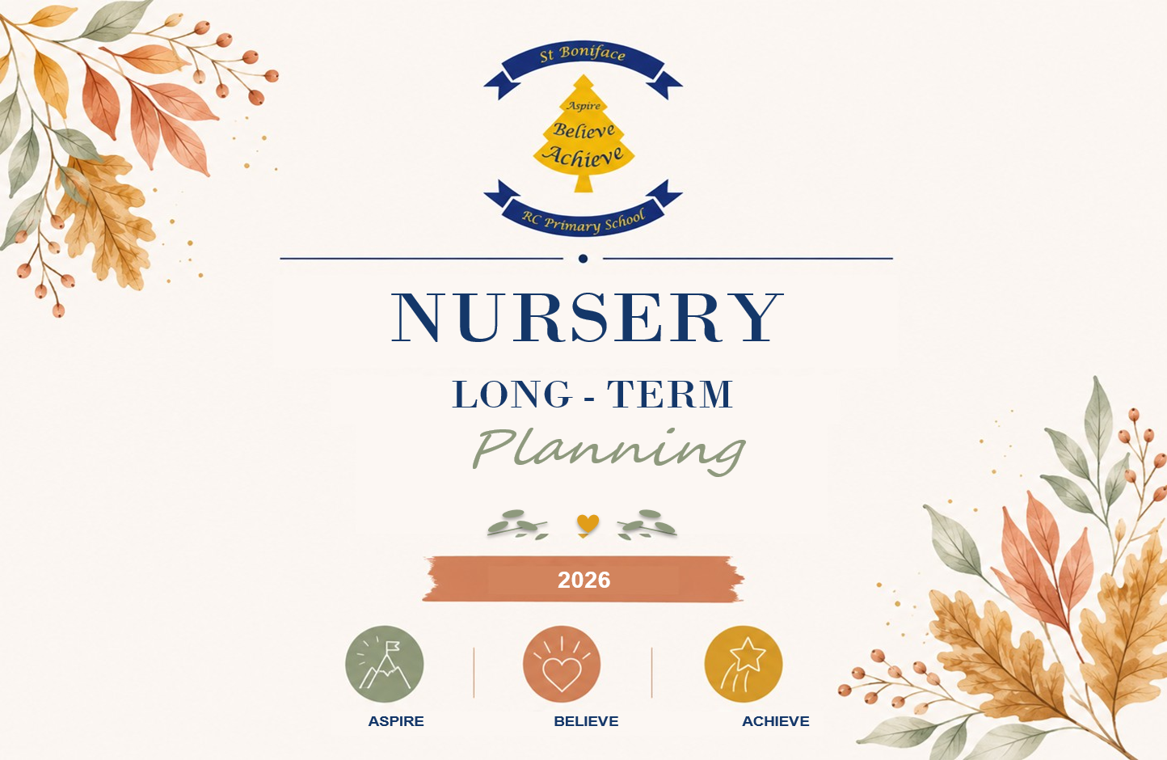

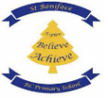
St Boniface RC Primary School
EYFS Long – Term Overview 2026
Nursery

Areas of Learning | NC Links | Autumn 1 | Autumn 2 | Spring 1 | Spring 2 | Summer 1 | Summer 2
 |  | All about Me! | How do we celebrate? | What is it like in space? | What helps us Grow? | People Who Help Us | Under the Sea
 |  | Getting to Know Me  My Family  My senses  My Body  My Feelings  Celebrating Me | Birthdays  Bonfire Night  Remembrance Day  Diwali  Celebrations around the world  Weddings | Day & Night  Space Travel  Planets & Stars  Moon & Sun  Astronauts | Plants around us  Seeds and bulbs  Life Cycles  Healthy Grows  Animals  Celebrating Growth | Introducing helpers  Police  Firefighters  Doctors & Nurses  Teachers  People in the community  Celebrating People who help us. | Sea Creatures  Rock pools  Boats  Seaside Safety  The Beach  Sun Safety
Physical Development | Physical development is about both gross and fine motor skills, as well as healthy self-care habits. Children will have daily opportunities to move freely and develop coordination, balance, and control through climbing, running, jumping, and other large movements. Alongside this, fine motor skills—such as holding a pencil, using scissors, fastening buttons, and pouring—are nurtured to prepare children for writing and self-care. There is also an emphasis on healthy choices, such as the importance of being active, eating well and learning independence with dressing and toileting. These skills are closely linked to children’s confidence and readiness for more formal learning.
 | PE | Introduction to PE Unit 1 | Fundamentals  Unit 1 | Ball Skills: Unit 1 | Gymnastics: Unit 1 | Dance: Unit 1 | Games: Unit 1
 | Gross Motor Development  Intent  Vocabulary  Implementation | Walk and crawl confidently. Climb using two feet at a time. Knowing how to scoop and pour e.g. sand, mud. To run around the setting with some control and direction. Clapping and stamping to music.  Walk, crawl, skill, carefully, safe, safely, scoop, use, pour, dig, tools, sand, mud, water, run, careful, clapping, stamping.  Children playing games that involve walking and crawling, adults modelling good posture when walking and crawling, children supported on a climbing frame physically and verbally, children having access to mud, sand, water, children dancing and clapping during a guided singing time. | Begin to move slowly on a balance bike. Begin to use a climbing frame with support from an adult. Being able to use a swing with some independence.  Balance, careful, bike, safe, safely, climb, high, feet, watch, hands, help, swing, kick, move, jump.  Children using balance bikes with guidance from adults in the provision, children having access to a climbing frame and supported to use them, children using a swing and verbally supported or modelled to – how to use. | Children putting on their own coat (needing support to do their coat up still), Children putting on their own shoes. Going up and down stairs with control and balance.  Coat, independently, by yourself, help, ask, shoes, up, down, watch, careful, safely, control, balance.  Children encouraged to put on their coat and shown how to do this step by step, children encouraged to put on their shoes and shown how to do this step by step, children going up and down stairs to develop confidence and independence to do so. | Children can kick a large ball with some control. Children can throw a ball with some control. To begin to balance on one leg. To dance with control using different parts of their body. To use the available equipment to create an obstacle course to navigate.  Kick, large, ball, hands, feet, fast, slow, watch, control, balance, leg, hop, jump, still, dance, obstacle, move, jump.  Children having a range of different sized balls to play with independently, children supported to balance on one leg and playing games where they balance on one leg, children provided with music to dance to and adults to model dances for children to follow. | To use a balance bike more confidently. To run with more confidence and skill. To independently use a climbing frame or similar resource, To begin to show good posture when sitting on the carpet.  Balance, bike, look, watch, careful, skill, navigate, independently, climb, frame, careful, safe, straight, cross legs, cross arms, smart sitting.  Children having access to balance bikes to use independently, Children having access to a climbing frame and obstacle like equipment, children given time to sit and listen on the carpet and supported to sit correctly during this time. | To make up own movements with their body. To begin to use their core muscle strength to achieve good posture when sitting on the floor or at the table.  To be able to climb safely. Children choosing the right equipment to move safely.  Dance, Move, Sit, sitting up, straight, smart sitting, posture, floor, carpet, table, pen, pencil, scissors, ball, racket, rope, cone.  Children having music to dance to and move to, Children sitting at tables, sitting on the carpet, children having access to a range of tools and equipment such as pens, scissors, balls, rackets, cones to use.
 | Fine Motor development  Intent  Vocabulary  Implementation | Children using a palm grip when using mark making tools. Children using a spoon to feed themselves correctly. Children using spring loaded scissors to make snips into paper with adult support.  Pencils, tools, spoon, food, feed, safely, hand, scissors, snips.  Pencils available for children at all times, spring loaded scissors available for children to use, children supported to feed themselves. | Children mark making by scribbling and colouring. Children exploring a range of mine motor activities and implements, Children using a spoon and a fork to feed themselves.  Pen, pencils, scissors, paintbrush, finger, finger strong, dough, dough disco, colouring, spoon, fork.  Fine motor activities in the class as well as adult guided activities – drawing, writing, cutting, tracing etc. Children having access to mark making materials at all times, children encouraged to feed themselves with spoons and forks. | Beginning to use a four-finger grip to use mark making tools, using construction equipment correctly to build e.g. Duplo, Magnitiles. To develop more independence when using spring loaded scissors.  Pencil, grip, hand, fingers, skill, scissors, snips, control, build, independence.  Adults supporting children to develop their pencil grip – verbally, moving fingers, construction kits available for the children to use. | Children making more controlled marks when drawing and mark making, Children manipulating dough through rolling, squeezing, balling and patting.  Mark making, pencils, pens, colours, dough, dough disco, rolling, squeezing, balling, patting, poking.  Children having access to mark making materials to use independently, children having dough to use and manipulate, adults modelling the use of dough and how to draw with skill. | Children using a two finger and a thumb grip. I can draw and paint clearer shapes and pictures when drawing and painting. Children showing some threading skills.  Thumb and fingers, pencil, grip, draw, pencil, shape, drawing, care, time, threading.  Adults supporting children to develop their pencil grip – verbally, moving fingers, pencil grips if children need support. Threading activities and independent activities too e.g. leaves and string, children being able to draw freely. | Children using pencils and other equipment comfortably for them.  Children beginning to make snips in paper either using one hand or two independently. Children turning pages in a book one at a time. Children may form some letters in their name.  Pencils, tools, equipment, safely, hand, scissors, snips, letters, letter shapes.  Pencils available for children at all times, scissors available for children to use, activities for children that include mark making, name writing and snipping paper.
Communication, Language & Literacy. | Children’s spoken language, listening, and understanding skills form the foundation of all learning. In the early years, children will be immersed in language-rich environments where conversations, storytelling, songs, and role-play encourage them to develop a wide and varied vocabulary. Practitioners will model new words in context, encourage children to articulate their thoughts, and give them opportunities to listen carefully to others. The focus is on enabling children to express themselves clearly and confidently, while also building the ability to follow instructions and engage in meaningful back-and-forth conversations
 | Core Text: | Nursery  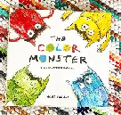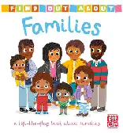  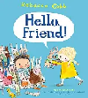 | 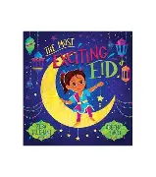  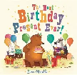  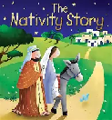 | 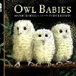  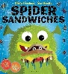  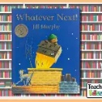 | 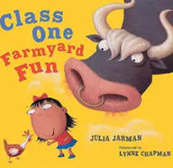  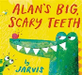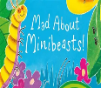 | 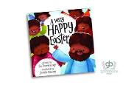  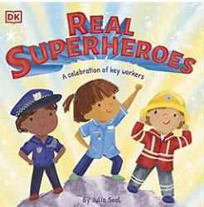 | 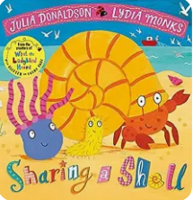  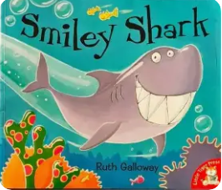  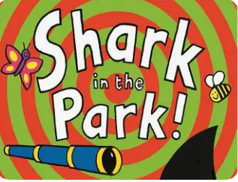
Literacy  Little Wandle  SSP | Literacy learning in the early years is focused on fostering a love of stories, books, and writing. Children will engage in daily story sharing, nursery rhymes, and songs to build early comprehension skills and awareness of rhythm and rhyme. They will begin to link sounds and letters through phonics and develop the ability to recognise familiar words. Mark-making activities—whether drawing, painting, or writing their names—support early writing development. By the end of the early years, children will be encouraged to write simple sentences and use their knowledge of sounds to spell words, while also being able to understand and talk about what they have read.
 | 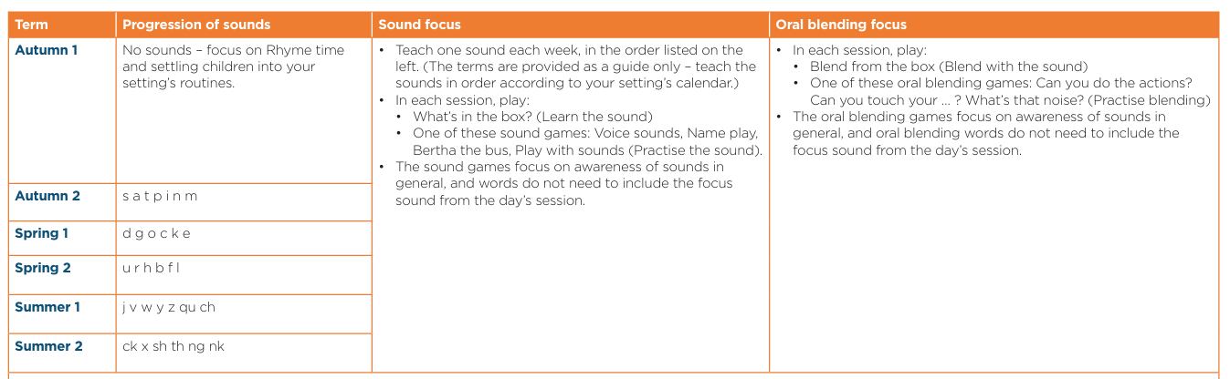
 | English | Rhyme Time | Tuning into sounds  s a t p i n m | Tuning into sounds  d g o c k e | Tuning into sounds  u r h b f l | Tuning into sounds  j v w y z qu ch | Tuning into sounds  ck x sh th ng nk
 | Emergent Writing Development / Mark Making  Intent Vocabulary Implementation | Develop an interest in making marks. I am beginning to distinguish between marks and pictures/drawings.  Marks, pencils, pens, paper, drawing, writing.  Adults to provide children with writing equipment in provision for children to access independently at any time. | Draws marks that are not always distinguishable.  Follows large pattern templates available. Marks, pencils, pens, paper, drawing, writing, trace, copy.  Adults to provide children with writing equipment in provision for children to access independently at any time. | Adds some marks to drawings. Adds marks that to them symbolizes their name.  Marks, pencils, pens, paper, drawing, writing, trace, copy, meaning.  Adults to provide children with writing equipment in provision for children to access independently at any time. Adults to provide children with access to their written name. | Beginning to give meaning to the marks I make.  Marks, pencils, pens, paper, drawing, writing, trace, copy, meaning.  Adults to provide children with writing equipment in provision for children to access independently at any time. | Understands that a written word conveys meaning. Name writes with the first letter of their name to ‘sign’ their mark making.  Marks, pencils, pens, paper, drawing, writing, trace, copy, meaning.  Adults to provide children with writing equipment in provision for children to access independently at any time. Adults to provide children with access to their written name. | Gives meanings to the marks made. Can pretend to write in a range of contexts.  Becoming more confident with name writing – I can write some or all of my name.  Marks, pencils, pens, paper, drawing, writing, trace, copy, meaning, letters, sounds.  Adults to provide children with writing equipment in provision for children to access independently at any time. Adults to provide children with access to  their written name.
Early Steps | I explore making marks, but I do not communicate meaning.  Random scribbling.  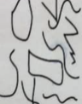 | I draw pictures.  I use lines to look like writing. Scribble writing  Left to right direction  I begin to assign meaning.  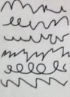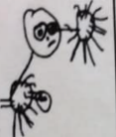 | I write symbols and shapes that look like writing.  I assign meaning to the marks  Attempts to write name  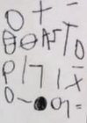 | I write random letters with no connection between letters and sounds. I talk about my writing.  Writes name from memory  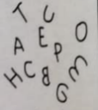 | I use letter strings which travel from left to right and top to bottom.  I attempt to ‘read’ my writing.  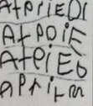 | I write letters with spaces between them to resemble the idea of words. | I copy words that I see in the environment around me.  I often do not know what the words say.  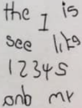
 | Letter formation development  Intent Vocabulary Implementation | Sits in a balanced position. Can pretend to write. Can make controlled marks using tools or their finger in sand, glitter etc.  Balance, comfortable, straight, pencil, marks, sand, glitter.  Adults to provide children with writing equipment in provision for children to access independently at any time. Activities set up for children to write in a range of materials  e.g. glitter, sand, mud. | Makes controlled marks e.g. dots, circles, scribbles. Copies shapes and patterns with developing accuracy.  Writing, mark making, pencils, pens, copy, trace.  Tracing materials available to children, writing materials always available to children. | Makes smaller controlled lines. Beginning to use a two finger and a thumb grip when writing.  Writing, mark making, pencils, pens, copy, trace, pencil grip.  Tracing materials available to children, writing materials always available to children. Tools with pencil grip support e.g. larger pencils, triangular pencils or pencils with a rubber grip on. | Holds a pencil or tool with a preferred hand.  Writing, mark making, pencils, pens, copy, trace, pencil grip, hand.  Tools with pencil grip support e.g. larger pencils, triangular pencils or pencils with a rubber grip on. | Uses a two finger and a thumb grip when appropriate. Writing, mark making, pencils, pens, copy, trace, pencil grip, hand Tools with pencil grip support e.g. larger pencils, triangular pencils or pencils with a rubber grip on. | Can use the basis of a three-finger pencil grip. Use a pencil or writing tool more confidently to write some letters (e.g. the letter in my name). Writing, mark making, pencils, pens, copy, trace, pencil grip, hand, letter writing.  Tools with pencil grip support e.g. larger pencils, triangular pencils or pencils with a rubber grip on.  Writing provision available at all times for the children to access.
Understanding the World | This area introduces children to the wider world around them, encouraging curiosity and respect for different people, places, and environments. They will learn about the past and present by talking about their own families, events, and stories from history. Diversity and community are celebrated through learning about different cultures, beliefs, and traditions. Children will also explore the natural world—observing plants, animals, weather, and seasonal changes—building an early understanding of science. Hands-on exploration, such as gardening, nature walks, and using simple technology, helps children make sense of the world and their place within it.
 | History | Talk about when I was a baby. | Continue to develop positive attitudes about the differences between people. | Discussions of journey’s children have embarked on. | To recognise plants, grow from a seed. | To look at home Emergency helpers and their equipment has changed over the years. | To Talk about special days, I have enjoyed.
 | Development of Past and Present  Intent  Vocabulary  Implementation | Children using words ‘now’ and ‘next’. Children talking about their family, who they live with and any pets.  Now, next, family, family members names, mum, dad, brother, sister, dog, cat, rabbit, pets,  Children playing discussion games where they take it in turns to talk about their family e.g. roll a ball and then whoever has the ball says who is in their house, adults promoting children to talk about their home and home life. | Children talking about their past life experiences e.g. birthdays, Christmas. Children using the words ‘then’ ‘now’ ‘next’ ‘before’.  Past, before, events, now, then, before, next.  Adults modelling these terms correctly and rephrasing children’s words so they are too using them correctly. Adults discussing with children their past experiences when celebrating them in nursery (e.g. Christmas time). | Children understanding the terms ‘old’ and ‘new’ and recognising old and new objects e.g. cars, shops, photos  New, old, past, present, now, different, same, rusty, black and white, modern.  Children going on a local walk and looking at old a new – houses, shops, cars, statues or memorials. Children looking at photos and objects or books from the past. | Children commenting on their own past experiences e.g. Easter. Children showing curiosity about objects from the past.  Past, happens, events, experiences, Easter, egg hunt, same, different, old, new.  Children discussing how they have celebrated Easter in the past. Children looking at photos and objects or books from the past. | Children confidently talking about who they are and who they live with, Children asking questions to family members about when they were young.  Family, live with, family tree, old, new, past, questions, happened.  Children discussing with adults during activities who they live with and who the adults are to them. Children exploring a family tree. Children having the opportunity to ask parents and grandparents about their lives in the past. | Children beginning to understand how to sequence two events. Children sequencing family members e.g. baby, mum, grandma.  Sequence, first, last, then, before, family, names, family tree.  Children being taught how to ‘sequence’ using two familiar events – either in the present day or from across the year. Children continuing with their work around families and family trees.
 | Geography | Families – My Own Home is in Lower Broughton | Celebrations  Discuss how celebrations all over the world maybe different to our own. | Draw a map of our playground drawing what we see along the way. | Past & Present  Look at pictures of the local area and discuss how they have changed. | To recognise people, have different jobs, look at a variety of jobs within our local community. | Early Geographers  Compare how living in Lower Broughton is different to living in a hot country.
 | Development of People, Culture and Communities  Intent  Vocabulary  Implementation | Children talking about their families. Children talking about who is special to them and why. Children naming their family members.  Family, family names, special.  Adults prompting children to talk about their families and homes. Adults asking children at drop off and pick up times who it was/will be today. | Children talking about how we look after our friends and families. Children talking about their homes and what they have inside their homes. Children talking about the celebration of Christmas.  Friends, family, care, look after, home, bedroom, kitchen, living room, bathroom, Christmas.  Adults encouraging children to look after their friends and family if they want to e.g. get them a tissue, adults discussing with children their homes and what is inside their homes, children exploring a range of celebrations at nursery including Christmas. | Children recognising familiar signs, shops in my environment and local environment. I can talk about the transport used in my community. I can talk about the similarities and differences between celebrations I know and celebrations in other countries e.g. Christmas and CNY.  Shop, memorial, stop sign, traffic light, transport, community, local areas, same, different, celebrate, Chinese New Year, Christmas.  Adults promoting the celebration of a range of festivals around the world, children exploring the local environment and looking at familiar shops/signs etc. | Children speaking positively about differences between people and ways of life. Children showing an interest in people with a range of occupations.  Differences, same, similar, jobs, firefighter, police officer, shop worker, postal worker, driver, doctor, nurse  Children having visits from a range of occupations and reading stories on a range of occupations too, children listening to stories that celebrate diversity and equality and encouraged and supported to do so in nursery too. | Children developing an idea of ‘belonging’. Children beginning to understand what the ‘wider world’ is and how we all play a part and get along with one another.  Belonging, groups, own ideas, the world, other countries, other people. Getting along, patience, tolerance.  Adults introducing the idea of British Values through activities, discussions and stories. Children discussing patience and tolerance and adults supporting children to be tolerant and patient. | Children using the correct vocabulary to name different features of their community. Children know there are other countries than England and that they look different to ours.  Names of the features in the environment, countries, same, different, hot, cold.  Children exploring the local environment drawing maps, creating small worlds versions of their local area, children learning about other countries around the world and comparing them to the country we live in.
 | Science | Our Bodies | Freezing and Melting | Light and Dark | Planting flowers | What’s changed – Ourselves | Floating and sinking
 | Development of the Natural world  Intent  Vocabulary  Implementation | Children showing respect and care for their environment. Children talking about their home environment and school environment. Children exploring their world and environment through their senses.  Respect care, look after, home, school, nursery, touch, see, feel, smell, hear, taste.  Adults modelling respect and care and encouraging children to do this too, Adults talking to children about their home environment and school environment, adults setting up activities for children to explore. | Children exploring the changing weather and seasons (Summer), Children noticing changes such as ice melting in the sun and offering a reason why. Weather, sunny, raining, snowing, ice, autumn, winter, summer, spring, changes, why  Stories, discussions and activities based on the weather and seasons, Adults setting up activities where ‘changes’ and ‘processes’ are involving such as ice melting or colour changing experiments. | Children understanding how and why we respect and care for animals. Children exploring a range of materials and natural objects.  Respect, care, look after, materials, man-made, natural, nature.  Adults teaching children about nature, the world and animals and how and why we care for them, Adults setting up activities to explore materials and their functions. | Children growing plants from seeds and caring for them, Children exploring how these plants grow and change over time.  Seeds, soil, water, care, look after, grow,  Adults supporting children to plant their own seeds and grow them, Children re-visiting their plants to see how they have grown. | Children exploring the changing weather and seasons (Spring), Children learning about new life and plants based around Spring time  Weather, sunny, raining, snowing, ice, autumn, winter, summer, spring, Stories, discussions and activities based on the weather and seasons, adults setting up activities for children to explore, spring-based stories, activities, looking at lambs, chicks, tadpoles, | Children exploring the changing weather and seasons, Children continuing to explore using their senses. Children naming parts of the body. Children showing more of an interest in the world.  Weather, sunny, raining, snowing, ice, autumn, winter, summer, spring, body part names, explore.  Stories, discussions and activities based on the weather and seasons, adults setting up activities for children to explore, books on the body, discussions on the world, adults basing activities on children’s interests.
 | RE | 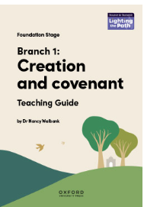 | 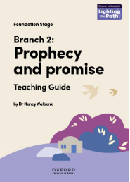 | 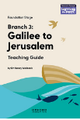 | 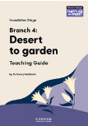 | 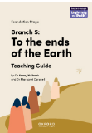 | 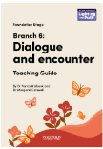
Personal, Social & Emotional Development | This area supports children in understanding themselves and others, managing their feelings, and developing positive relationships. Children will learn to share, take turns, and resolve simple conflicts with guidance. They will be encouraged to talk about their emotions, understand how their actions affect others, and develop resilience in the face of challenges. Independence is fostered through managing self-care, making choices, and taking responsibility for tasks. PSED also lays the foundation for empathy, respect, and appreciation of diversity—helping children build secure attachments and a strong sense of belonging in their community.
 | PHSE  RSE | TenTen – Module 1 Created and Loved by God  Unit 1  Religious Understanding  Unit 2  Me, My Body, My Health  Unit 3  Emotional Well-Being  Unit 4  Life Cycles |  | TenTen – Module 2 Created to love others.  Unit 1  Religious Understanding  Unit 2  Personal Relationships  Unit 3  Life Online  Unit 4  Keeping Safe |  | TenTen – Module 3 created to live in community  Unit 1  Religious Understanding  Unit 2  Living in the Wider World
 | Self-Regulation  -Expressing feelings  - Managing behaviour  Intent  Vocabulary  Implementation | I can express when I feel happy, sad, tired or upset. I can find out about emotions through stories and discussions.  Feelings, emotions, happy, sad, angry, tired, upset, scared,  Books read focusing on feelings and emotions. Group discussions on emotions – particularly relating to starting nursery. Adults asking children to express how they’re feeling- adults modelling too. | I can sit nicely and keep my feet to myself. I can look after the toys and equipment at my setting.  Sit, smart sitting, listening ears, careful, look after, tidy up.  Children being supported and reminded to sit nicely on the carpet and keep their feet to themselves. Children having a regular tidy up time where they are supported and encouraged to tidy up. | I will talk about my feelings. I can wait my turn. I tidy up the resources that I have used. I am following the behaviour expectations of my nursery.  Feel, feelings, wait, turn, patience, tidy, tidy up, behaviour, rules, listening.  Adults supporting children to talk about their feelings. Children being told when it is tidy up time and told if an area needs to be tidied up, children reminded of the behaviour expectations and supported to follow them. | I know what ‘right’ choices are and I try my best to make the right choice. I can talk about my feelings and explore why I might be feeling this way.  Right, good choice, bad choice, feelings, why.  Adults prompting children to explain the choices they have made. Children talking about their feelings with adults at their setting and exploring together why they feel this way – discussions, stories etc. | I can calm myself down using a strategy that works for me. I am managing my feelings. I show control with my emotions. I can think about how others feel.  Calm, breathe, quiet space, feel, friends.  Adults modelling calming techniques, children being supported to manage their feelings and emotions and given tools to do this independently. | I am showing more control over my feelings and behaviours. I am showing more perseverance and resilience when facing a challenge. I can talk about the changes as I start school and how I feel.  Emotion, feeling, happy, sad, frustration, explain, why, turn taking, my turn, your turn, nervous, excited, change  Adults modelling calming techniques, children being supported to manage their feelings and emotions and given tools to do this independently. Discussions around starting school and transition between nursery and school.
 | Managing Self  -Self-awareness  -Keeping healthy  -Independence  -Collaboration  Intent  Vocabulary  Implementation | I can take turns with other children with adult support. I can explore the classroom with adult support. I can use the toilet with adult support.  Turn taking, children, friends, classroom, explore, areas, toilet, wipe, flush, wash hands.  Adults supporting children to turn take, children encouraged to explore their setting and the available resources, children supported to use the toilet in their setting. | I will have a go at new things. I am washing my hands after using the toilet with some reminders to do so.  Try, have a go, washing hands, soap, water, dry.  Children encouraged to try new things in their setting and regular activities available for children to choose from, children encouraged verbally to use the toilet. | I am showing more independence and confidence in my setting and when exploring areas. I will use the visual timetable to know what is happening in my day.  On my own, by myself, independently, confident, explore, have a go, try, timetable, next.  Children encouraged to independently do things by the staff, children having access to the visual timetable that is changed daily. | I can use the toilet independently. I can focus on my task for a longer period of time. I can talk about healthy food choices.  Toilet, wipe, flush, wash hands, focus, attention, listen, healthy, treat food, fruit and vegetables.  Children encouraged to use the toilet independently, children working in guided groups to complete activities, children learning about food choices and what a healthy food choice is. | I can manage when routines change. I can talk about why we need to wash our hands. I can play nicely with others and extend others play.  Routine, happens next, change, wash hands, healthy, health, play, nice, friends, turn taking, sharing, joining in.  Children learning about germs and then importance of washing our hands and bodies to keep safe and clean, children encouraged and supported to play nicely with other children. | I can talk about my achievements in a positive way. I am becoming more independent in looking after myself, ready to start school.  Proud, pride, positive, happy, independent, on my own, by myself, school.  Discussions about the year and the progress the children have made, children encouraged to be independence in their care and learning and linking this to discussions around school readiness.
 | Building Relationships  -Social Skills  -Communication  Intent  Vocabulary  Implementation | I can take turns with other children with support from the adults in my setting. I can separate from my parent/caregiver with adult support.  Turn taking, sharing, friends, help, listening, later, worry, parent names.  Children supported to separate from care giver – transition settling in sessions to take place before full time nursery is possible, children supported to turn take in a guided group session. | I will play alongside other children in my setting and may need adult support to do this. I play simple turn taking games in adult guided groups. I am showing more interest in other children’s play.  Play, nicely, share, turn take, adult, help, nicely, join in, friends.  Adults modelling play and verbally supporting play, children playing turn taking games in the adults. | I can come into my setting with minimal support from an adult. I can talk about my family. I am beginning to show friendly behaviours to my peers.  Happy, proud, come in, family, family names, friends, friendly.  Children praised for coming into their setting well, adults prompting children to discuss their families and who lives with them – guided and independent tasks based around this, children encouraged to be friendly to the other children in their setting. | I am forming friendships with some children in my setting. I am becoming more confident in the social situations.  Friends, special friend, best friend, confident, talking.  Adults modelling social situations and back and forth conversation, children having time to play with who they want in the area of their choosing. | I help others who are upset. I am beginning to solve conflicts with others. I am showing more social confidence.  Sad, help, upset, tissue, problem, solve, together, friends, turn taking, confident, outgoing, talking.  Adults modelling supporting upset children for children to copy themselves e.g. giving hugs, giving tissues or a favourite teddy, children given methods to resolve conflicts such as using a sand timer when sharing a toy. | I can ask new adults questions. I find solutions to conflicts I have had. I can talk about what a friend is and name some of my friends when asked.  Questions, why, where, what, when, solution, fix, turn take, adult help, friend, friend names.  Children encouraged to ask questions to people, children encouraged to resolve conflict using the techniques learnt at school children discussing who they are going to school with next year.

Mathematics | Early maths is taught through play, problem solving, and exploration of the world around children. The focus is on developing a strong sense of number—recognising numerals, counting objects, comparing quantities, and understanding the concept of more or fewer. Children will explore numerical patterns, such as odd and even numbers, doubling, and sequences. While shape, space, and measures are no longer a separate Early Learning Goal, they remain embedded in practice through activities like building with blocks, cooking, and exploring capacity with sand and water. The aim is for children to see maths as practical, enjoyable, and relevant to everyday life.
 | Maths | More than, fewer than, same  Explore and build with shapes and objects  Explore repeats  Hear & say number names | Begin to order number names  I see 1,2,3  Join in with repeats  Explore position and space | Show me 1,2,3  Move and label 1,2,3  Shape, Space & Explore position and routes  Explore pattern | Take and give 1,2,3  Shape, Space & Match, talk, push and pull  Talk about dots  Compare and sort collections | Lead on own repeats  Start to puzzle  Make patterns together  Make games and actions | Show me 5  My own pattern  Stop at 1,2,3,4,5  Match, sort, compare
 | Number and Numerical Patterns  Intent  Vocabulary  Implementation | To recognise, name and match colours. To begin to show an interest in counting aloud verbally to 5. To be able to ‘give 1’ when asked.  Count, number, one, colour, colour names, number songs.  Adults providing colour matching activities and modelling naming colours, adults to model counting out during various activities and daily routines, adults to ask children for one of something and support children who are still learning to do this. | To be able to verbally count to 5 with developing accuracy. To develop an understanding of ‘2’ e.g. giving 2 items or noticing 2 in the environment.  Count, number, one, two, number songs.  Adults to model counting out during various activities and daily routines, adults to ask children for two of something and support children who are still learning to do this. | To begin to be able to verbally count to 10 with developing accuracy. To develop an understanding of ‘3’ e.g. giving 3 items or noticing 3 in the environment. To begin to compare quantities that are significantly more than and less/ fewer than visually without counting them.  Count, number, one, two, three, number songs, more, less.  Adults to model counting out during various activities and daily routines, adults to ask children for three of something and support children who are still learning to do this, activities based on more than and fewer than. | To verbally count to 10 with developing accuracy. To develop an understanding of ‘4’ e.g. giving 4 items or noticing 4 in the environment. To compare quantities that are significantly more and less visually without counting them.  Count, number, one, two, three, four, number songs, more, less.  Adults to model counting out during various activities and daily routines, adults to ask children for four of something and support children who are still learning to do this, activities based on more than and fewer than. | To accurately count to 10. To develop an understanding of ‘5’ e.g. giving 5 items or noticing 5 in the environment. To play simple dice and track games developing Subitising skills.  Count, number, one, two, three, four, five, number songs, dice, die, track, counting on, subitise, without counting.  Adults to model counting out during various activities and daily routines, adults to ask children for five of something and support children who are still learning to do this, dice and track guided activities and within the nursery provision. | To begin to understand that 5 can be shown in different ways, to begin to subitise to 5. To count to 10 and beyond.  Count, number, one, two, three, four, five, number songs, dice, die, track, counting on, subitise, without counting, number bonds, different.  Children showing 5 on their fingers in different ways e.g. how many fingers are up and how many are down, children Subitising using dice, numicon or dot cards, children counting to 10 and beyond during games, in adult guided groups or independently in play.
 | Shape, Space and Measure  Intent  Vocabulary  Implementation | To be able to play with shapes and begin to make pictures with these. To build a simple jigsaw.  Shape, shape names, together, new shape, pictures and images, jigsaw, missing, turn, tessellate.  Children to have access to shapes to play with and build pictures with, children to have access to puzzles to complete. | To begin to describe the height and size of something using the terms ‘tall’ or ‘short’ and ‘big’ or ‘small’.  Compare, big, small, tall, short, different.  Adults modelling the use of vocabulary, children completing activities based on height and size comparison. | To use positional language ‘in’, ‘out’, ‘on’. To find shapes in the environment. To use 3D shapes to build models.  In, out, on, shape, shape names, 3d shape, shape names, build, model, flat surface, smooth surface, curved surface.  Adults modelling the use of positional language. 3D Shapes available in provision for children to build with – adults modelling this and modelling the use of curves shapes Vs flat shapes. | To use the terms ‘long’ and ‘short’ when describing height and size. To understand and follow the instructions ‘forwards’ and ‘backwards.  Long, short, describe, compare, height, size, forwards, backwards.  Adults modelling the use of language, modelling forwards and backwards and playing games involving the skill. | To begin to understand what a pattern is and follow a 2-part simple pattern. To begin to describe and name some simple shapes – circle, square, triangle.  Pattern, repeat, colour names, follow, copy, name, describe, shape, shape names, circle, square, triangle.  Adults explaining what a pattern is and the rules of a repeating pattern, patterns in provision and activities, shapes for children to play with and use. | To describe weight using ‘heavy, light. To copy or create a 2-part pattern. To understand and use a range of prepositional language.  Heavy, light, weight, heavier, lighter, pattern, colour, repeat, up, down, under, on top, near, next to, across  Children taking part in weight exploration tasks, children completing pattern tasks in guided activities, adults modelling prepositional language and supporting children to use these terms too.
Expressive Art & Design | Creativity and imagination flourish in this area, as children are given opportunities to experiment with different materials, tools, and techniques. They will explore colour, texture, shape, and sound through art, music, movement, and role-play. Children are encouraged to create their own artwork, models, and performances, as well as to express their ideas through storytelling and pretend play. This area will support developing children’s confidence, originality, and the joy of experimenting. Staff will support children to be imaginative and expressive to enhance children’s problem-solving skills, resilience, and ability to communicate their thoughts and feelings in a way that is unique to them individually.
 | Art  DT | Handprints  Self portraits  Building houses  Daily access to paint and tools to create and build. | Create a party Hat  Firework paintings  Bake a cake | Rocket Making  Moon surface paining  Alien collages | Handprint flower garden  Fruit and veg printing  Yoghurt pot cress heads | People who help us paper face painting  Design a doctors bag – cut and stick | Shell painting  Sand texture art  Using disks make a rainbow fish.
 | Creating with Materials  Intent  Vocabulary  Implementation | Recognises colours and chooses them for a purpose. Uses thick paint brushes. Uses playdough to roll, cut, ball, sausage. Builds towers with large construction equipment.  Colour, colour names, paint brush, paint, thick, paper, create, make, ideas, landscape, portrait, dough, roll, squeeze, shape, ball, cut, tower, build, up  Children painting and colouring pictures using crayons and pencils, children having access to paint and thick paintbrushes to use, children having a malleable area with dough and tools to use, children having larger constructions equipment available. | Uses a glue stick to join materials together. Creates an independent craft using available materials e.g. An independent Christmas Card.  Glue, glue stick, join, lid, wind up, craft, glitter, design, ideas.  Children having glue sticks modelled to them by the adults in the setting, glue sticks available for children to use at all times, children being shown ideas e.g. for a Christmas card and then given the free choice to make the card. | Becoming more confident when drawing e.g. potato people, Names what they have drawn and draws from memory, Adding more to their pictures and creations e.g. pom-poms, glitter.  Drawing, pencils, paper, colouring pencils and pens, what, where, why, pom-poms, glitter, feathers, pasta, sequins.  Children having free access to paper and pencils to draw with, adults modelling drawing while at the drawing table, adults talking to children about their artwork and process, adults ‘stocking up’ the creative area with a range of resources for children to freely access. | Using spring loaded scissors to snip, using printing materials in the paint such as sponges and shapes, continues to develop their drawing skill.  Scissors, careful, snip, print, paint, colour, clear, sponge, shapes, shape names, drawing, pencils, copy, ideas.  Children having access to spring loaded scissors. Children having scissor-based activities to develop their scissor skills, adults modelling scissor safety, adults guiding children to print clearly and name the tools and then these to be available in the provision for children to use themselves. | Building using smaller construction kits correctly, uses a range of painting and printing materials to explore form and function, children experimenting and mixing colours together, Children may create with a friend.  Construction, build, ideas, paint, print, why, what, colour, mixing, new, create, collaborate, friend, together.  Children having a range of construction kits available – starting large in Autumn and getting smaller by Summer. Children having access to printing materials and tools. | Children cutting with more confidence, children independently creating and making using the ideas they have seen and come up with, Children building for a purpose using a range of construction equipment. Children using a range of ‘sticking’ tools to join their artwork e.g. cellotape, masking tape, PVA glue, glue stick.  Scissors, cutting, safe, independently, creating, making, ideas, construct, build, stick, glue, cellotape, making tape, PVA glue, spreader.  Children having scissor skill-based tasks and access to the scissors at all times, children having a range of glue types to explore, children building for a range of purposes and supported to do this using a range of materials – not just one ‘kit’.
 | Being Imaginative and Expressive  Intent  Vocabulary  Implementation | Children dancing to music, Children exploring moving to music in different ways, Children showing an interest in the small world and roleplay areas, children roleplaying their first-hand experiences.  Dance, music, move, arms, legs, high, low, small world, roleplay, act out, play  Listening to music and songs together, learning new nursery rhymes, adults modelling dancing to music, small world area set up for children based on their interests and more resources available for children to create their own small world, roleplay area and dressing up clothes or materials. | Children developing storylines in their play, children using familiar props in their play, children singing to familiar songs and nursery rhymes they have learnt or are learning.  Instruments, play, music, sounds, singing, songs, actions, listen, loud /quiet / fast / slow, dance, shouting  Roleplay area and clothes for children to try on, props for children to use, adults modelling roleplaying and joining in as well as singing song and nursery rhymes with the children daily | Children including their experiences in their roleplay, children talking about music (their favourite songs or songs they do not like), children knowing and singing along to more nursery rhymes, children listening to songs from different cultures.  Roleplay, talk, music, feel, like, dislike, sing, join in, nursery rhymes, culture, around the world, same, different, instruments.  Adults supporting children to roleplay if needed, adults setting up roleplay areas with props following children’s interests, children working in guided sessions to listen to different music from around the world and compare it. | Children exploring a range of musical instruments and learning to hold a beat, children using vocals and instruments to make music either together or separately, children linking real life and stories into the small world, children using props in their play.  Instruments, music, listen, play, bang, hit, play, sing, story, join in, play, dress up.  Children exploring a range of musical instruments together with an adult and then having them in the class. Children having access to small world and roleplay materials. | Children joining in with the actions to songs, children engaging in roleplay in and out of the home-corner and becoming more immersed in their play.  Actions, songs, words, join in, singing, roleplay, friends, props, home, local area, holiday, weekend, family.  Daily singing of a range of songs and learnt rhymes where children join in and follow the actions too, children having access to a roleplay and small world resources / area to play in. | Children making up stories verbally while playing, children acting out stories with the small world or in their play, children performing songs either vocally or with an instrument,  Stories, small world, imagination, imaginary, ideas, songs, games, sing, instrument.  Children encouraged to sing and perform to one another or in front of a small group, children encouraged to act out stories and roleplay and having the available resources to do this, children listening to a range of stories to base their roleplaying on.
 | Music  Get Set 4 Music | EYFS  Traditional Tails | Whatever the Weather | Journey’s | Circus | Minibeast | Deep Blue Sea

