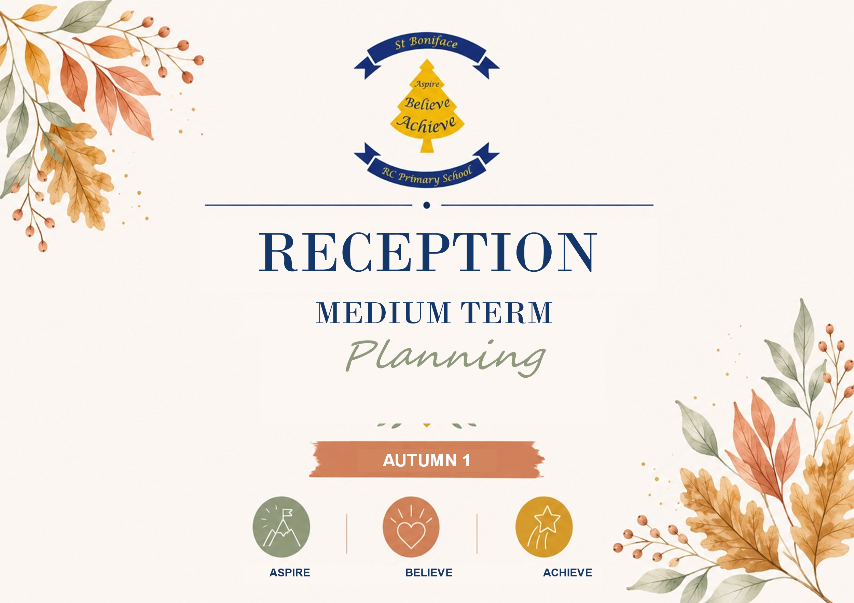
Communication, Language & Literacy.
What do children know now?  Enjoy listening to stories  Pay attention to more than one thing at a time  Joins in with familiar nursery rhymes  Beginning to join in with familiar phrases from a story |  |  |  |  | Enquiry/Hook:  Children to find lots of different coloured pom poms spilt on the floor with a letter from the colour monster asking them to help sort them into the correct coloured jars.
What do children want to find out following the hook (feed into planning)?
Texts/Resources:  Starting School, The Colour Monster, Owl Babies, The Family Book, Why Am I Me? One Family, The Very Helpful Hedgehog, Leaf Man, Fletcher and the Falling Leaves, A Superhero Like You, Real Superheroes, Busy Day Firefighter, The Jolly Postman, When You’re Fast Asleep, Mog and the V.E.T, Your Name is a Song, I am Rosa Parks, Handa’s Surprise. |  |  |  |  | Cross Curricular Links:  PSED – Aware of the boundaries set and of behavioural expectations in the setting, work as part of a group or class, and understand and follow rules, show sensitivity to others’ needs and feelings and form positive relationships with adults and other children, play cooperatively, taking turns with others, explains own knowledge and understanding, and asks appropriate questions of others, confident to speak to others about own needs, wants, interests and opinions  PD – Experiment with different ways of moving, travels with confidence and skill around, under, over and through balancing and climbing equipment,  Literacy - Hear and say the initial sound in words, can segment the sounds in simple words and blend them together and knows which letters represent some of them, enjoy an increasing range of books, gives meaning to marks they make as they draw, write and pain, gives meaning to marks they make as they draw, write and paint.  Maths – Recognise some numerals of personal significance, use everyday language related to time, order and sequence familiar events  UTW – Enjoys joining in with family customs and routines, looks closely at similarities, differences, patterns and change, children know about similarities and differences in relation to places, objects, materials and living things  EAD – Begin to build a repertoire of songs and dances, explore the different sounds of instruments, constructs with a purpose in mind, using a variety of resources, chooses particular colours to use for a particular purpose
Objectives/Skills to cover:
Listen to others 1:1, in small groups and whole class. Enjoy listening to stories and can remember what happens. Listen carefully to rhymes and songs, paying attention to how they sound.
Maintain attention in whole class and small group contexts for a short time.
Engage in story times. Join in with repeated refrains and anticipate key events and phases in stories or rhymes. Respond appropriately when asked e.g., ‘smart sitting on the carpet’.
Follow 1 step instructions e.g., put book-bag in drawer. Understand ‘why’ questions.
Use sentences of 4-6 words. Sing a large repertoire of songs e.g., nursery rhymes or number songs. Begin to use social phrases. Use talk to organise themselves and their play.
Vocabulary:
Listen, reading, wait, turn, story, carpet time, join in, hand up, question, song, rhyme, poem, sitting, listening, joining in, group, book, reading, author, illustrator, instruction, telling, follow, why, question, explain, because, sentence, songs, joining in, rhymes, poems, good morning, good afternoon, school, routine, timetable, home, family, feelings, special, unique, Autumn, hibernation, tree, leaves, season, weather, day, month, today, tomorrow, yesterday, job, community, Africa, globe, world, map, continent country, same, different.
 | Teaching Knowledge/Modelling | Key Questions | Further lines of enquiry | Focus Activities | Independent Activities /Enhancements
Week 1 | Texts to read: Starting School by Allan Ahlberg & Janet Ahlberg  The Colour Monster by Anna Llenas  Owl Babies by Martin Waddell  Go through carpet expectations: good sitting, ears open, looking eyes etc. Create ‘class promises’ together  Discuss daily routine and introduce visual timetable and self registration  Song suggestions: familiar nursery rhyme songs (Twinkle Twinkle, Wheels on the bus etc) | What do you think happens in school?  How did the colour monster feel?  How did you feel when you came to school this morning?  Which new friends have you made?  How do you think the owls feel when they wake up?  How do the owls feel when Mummy comes home?  Why did Mummy owl leave? | Things that make us happy/sad/worried/cross  Strategies to help when us we feel this way – Zones of Regulation  Making friends, taking turns, asking adults for helps when needed | Roll a ball to each other in a circle to learn names  Parachute games e.g. fruit salad  School items sorting activity – offer a range of items and discuss why we might/might not find these in school  Draw a worry tree and add in colour monsters worries from the story. Ask chn to add their own worries to it | Colour/collage/paint your own colour monster according to how you feel today  3 soft toy owls and branch to use as props to retell owl babies  Nursery rhyme sack  Puzzles and board games
Week 2 | Texts to read: The Family Book by Todd Parr  Why Am I Me? By Paige Britt, Sean Qualls & Selina Alko  One Family by George Shannon  Introduce talk partners  Discussion points: Types of family units, diversity, similarities & differences  Song suggestions: familiar nursery rhyme songs (5 cheeky monkeys, humpty dumpty etc) | Who is special to you?  Who lives in your house?  What makes you unique? | Different types of housing  Local environment  Countries around the world  People from different cultures | Share photos from home (Ask parents/carers to send in)  Make a class list of what children do at home with their families  Play Who am I? Give clues, chn to guess who it is | Add loose parts to play dough for chn to create someone special to them (lollipop sticks, buttons)  Draw a portrait of your family  Role play clothes & props for chn to explore different cultural backgrounds  Mirrors and range of different skin toned coloured pencils  Use collage materials to create your house  Pictures of different types of housing in construction area
Week 3 | Texts to read: The Very Helpful Hedgehog by Rosie Wellesley  Leaf Man by Lois Ehlert  Fletcher and the Falling Leaves by Julia Rawlinson & Tiphanie Beeke  Discussion points:: Seasons, weather, daily calendar, signs of Autumn, hibernation  Teach days of the week song  Song suggestions: All the leaves are falling down & five little leaves | What is the weather today?  What day is it today? Yesterday? Tomorrow?  What month is it?  What are the signs of Autumn? | Migrating birds  Wildlife  Harvest | Signs of Autumn scavenger hunt  Discuss how different seasonal weather may affect leaf man  Sort pictures of what you may/may not find during Autumn | Finger print autumn tree  Leaf art - collect and dry fallen leaves to make a collage  Leaf rubbings  Observational paintings  Natural loose parts in play dough – conkers, leaves, acorns, pine cones etc  Non fiction books about Autumn in class library
Week 4 | Texts to read: A Superhero Like You by Dr Singh  Real Superheroes by DK & Julia Seal  Busy Day Firefighter by Dan Green  Discussion points: people who help us, different job roles  Song suggestion: Miss Polly had a dolly | Who helps to keep me safe and healthy?  How can I keep myself safe?  Who helps me at school? Who helps me at home? | Jobs in our local community  Future aspirations  Stranger Danger | Match the job role to the description  Create a class book with a profile on each page about a different job role | Visit from local fire service  Make a thank you card  Firefighter obstacle course – balancing, agility & large scales movements  Props in role play area e.g. uniforms, doctors set, helmet  Emergency vehicles and small world people
Week 5
Week 6 | Texts to read: Your Name is a Song by Jmaila Thompkins-Bigelow  I am Rosa Parks by Brad Meltzer  Handa’s Surprise by Eileen Browne  Discussion points: Black History Month, Rosa Park’s life, inclusive, African culture  Song suggestion: learn a call and response song from Ghana: Che Che Kule | Where is Africa on the world map?  What is a continent? What is a country?  What is the weather like there?  What is the same? What is different? | Anti – bullying  Inclusive and diverse classroom  African art  Animals of Africa | Display a world map and pinpoint on it the places where your children and families originate  Make a display with examples of all the languages children speak and understand  Add instruments to call and response song and perform | Explore and display patterns used in different cultures e.g. Nigerian Kente cloth. Weave patterns with different coloured cloth on the railings or fence  African music & instruments for children to explore  Make and decorate hats, wrist bands etc. in flag colours  Make a rain stick
Links to Year 1:
Develops pleasure in reading, motivation to read, vocabulary and understanding
Understands what they read, in books read independently
Assessment Checkpoints EYFS:
C+L (40-60 months)
Able to follow a story without pictures or props.
Maintain attention, concentrates and sit quietly during appropriate activity
Links statements and sticks to a main theme or intention
Uses talk to organise, sequence and clarify thinking, ideas, feelings and events.
Introduces a storyline or narrative into their play
Evaluation of objectives/next steps/Impact:

Literacy Progression
RECEPTION AUTUMN 1 LITERACY PROGRESSION
Oral language, comprehension, purposeful play and developmentally appropriate early writing
Week | Week 1 | Week 2 | Week 3 | Week 4 | Week 5 | Week 6 | Week 7
Core text & theme | 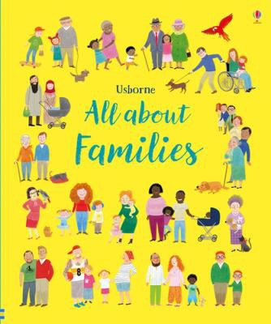  All About Families  Families, belonging & identity |  |  | 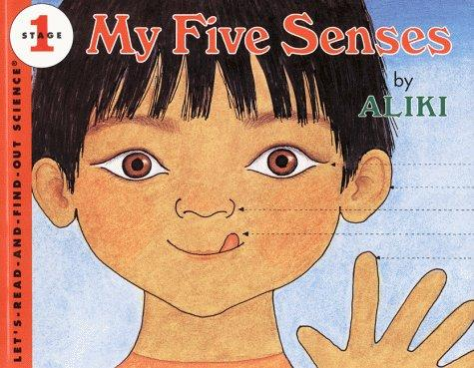  My Five Senses — Aliki  Exploring through the senses |  | 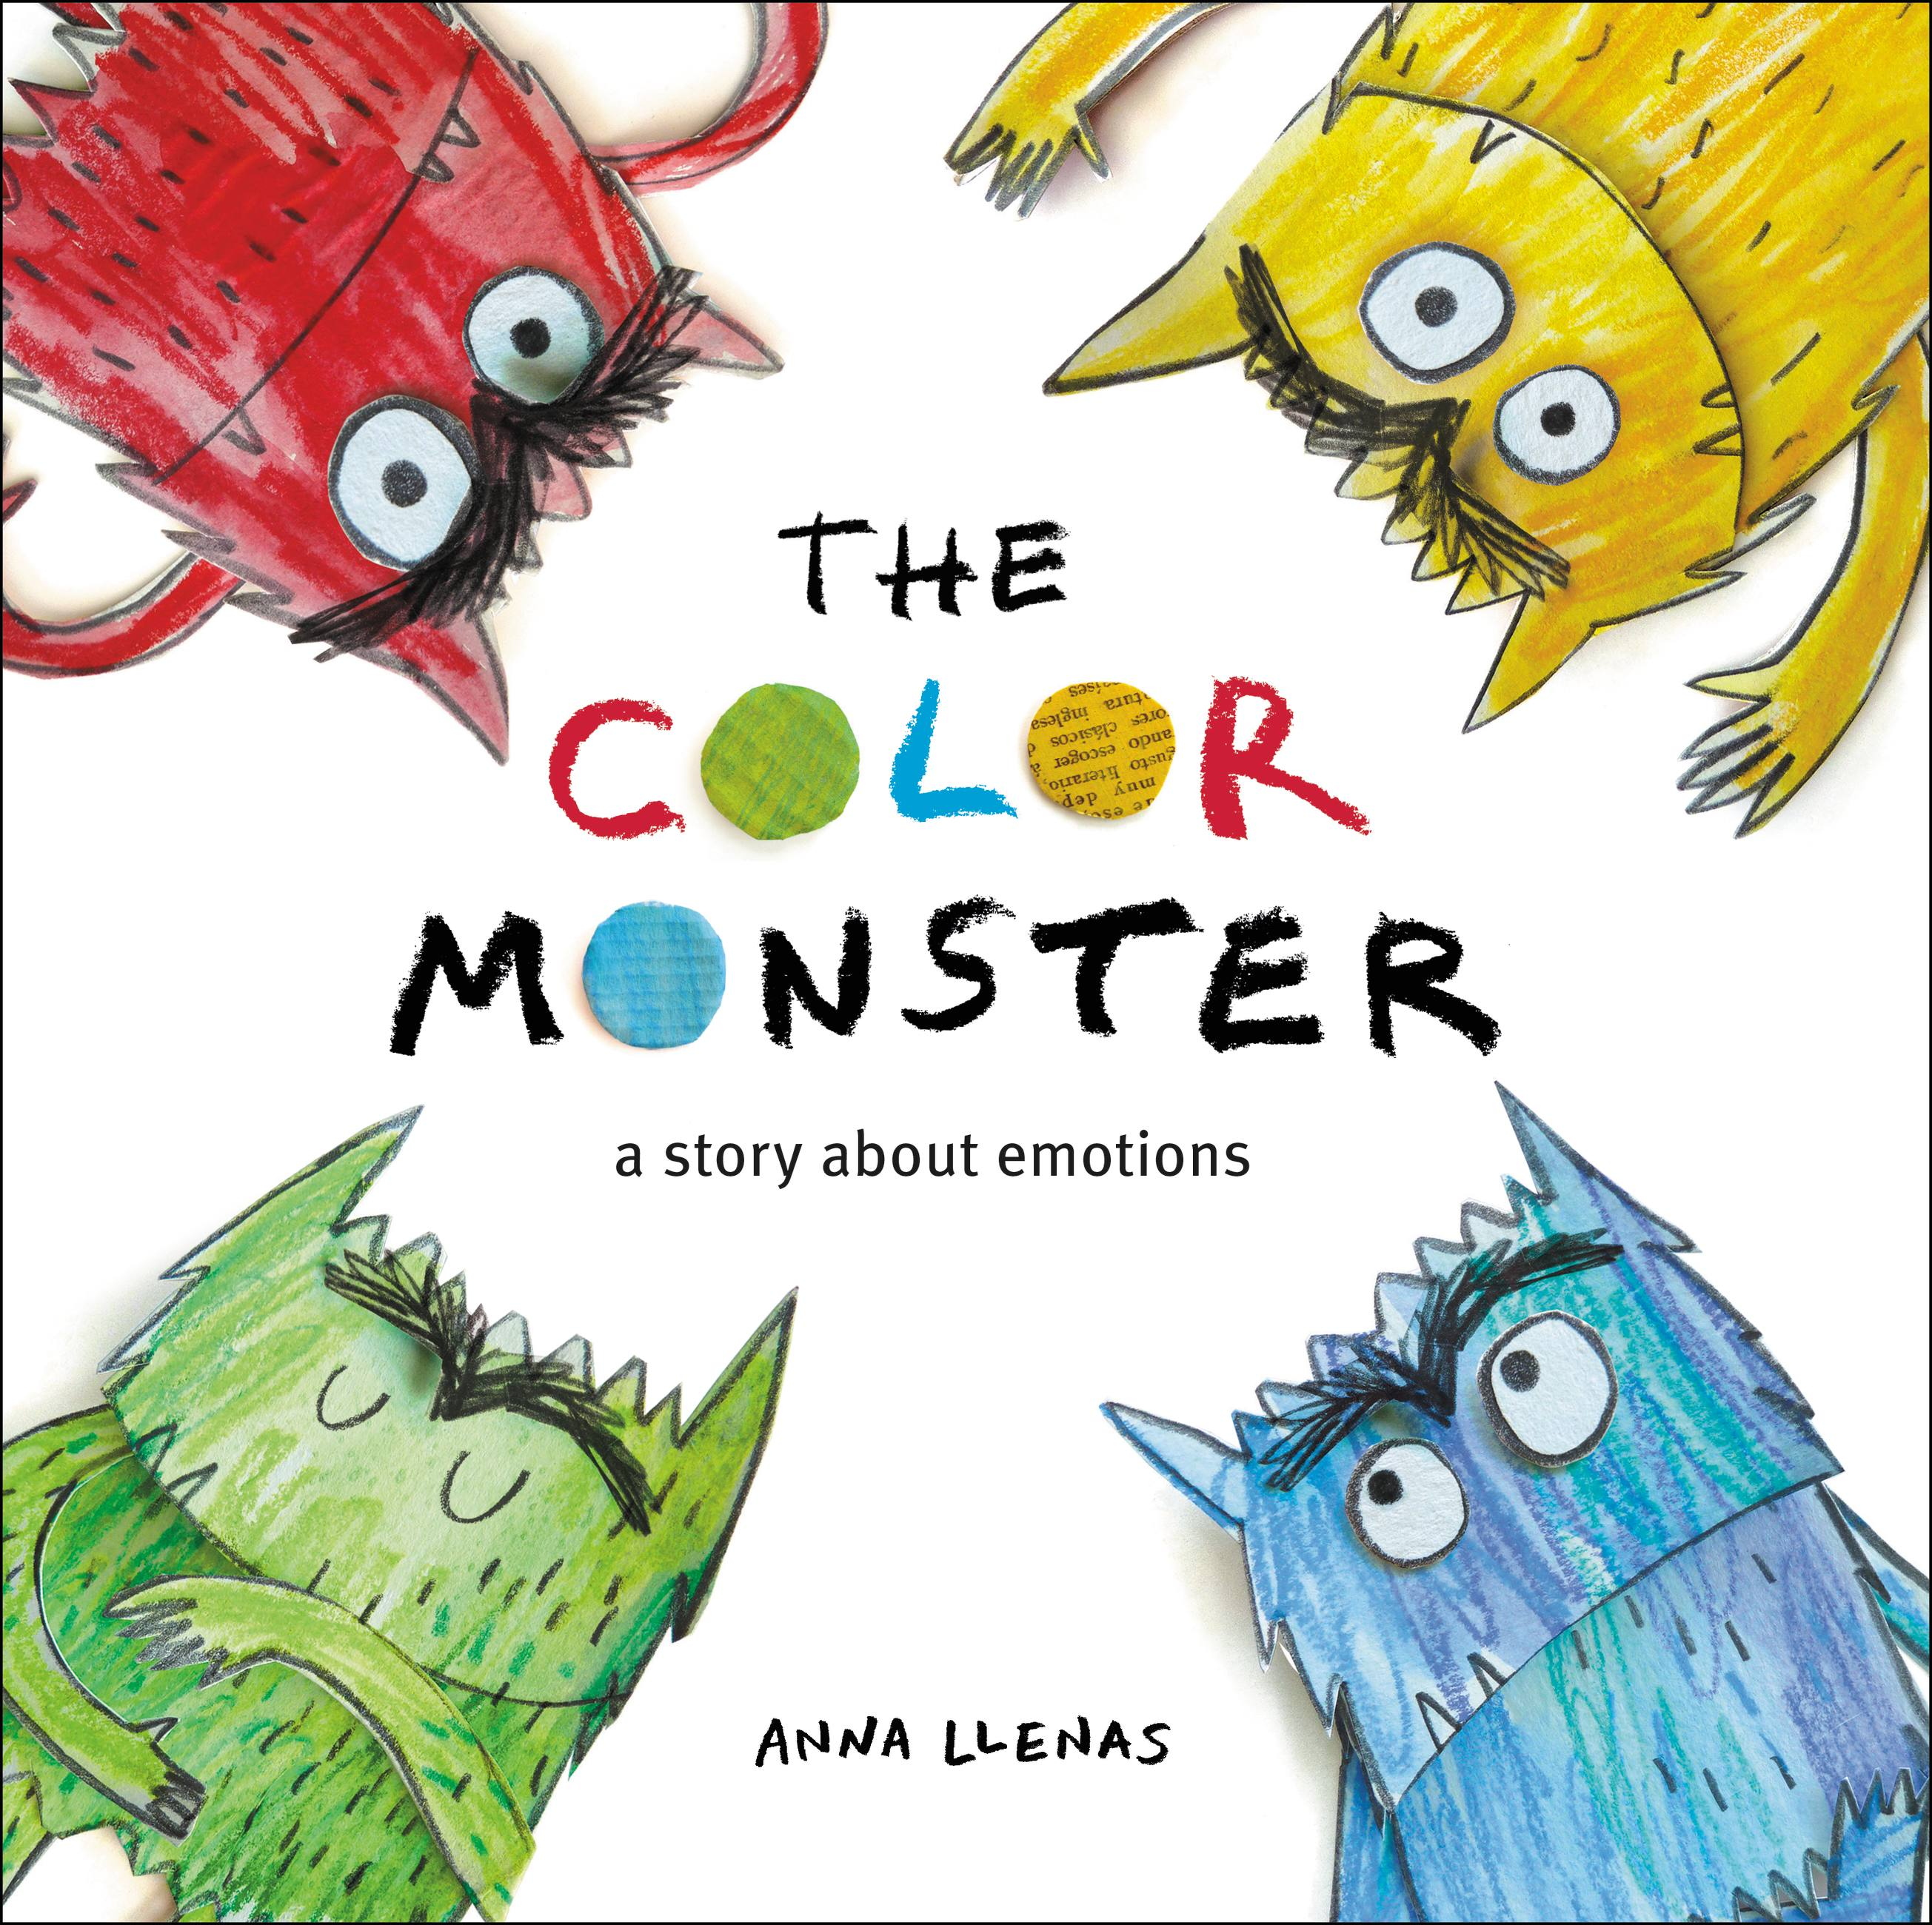  The Colour Monster  Feelings, colour & self-regulation
Pre-teach / book prep | Prepare for belonging  Gather inclusive family photos/figures; check preferred family language; pre-teach family and belong. | Prepare for sharing  Invite an optional family photo; rehearse safe choices: speak, point, draw or ask an adult to share. | Prepare to compare  Select images showing varied families and celebrations; prepare 3-part sequencing cards. | Prepare a senses lab  Set up safe smell, sound, texture and visual objects; check allergies before any tasting. | Prepare to describe  Create paired sensory objects and symbol-supported adjective cards. | Prepare emotions  Provide colour jars, mirrors and emotion cards; establish that colours do not have one fixed meaning. | Prepare regulation talk  Create a feelings toolkit and simple beginning–middle–end story map.
Key vocabulary & language structures | Words & stems  family, belong, home, care; “I am…” “In my family…” | Relationships  parent, carer, sibling, grandparent; “This is my…” | Compare  same, different, celebrate, together; “We both…” “My family…” | Five senses  see, hear, smell, taste, touch; “I use my ___ to ___.” | Describe  rough/smooth, loud/quiet, sweet/sour; “I notice…because…” | Feelings  happy, sad, angry, calm, scared, worried, confused. | Explain & regulate  “I feel…when/because…”; breathe, pause, rest, talk, help.
Listening, attention & comprehension | Attend & respond  Attend to a short shared story with visual support; name people/actions and join repeated language. | Retrieve  Answer who and where questions from illustrations and personal experience; listen to a peer. | Sequence  Order a familiar family event using first, then and finally with pictures or objects. | Use non-fiction  Use illustrations and headings to ask and answer simple questions; follow one-step instructions. | Compare  Listen to two descriptions and offer a relevant similarity or difference. | Retell change  Track the monster’s changing emotions and retell the colour sequence using props. | Listen with empathy  Sequence the emotional journey and respond kindly to another child’s contribution.
Oracy / dictation opportunities | Photo talk & oral rehearsal  Pass a talking object. Adult says a short sentence; children repeat, then adapt one word. Adult scribes exact child language. | Partner rehearsal  Rehearse “This is my…” before sharing. Repeat a modelled sentence in meaningful chunks; no written dictation expected. | Oral sequencing  Retell a family event with picture prompts. Echo first/then/finally sentences and contribute to shared composition. | Mystery sense bag  Describe without naming; peers ask questions. Repeat “I use my ___ to ___” before adult records it. | Sensory expert  Compare findings to a partner. Rehearse a complete observation orally before drawing or adult scribing. | Freeze-frame & hot-seat  Show an emotion through face/body. Echo and adapt “The monster feels ___ because ___.” | Problem-solving circle  Orally rehearse “I feel…because…” and a helpful response; perform the class retelling.
Writing opportunities - two literacy tasks | Task 1 - This is me  Create a self-portrait and name-like marks; explain the marks while an adult scribes the child's spoken introduction.  Task 2 - People who care for me: select/draw familiar people and orally complete “In my family…” | Task 1 - My family page  Draw familiar people and attempt a name or initial sound if ready; adult scribes the child's exact sentence.  Task 2 - Family message: make a card/message using pictures, marks or a name and explain who it is for. | Task 1 - Shared family book  Contribute a drawing, symbol, name or label and orally compose a caption.  Task 2 - Family event sequence: order three pictures and rehearse a first/then/finally account for adult transcription. | Task 1 - Senses hunt  Record discoveries using pictures, symbols, colours or purposeful marks.  Task 2 - My senses page: draw one experience and orally complete “I use my ___ to ___”; add a label or adult-scribed sentence. | Task 1 - Sensory observation  Make a detailed observational drawing and add labels where developmentally appropriate.  Task 2 - Class senses fact page: choose a sensory word/picture and orally compose a fact for adult transcription. | Task 1 - Sort the feelings  Match monsters, colours and emotion words; make a purposeful mark or select a label to show a feeling.  Task 2 - My feeling monster: draw/paint a monster and orally compose “It feels ___ because ___” for adult scribing. | Task 1 - Independent emotion page  Draw or mark an emotional response; attempt a name, initial sounds or caption according to readiness.  Task 2 - Feelings toolkit: create a help card/message showing a regulation strategy and explain how it helps.
Learning outcome | Learning outcome  Attend to shared reading, contribute a word/gesture/phrase and give meaning to a drawing or mark. | Learning outcome  Use a supported sentence about family and listen to another child’s contribution. | Learning outcome  Orally sequence a simple experience and contribute to a shared class family book. | Learning outcome  Name the five senses and orally complete a simple patterned sentence. | Learning outcome  Use precise sensory vocabulary to compose an oral observation and represent it through marks/drawing. | Learning outcome  Name emotions and retell key parts using colour, props and repeated language. | Learning outcome  Explain a feeling using when/because and create an individual emotion response with support.
How to support SEN | Access  Use real objects, family figures, visuals and now/next; accept pointing, signing or one-word responses. | Safe participation  Never require personal disclosure; offer a familiar adult, photo choice and pre-rehearsed sentence stem. | Reduce language load  Use 3-picture sequences, first/then boards, repetition and adult recasting rather than correction. | Multi-sensory access  Offer one stimulus at a time, sensory breaks and alternatives for children with sensitivities/allergies. | Scaffold comparison  Use forced-choice visuals, objects in hand and paired rehearsal before whole-group talk. | Co-regulate  Use emotion symbols, mirrors, colour choices and a calm space; model language without insisting on eye contact. | Flexible response  Allow puppet/visual/AAC responses, repeat the same sentence frame and scribe without over-questioning.
Phonics | Children will begin their Little Wandle Phase 2 phonics journey, developing listening and phonological awareness alongside learning new phonemes and graphemes. They practise oral blending, segmenting and reading simple words using the sounds they have learned. Children begin to apply their phonics knowledge to early writing by practising correct letter formation, making marks, writing graphemes and attempting to spell simple words. Phonics is embedded throughout the day through speaking, listening, reading and writing opportunities, helping children to develop confidence as early readers and writers.
How writing links to KS1 | Foundations for KS1  Listening to a text, oral sentence rehearsal, meaning-making and understanding that marks communicate. | Sentence foundations  Speaking in a complete idea, learning vocabulary and hearing an adult model transcription. | Sequence & composition  Ordering ideas orally before writing; linking events with first, then and finally. | Non-fiction foundations  Using headings/pictures, subject vocabulary and a patterned factual sentence. | Description  Selecting precise adjectives orally before labels and simple sentences in KS1. | Narrative foundations  Character feeling, cause and effect, sequence and oral retelling before written narrative. | Independent composition  Holding an idea, saying it aloud, representing it and rereading/explaining meaning.
Teacher observations / assessment / next steps

Physical Development
What do children know now?  Children can skip, hop, stand on one leg and hold a pose for a game like musical statues.  Children can use large-muscle movements to wave flags and streamers, paint and make marks.  Children are working co-operatively in groups and taking part in circle and team games.  Children are increasingly able to use and remember sequences and patterns of movements which are related to music and rhythm.  Children are beginning to choose how to move along apparatus that is suitable for their skill and ability.  Children are becoming more independent in selecting the right resources to carry out their own plan. For example, choosing a spade to enlarge a small hole they dug with a trowel.  Children are using one-handed tools and equipment, for example, making snips in paper with scissors.  Most children are able to use a comfortable grip with good control when holding pens and pencils, as well as having a preference for which hand to use.  Children are increasingly independent as they get dressed and undressed, for example, putting coats on and doing up zips. |  |  |  |  | Enquiry/Hook:  Teddy Bears picnic – setting the picnic, ensuring they have plates and cutlery and teaching them how to use them, making sandwiches or biscuits for the picnic
What do children want to find out following the hook (feed into planning)?
Texts/Resources:  Starting School, The Colour Monster, Owl Babies, The Family Book, Why Am I Me? One Family, The Very Helpful Hedgehog, Leaf Man, Fletcher and the Falling Leaves, A Superhero Like You, Real Superheroes, Busy Day Firefighter, Postman Pat, When You’re Fast Asleep, Mog and the V.E.T, Your Name is a Song, I am Rosa Parks, Handa’s Surprise. |  |  |  |  | Cross Curricular Links:  PSED – Aware of the boundaries set and of behavioural expectations in the setting, work as part of a group or class, and understand and follow rules, show sensitivity to others’ needs and feelings and form positive relationships with adults and other children, play cooperatively, taking turns with others, explains own knowledge and understanding, and asks appropriate questions of others, confident to speak to others about own needs, wants, interests and opinions  C&L - Listen to others 1:1, in small groups and whole class. Enjoy listening to stories and can remember what happens. Listen carefully to rhymes and songs, paying attention to how they sound.  Maintain attention in whole class and small group contexts for a short time.  Engage in story times. Join in with repeated refrains and anticipate key events and phases in stories or rhymes. Respond appropriately when asked e.g., ‘smart sitting on the carpet’.  Follow 1 step instructions e.g., put book-bag in drawer. Understand ‘why’ questions.  Use sentences of 4-6 words. Sing a large repertoire of songs e.g., nursery rhymes or number songs. Begin to use social phrases. Use talk to organise themselves and their play.  Literacy - Hear and say the initial sound in words, can segment the sounds in simple words and blend them together and knows which letters represent some of them, enjoy an increasing range of books, gives meaning to marks they make as they draw, write and pain, gives meaning to marks they make as they draw, write and paint.  Maths – Recognise some numerals of personal significance, use everyday language related to time, order and sequence familiar events  UTW – Enjoys joining in with family customs and routines, looks closely at similarities, differences, patterns and change, children know about similarities and differences in relation to places, objects, materials and living things  EAD – Begin to build a repertoire of songs and dances, explore the different sounds of instruments, constructs with a purpose in mind, using a variety of resources, chooses particular colours to use for a particular purpose
Objectives/Skills to cover:
Children will further develop the skills they need to manage the school day successfully: lining up and queuing, mealtimes, personal hygiene as well as getting changed for PE, begin to use their core muscle strength to achieve good posture when sitting on the floor or at the table, begin to safely use tools and equipment, children using pencils and other equipment comfortably for them, children making snips in paper either using one hand or two.

Vocabulary:
Line up, wash hands, wait, sit down, carpet time, dinner time, and toilet, sit, sitting up, straight, smart sitting, posture, floor, carpet, table, pen, pencil, scissors, ball, racket, rope, cone, pencils, tools, equipment, safely, hand, scissors, snips, grasp, move, routine, comfortable, hand, grip, hold, marks.

 | Teaching Knowledge/Modelling | Key Questions | Further lines of enquiry | Focus Activities | Independent Activities /Enhancements
Week 1 | Carefully explain some of the rules of lining up and queuing, such as not standing too close or touching others.  Give simple verbal and visual reminders. Class rules  Singing songs about routine and familiar movement rhymes  Walking in the classroom, Faster movements outside  Daily Literacy sessions – teaching pencil grip  Linked books: Starting School, The Colour Monster | How do we line up?  Why is it important not to stand too close to others?  What do you need to remember to do when we line up?  Howe can you move safely? | Taking turns, asking adults for help when needed  People who help us at school and familiarising with the grounds and rooms | Roll a ball to each other in a circle to learn names  Parachute games e.g. fruit salad  Circle games for spatial awareness  Practise changing for PE  Draw a worry tree and ask children to draw their own colour monster and add in a worry. | Non-fiction books on people who help us  Dressing up clothes  Lining up toys for role play  Counting out sets of objects, ordering, sequencing and grouping  Dressing and undressing dolls
Week 2 | Adults to support children to learn the school day and routines – praise and reward children as they develop patience, turn taking and self-control  Model and demonstrate how to use the scissors  Sit with at mealtimes to model appropriate behaviour and sitting. Teach and model how to eat with good manners in a group.  Linked books: Owl babies (sitting and waiting patiently) | What do you need to remember to do when we line up?  What good manners do you know to do at the table? | Healthy eating | Changing for PE  Follow whole school PE programme for Reception (if applicable)  Create a class list of good manners for mealtimes. | Dough with tools and scissors  Clay and tools including safety knives  Board games and puzzles  Role play clothes & props to explore different cultural backgrounds. Home corner using a knife and fork, playdough or real food to cut up, modelling good manners  Use collage materials to create your house – using scissors to cut materials  Pictures of different types of housing in construction area
Week 3 | Adults continuing to support children to learn the school day and routines  Teach and model how to eat with good manners in a group.  Daily Literacy sessions – teaching pencil grip  Linked books: The Family Book, One Family, Leaf Man | Who helps me at school?  Who helps me at home?  How do we eat at the table?  How do we behave at the table? | Autumn – wind, sounds, signs, exploring natural objects  Healthy Autumn recipes | Signs of Autumn scavenger hunt outside  Follow whole school PE for programme for Reception (if applicable)  Small groups in the home corner using a knife and fork, playdough or real food to cut up, modelling good manners | Fingerprint Autumn tree  Leaf art - collect and dry fallen leaves to make a collage  Leaf rubbings  Observational paintings  Natural loose parts in play dough – conkers, leaves, acorns, pinecones etc
Week 4 | Model posture when sitting on the carpet and at the chairs. Give children reminders about posture  Daily Literacy sessions – teaching pencil grip  Linked books: The Very Helpful Hedgehog, Why am I me? A Superhero Like You, Real Superheroes, Busy Day Firefighter | How do we sit on the carpet?  How do we sit on our chairs to ensure we are comfortable?  What can we do if we need more space? | Jobs and occupations – emergency services | Follow whole school PE programme for Reception (if applicable) | Visit from local fire service. Share Busy Day Firefighter by Dan Green  Make a thank you card  Firefighter obstacle course – balancing, agility & large scales movements  Props in role play area e.g. uniforms, doctors set, helmet  Emergency vehicles and small world people
Week 5 | Model using equipment and tools safely – small equipment such as scissors and snips in paper  Daily Literacy sessions – teaching pencil grip | How do we hold small equipment and tools safely?  How do we move when holding tools and equipment?  What are the rules? | Helping others & friendships | Follow whole school PE programme for Reception (if applicable)  Obstacle course outside and in hall | Cutting out shapes  Play follow the leader’
Week 6 | Model using equipment and tools safely – large equipment  Spatial awareness games in hall using mats such as ‘islands’ and ‘sharks’  Daily Literacy sessions – teaching pencil grip  Linked books: Handa’s Surprise | How do we hold large equipment and tools safely?  How do we move when holding tools and equipment?  What are the rules?  How can we make more space?  How do you hold your pencil? | Anti-bullying  Inclusive and diverse classroom  Black History Month | Follow whole school PE programme for Reception (if applicable)  Using and putting mats away safely  Add instruments to call and response song and perform | Weave patterns with different coloured cloth or ribbon on the railings or fence  African music & instruments for children to explore  Make and decorate hats, wrist bands etc. in flag colours  Bikes, balance bikes, wheelbarrows, carts and prams
Links to Year 1:
- are physically active for sustained periods of time
- lead healthy, active lives
Assessment Checkpoints EYFS:
Ongoing checks on how children:
- Before teaching children the correct pencil grip and posture for writing, or how to use scissors and knife and fork - Can children move and rotate their lower arms and wrists independently?
- Hold pencils for writing
- Scissors
- Knives and forks
Evaluation of objectives/next steps/Impact:

Personal, Social and Emotional Development
What do children know now?  Some of the boundaries set at school and at home.  The adults that they can talk to if they need help.  How to select and use activities and resources, with help, when needed.  Developed their sense of responsibility and membership of a community.  Increasingly follow rules, understanding why they are important. Begin to follow school rules more without adult guidance.  Begin to develop ways of being assertive.  Show understanding of how others are feeling.  Talk about their feelings using words such as; happy, sad, cross or worried.  To wash their hands after using the toilet. |  |  |  |  | Enquiry/Hook:  Sit in a circle. Introduce and name a class teddy. Teddy is a bit shy and won’t look at the children. How can we help teddy? Ask him what is wrong. Teddy is a bit worried, do you know why? It is his first day at school. He hasn’t seen you all before and he doesn’t know your names! How can we help teddy? Let’s introduce ourselves by playing the name game. Model saying to teddy “Hello, my name is………, pleased to meet you!” Children take turns to do the same, passing teddy around the circle. Finally, ask teddy how he feels now. Does he feel a bit better now he knows everyone?
What do children want to find out following the hook (feed into planning)?

Texts:  Starting School by Janet & Allan Ahlberg, The Colour Monster by Anna Llenas, The Family Book by Todd Parr, Why am I Me? By Paige Britt  Resources:  Letter logs/tiles, playdough and loose parts, sensory mark-making, scarves and music to sing and dance to, puzzles and board games, turn-taking games, collage, paint, paper plates, mirrors, emotion faces, various skin toned coloured pencils, wool for hair, colour materials in the craft area, small world dolls house, puppets, blank face templates, empty picture frames, cooking in the home corner, role play clothes & props, paper plate faces using different materials, people shaped templates, construction blocks and materials. |  |  |  |  | Cross Curricular Links:  PD – Know and talk about the different factors that support their overall health and wellbeing.  C & L – Understand how to listen carefully and why listening is important  Maths – Experiment with own symbols and marks as well as numerals.  UTW – Talks about members of their immediate family.  Literacy - Learn and use new vocabulary.  EAD – Take part in pretend play. Remember and sing entire songs.  .
Objectives/Skills to cover:
Self-Regulation:
Talk about feelings to trusted adults or special friends.
Express feelings and explain why they feel that way.
Be comforted by adults if upset.
Recognise when a friend is upset.
Managing Self:
Develop an awareness of themselves and form own opinions
Use toilet and wash hands independently.
Use a knife and fork at meal times.
Become more independent at school arrival and home time.
Develop personal, social and emotional skills throughout the Reception year.
Building Relationships:
Listen to the rules and expectations and begin to understand them.
Begin to learn the classroom rules and follow these with some reminders.
Build new positive relationships with pupils and staff in the new setting.
They may begin to play alongside other children if ready.
Learn to share and take turns.
Children will develop their personal, social and emotional skills throughout the Reception year and these skills are taught through significantly adult modelling and guidance. Children will pick up on adults’ language used, vocabulary, mannerisms, tone of voice, verbal and non-verbal communications and therefore adapt these into their own communication.

Vocabulary:
Feelings, emotions, happy, sad, angry, good, bad, upset, sad, feeling, emotion, rules, safety, like, dislike, rules, listening, safe, behaviour, get, book bag, water bottle, pack-up, timetable, toilet, wiping, listening, friend, teacher, peer, class, others, happy, talk, conversation, play, group, roleplay, small world, nicely, turn taking, having a go.
 | Teaching Knowledge/Modelling | Key Questions | Further lines of enquiry | Focus Activities | Independent Activities /Enhancements
Week 1 | Suggested book:  Starting School by Janet & Allan Ahlberg  Knowledge/model/Input:  Discussion about being a good listener – use listening ears  Create a visual timetable  Think about who can help us  Create classroom rules  Ensure children know where to put things and create labels with pictures | Is there anything you are excited about?  Is there anything you are worried about?  Who can you talk to if you are worried?  What do you want to play with? | Asking adults for help when needed  Where to put my things  What happens when  Learning new rules and routines | Roll a ball to each other in a circle to learn names.  Teddy Talk – Teddy wants to know……What is your favourite story/song/food/drink/colour  Names – How many letters in your name? Compare with friends.  Why do you think we come to school? Why do teachers come to school? Chart ideas on large paper.  Parachute games e.g., fruit salad | Letter logs/tiles to make our names  Use playdough to make their names  Sensory mark-making  Singing and dancing together  Puzzles and board games  Turn-taking games
Week 2 | Suggested book:  The Colour Monster Anna Llenas  Knowledge/model/Input:  Introduce a feelings chart and discuss different emotions  Create a worry box or have a buddy system  Zones of Regulation  Circle time – friendly behaviour and making new friends, how do I feel? | How did the colour monster feel?  How did you feel when you came to school this morning?  Which new friends have you made? | Explore the meaning of different types of emotions  Things that make us happy/sad/worried/cross  Strategies to help when us we feel this way – Zones of Regulation  Making friends, taking turns | Draw a worry tree and add in colour monsters worries from the story. Ask children to add their own worries to it  Teddy Talk – Teddy wants to know……What makes you happy/sad/cross? Is it okay to feel this way? | Colour/collage/paint your own colour monster according to how you feel today  Emotion faces – match the feeling to the colour monster  Draw a colour monster and label it  Explore colour in the craft area – how do different colours make you feel?  Pom pom sorting - lots of different coloured pom poms spilt on the floor with a letter from the colour monster asking them to help sort them into the correct coloured jars
Week 3 | Suggested book:  The Colour Monster goes to School by Anna Llenas  Knowledge/model/Input:  Facial expressions, reflection, different situations/scenarios | Which colour monster are you today?  What do different feelings look like? | How do we feel in different situations?  Explore characters in the story and make links with our own emotions | Talk about how we feel in different situations  Create a ‘Today I feel….’ Display using children’s photos  Using mirrors to explore what different feelings look like | Small world dolls house set up with people/characters to act out different emotions  Puppets to role play different situations and feelings  Emotion faces – blank face templates to draw different facial expressions  Mood dancing – Express different feelings by moving according to the music
Week 4 | Suggested book:  The Family Book by Todd Parr  Knowledge/model/Input:  Talk about our family and other families  Make a family vocabulary bank with the words: same, different, unique, special, mum, dad, brothers, sisters, gran, grandad, pets | Who is in your family?  Who is special to you? | Discuss the different types of family in the book  Are all our families the same? What is different about them?  Do you have any pets?  What do you love to do with your family? | Share family photos from home (Ask parents/carers to send in)  Teddy Talk – Teddy wants to know…..Who is in your family? Are all our families the same? | Add loose parts to play dough for children to create their families (lollipop sticks, buttons)  Add picture frames to the home corner – encourage children to draw a portrait of their family do display.  Role-play cooking their family’s favourite meal.  Role play clothes & props for children to explore different cultural backgrounds
Week 5 | Suggested book:  Why am I Me? by Paige Britt  Knowledge/model/Input:  Talk about differences – look at images and portraits drawn. Add additional words to the word bank such as: me, I, you, we, hair, eyes, tall, short  Discuss personal attributes and make a kindness tree | Why are you, you?  Are we all the same, or different? | What does ‘unique’ mean?  What makes you unique? | Share baby photos from home (Ask parents/carers to send in). Discuss how children have changed. What can you do now that you couldn’t do when you were a baby?  Teddy Talk – Teddy wants to know…..Why is it good to be you? | Paper plate faces using different materials  Self-portraits using mirrors and range of different skin toned coloured pencils. Check your eye and hair colour too.
Week 6 | Suggested book:  Why am I Me? By Paige Britt  Knowledge/model/Input:  Discussion about how we are similar and different to characters in the stories we read  Add further words to the word bank: kind, funny, helpful, friend, only one, individual  Celebrate work at the end of the day. Talk about what we have achieved in the day – ongoing for year | What is the same/different about the character in the story?  What would you like to be able to do?  If you could be anything or anyone, what would you be? | Tell me about your friend – what is special about them? Why are you friends?  Isn’t it great that there is only one of you, and only one of me?  What is a ‘talent’? What is your talent? | Talent display/book – Ask everyone about their talents – What are you good at? Or What do you like doing? Children draw themselves doing their talent and compile on a display or in a book. Share everyone’s talents. It doesn’t have to be a hobby, e.g., you could be very kind/helpful/caring, etc.  Teddy Talk – Teddy wants to know……. What is special about your friend? | Build me – Use construction blocks and materials to build yourself. Think carefully about what to use for your head, arms, legs, etc.  People shaped templates – Create your friend and write key words about what makes them special.
Links to Year 1:
PSHE (Personal, Social, Health & Economic) education – Year 1 National Curriculum Pupils should be taught: - Families and friendships: Roles of different people; families; feeling cared for. Safe relationships: Recognising privacy; staying safe; seeking permission. Respecting ourselves and others: How behaviour affects others; being polite and respectful.
Assessment Checkpoints EYFS:
Sustained longer focus at chosen and directed activities, Express their feelings, Manage their own personal hygiene, Begin to find solutions to conflicts and rivalries and suggest other ideas, Remember rules without needing an adult to remind them (most of the time), Be able to share and take turns with minimal adult intervention, Develop confidence in front of larger groups.
Evaluation of objectives/next steps/Impact:

UTW
What do children know now?  Uses all their senses in hands-on exploration of natural materials.  Explored collections of materials with similar and/or different properties.  Talk about what they see, using a wide vocabulary.  Begin to make sense of their own life story and family history.  Show interest in different occupations.  Spent time exploring how things work.  Plant seeds and care for growing plants.  Understand the key features of the life cycle of a plant or an animal.  Show an understanding of the need to respect and care for the natural environment and all living things.  Explored and talked about different forces they can feel.  Talk about the differences between materials and changes they notice.  Developing positive attitudes about the differences between people.  Know that there are different countries in the world and talk about the differences they have experienced or seen in photos. |  |  |  |  | Enquiry/Hook:  An old toy from the past – how did it get here? What does it do? How do you use/play with it? Who would have used it? Do we have anything similar to it now?
What do children want to find out following the hook (feed into planning)?
Texts/Resources:  Starting School, The Colour Monster, Owl Babies, The Family Book, Why Am I Me? One Family, The Very Helpful Hedgehog, Leaf Man, Fletcher and the Falling Leaves, A Superhero Like You, Real Superheroes, Busy Day Firefighter, Postman Pat, When You’re Fast Asleep, Mog and the V.E.T, Your Name is a Song, I am Rosa Parks, Handa’s Surprise. |  |  |  |  | Cross Curricular Links:  PSED – Aware of the boundaries set and of behavioural expectations in the setting, work as part of a group or class, and understand and follow rules, show sensitivity to others’ needs and feelings and form positive relationships with adults and other children, play cooperatively, taking turns with others, explains own knowledge and understanding, and asks appropriate questions of others, confident to speak to others about own needs, wants, interests and opinions  C&L - Listen to others 1:1, in small groups and whole class. Enjoy listening to stories and can remember what happens. Listen carefully to rhymes and songs, paying attention to how they sound.  Maintain attention in whole class and small group contexts for a short time.  Engage in story times. Join in with repeated refrains and anticipate key events and phases in stories or rhymes. Respond appropriately when asked e.g., ‘smart sitting on the carpet’.  Follow 1 step instructions e.g., put book-bag in drawer. Understand ‘why’ questions.  Use sentences of 4-6 words. Sing a large repertoire of songs e.g., nursery rhymes or number songs. Begin to use social phrases. Use talk to organise themselves and their play.  PD - Children will further develop the skills they need to manage the school day successfully: lining up and queuing, mealtimes, personal hygiene as well as getting changed for PE, begin to use their core muscle strength to achieve good posture when sitting on the floor or at the table, begin to safely use tools and equipment, children using pencils and other equipment comfortably for them, children making snips in paper either using one hand or two.  Literacy - Hear and say the initial sound in words, can segment the sounds in simple words and blend them together and knows which letters represent some of them, enjoy an increasing range of books, gives meaning to marks they make as they draw, write and pain, gives meaning to marks they make as they draw, write and paint.  Maths – Recognise some numerals of personal significance, use everyday language related to time, order and sequence familiar events  EAD – Begin to build a repertoire of songs and dances, explore the different sounds of instruments, constructs with a purpose in mind, using a variety of resources, chooses particular colours to use for a particular purpose
Objectives/Skills to cover:
Children talk about members of their family and the relationship to them e.g. Mum, Dad, children know that you can find out information from different sources, children respect special things in their own lives, children learn about the seasons and know it is Autumn, children talk about the seasons and have some understanding about the changes that happen in the world.

Vocabulary:
Family, relationships, Mum, Dad, sister, brother, grandma, grandad, friends, information, books, videos, search, the, now, internet, special, teddy, photo, people, toy, maps, mapping, environment, features, classroom map, local area map, signs, logos, Autumn, day, dark, light, Winter, night, season, Moon, Sun, lighter, darker, shadow

 | Teaching Knowledge/Modelling | Key Questions | Further lines of enquiry | Focus Activities | Independent Activities /Enhancements
Week 1 | Starting school: familiarising with the rooms - walking around and encouraging children to put resources away. Model reading the labels for drawers, belonging and resources  Walks around the building, the outside areas  Refer to classroom maps  Research what is in our local area, features of our local environment  Model respecting our environment – classroom and outdoors  Children joining in with discussions and stories about family. Children focusing on work based on ‘all about me’ and their family and friends.  Linked books: Starting School, The Colour Monster | Where will you find the..?  How can you get to..?  Who will help you?  What is our routine for the day?  What can you see?  Can you describe…?  How can we look after our environment? | Taking turns, asking adults for help when needed  People who help us at school and familiarising with the grounds and rooms | Getting to know you, activities  Drawing maps of the classroom  Walk around the school grounds and identifying features and discussing changes noticed  Class rules for looking after classroom and outdoors | Non-fiction books on people who help us, information books on schools, maps  Dressing up clothes  Lining up toys for role play  Counting out sets of objects, ordering, sequencing and grouping  Drawing pictures of playing in the playground
Week 2 | Discussion on family members, identifying members, pets  Talk about favourite toys at home – compare with old toy from the hook  Make a birthday chart and discuss ages and birthdays, respect for others and their special things  Linked books: The Family Book, One Family, Leaf Man | Who is in this photo?  What could you do when you were a baby?  What did you need help with?  Who is in your family?  What toys do you play with at home? | Family life in other cultures and countries  Jobs and occupations | Baby photos  -Who is who?  Family portraits  Family trees | Playdough faces and people  Sharing board games and puzzles  Role play clothes & props to explore different cultural backgrounds. Home corner using a knife and fork, playdough or real food to cut up, modelling good manners  Use collage and natural materials to create your house – using scissors to cut materials  Dressing and undressing dolls  Pictures of different types of housing in construction area
Week 3 | Continue discussing family members, identifying members, special toys, discussing changes – then and now,  Talk about bedtime routines, seasons  Sing the days of the week, months of the year  Opportunities to explore seasonal natural materials  Linked books: Owl babies | What was it like then?  What is it like now?  What is your favourite time of the day?  How would you feel if you were the owls?  What time do you go to bed?  What do you notice outside – what is happening and why? | Autumn and seasons – wind, sounds, signs, exploring natural objects  Dark and light  Nocturnal animals | Signs of Autumn scavenger hunt outside  Leaf art - collect and dry fallen leaves to make a large-scale collage or scene from Owl Babies  Making a record of the seasons or weather such as a weather chart, seasons booklet etc. | Fingerprint Autumn tree  Leaf rubbings  Observational paintings  Natural loose parts in play dough – conkers, leaves, acorns, pinecones etc  Sorting natural materials
Week 4 | Research different jobs on the internet and in book.  Locate important places such as police station, fire, hospitals etc on a local map, identify logos.  Adults modelling how to find information using a range of sources. Adults giving children access to books to find information.  Linked books: The Very Helpful Hedgehog, why am I me? A Superhero Like You, Real Superheroes, Busy Day Firefighter | What does this person do?  How do they help?  What is special about this job?  Where can you find the...?  What does this mean/say? | Jobs and occupations – emergency services | Write facts and label pictures of emergency services  Make a large-scale town with important places  Identify shop names and brands by logos | Visit from local fire service. Share Busy Day Firefighter by Dan Green  Make a thank you card  Firefighter obstacle course – balancing, agility & large scales movements  Props in role play area e.g. uniforms, doctors set, helmet  Emergency vehicles and small world people
Week 5
Week 6 | Talk about similarities and differences between people and inclusion during circle time  Refer to British values and model sharing and co-operation in play  Discuss how we can we show respect for others through play and conversation  Linked books: Handa’s Surprise | What is similar about…?  What is different about…?  How can we include others? | Anti-bullying  Inclusive and diverse classroom  Black History Month | Play Changing places game  Focus on a person for Black History Month to research – fact file – what are they known for? What makes them important? What do they do? | Weave patterns with different coloured cloth or ribbon on the railings or fence  African music & instruments for children to explore  Make and decorate hats, wrist bands etc. in flag colours  Bikes, balance bikes, wheelbarrows, carts and prams
Links to Year 1:
The Science National Curriculum (2014
Plants: identify and name a variety of common wild and garden plants, including deciduous and evergreen trees, identify and describe the basic structure of a variety of common flowering plants, including trees. Animals including humans: identify, name, draw and label the basic parts of the human body and say which part of the body is associated with each sense. Seasonal Changes: observe changes across the 4 seasons, observe and describe weather associated with the seasons and how day length varies.
The Geography National Curriculum (2014)
Place Knowledge: use basic geographical vocabulary. Geographical Skills and Fieldwork: use locational and directional language to describe the location of features and routes on a map, use aerial photographs and plan perspectives to recognise landmarks and basic human and physical features; devise a simple map; and use and construct basic symbols in a key, use simple fieldwork and observational skills to study the geography of their school and its grounds and the key human and physical features of its surrounding environment.
The History National Curriculum (2014)
Changes within living memory. Significant historical events, people and places in their own locality.

Assessment Checkpoints EYFS (ongoing):

- Begin to talk about members of their immediate family and community.
- Name and describe people who are familiar to them.
- Comment on images of familiar situations in the past.
- Compare and contrast characters from stories, including figures from the past.
- Understand that some places are special to members of their community.
- Recognise that people have different beliefs and celebrate special times in different ways.
- Explore the natural world around them.
- Begin to describe what they see, hear and feel whilst outside.
- Start to recognise some environments that are different from the one in which they live.
- Begin to understand the effect of the changing seasons on the natural world around them.
Evaluation of objectives/next steps/Impact:

EAD – Expressive Art & Design
What do children know now?  Take part in simple pretend play and begin to develop storylines through small-world and role-play experiences. Explore different materials freely and begin to develop their own ideas about what to make. Experiment with colour, texture, shape and different ways of making marks. Begin to use lines and shapes to represent objects and people and add increasing detail to drawings, including facial features. Explore colour mixing and use colour to express ideas and emotions. Listen with increased attention to music and sounds and respond through movement, singing and instruments. Join in with familiar songs and rhymes, remembering words and actions. Begin to explore rhythm, beat, pitch, loud and quiet sounds. Use instruments with increasing control and explore how music and movement can represent characters and stories. |  |  |  |  | Enquiry/Hook:  Sit children in a circle and introduce The Colour Monster by Anna Llenas. Explore the different colours and emotions in the story. Provide coloured scarves and invite children to choose a colour to represent how they are feeling.  Introduce a mirror and encourage children to look closely at their faces and expressions. Introduce Pablo Picasso and explore one of his portraits, discussing the colours, shapes and facial features children can see.  Introduce traditional tales through music and movement, following the Get Set 4 Music programme.
What do children want to find out following the hook (feed into planning)?

What do children want to find out following the hook?
What colours can we see?
Can colours show how we feel?
How can we make different colours?
How can we draw a person?
What shapes can we use to make a face?
How can we show feelings through art?
What sounds can we hear?
How can music tell a story?
How can we use instruments to represent characters?

Texts/Resources:  The Colour Monster – Anna Llenas  Pablo Picasso – selected portrait  Traditional tales and music from Get Set 4 Music  paint, paintbrushes, pipettes, spray bottles, string, sponges, mirrors, paper, card, crayons, pencils, watercolours, loose parts, natural materials, playdough, collage materials, scissors, glue, printing resources, musical instruments, claves, shakers, scarves, puppets and small-world resources. |  |  |  |  | Cross Curricular Links:  PSED – Confident to speak about own needs, wants, interests and opinions and begin to recognise and talk about different emotions.  PD – Shows increasing control when using pencils, paintbrushes, scissors, musical instruments and other tools.  C & L – Maintains attention and listens carefully to stories, rhymes, music and instructions.  Maths – Explores colour, shape, pattern and sorting through creative activities.  UTW – Explores different materials and notices colours, textures and sounds in the environment.  Literacy – Enjoys listening to and talking about stories and rhymes. Gives meaning to marks and begins to represent people, ideas and experiences through drawing and painting.
Objectives/Skills to cover:

Singing familiar songs and rhymes and learning new daily rhymes. Listening carefully to and describing sounds. Exploring beat, rhythm, loud/quiet and fast/slow through music and movement. Exploring and naming colours and experimenting with colour mixing. Exploring different materials and textures. Developing pencil grip and control and creating lines, circles and shapes. Giving meaning to marks and beginning to represent people and facial features. Exploring portraits and the work of Pablo Picasso. Using colour and art to express feelings and emotions. Using a range of tools and materials safely and appropriately. Exploring transient art using loose parts. Developing imaginative play and storylines through traditional tales, small-world and role-play. Exploring instruments and responding to music through movement and dance.

Vocabulary:

Pitch, music, singing, songs, nursery rhymes, actions, listen, loud /quiet / fast / slow, dance, shouting, song words, clap, stamp, move, Jackson Pollock, abstract, colour, work, drink, together, collaborate, splatter, flick, Grip, pinch and flick, tight, loose, hand, lines, circles, shapes, copy, explain, colours, colour names, change, lighter, darker, mix, primary colour, secondary colours, light, dark, paint, painting, colour, choice, splatter, flick, print, paint, choice, hands, feet, fingers, smudge, clear print, materials, textures, fabric, play-dough, natural, soft, hard, bendy, rough, smooth, transient art, loose parts, moveable, creation, colour, shape, patterns, tools, cutting, scissors, care, safety, equipment, snips, small snips, large snips, paper, join in, pretend, role-play, home corner, mums, dads, baby, small world, people, vehicles, cars, recreate, represent, shops, schools.
Specific vocabulary:

Art:
colour, red, yellow, blue, green, orange, purple, light, dark, mix, paint, brush, draw, mark, line, circle, shape, portrait, artist, Picasso, face, eyes, nose, mouth, ears, hair, expression, emotion, happy, sad, angry, worried, calm, texture, soft, hard, rough, smooth, pattern, collage

Music:
music, sound, listen, loud, quiet, fast, slow, beat, rhythm, pulse, clap, tap, shake, sing, song, rhyme, instrument, movement, dance, character, traditional tale

Creative/Role-play:
pretend, role-play, story, character, prop, imagine, create, make, build, represent

 | Teaching Knowledge/Modelling | Key Questions | Further lines of enquiry | Focus Activities | Independent Activities /Enhancements
Week 1 | Suggested book:  The Colour Monster – Anna Llenas  Knowledge/model:  Teach and revisit the names of colours through the story, songs and rhymes.  Talk about the different emotions represented by the colours.  Model how to access and use creative resources independently.  Model using paintbrushes, fingers, sponges and other tools safely.  Explore colour mixing. | What colour is this?  How does this colour make you feel?  What happens when we mix colours?  What can you use to paint?  Where can you find the resources you need? | Colours in the environment and colours linked to emotions. | Colour hunt.  Colour sorting and matching.  Colour mixing.  Choose colours to represent different emotions.  Colour songs and rhymes. | Colourful loose parts.  Paint and draw a colour monster.  Coloured playdough.  Colour sorting.  Colourful materials in role play.
Week 2 | The Colour Monster – Anna Llenas  Knowledge/model:  Introduce Pablo Picasso and look closely at a selected portrait.  Talk about facial features, shapes and colours.  Use mirrors to encourage children to look carefully at their own faces.  Model drawing a face using circles, lines and shapes and adding details. | What can you see in Picasso's portrait?  What shapes can you see?  What features can you see on the face?  How can we show that someone is happy?  What colours would you choose?  What makes your face special? | Explore how facial expressions can show different emotions. | Look closely at Picasso's portrait.  Self-portraits using mirrors.  Create Picasso-inspired portraits.  Draw different facial expressions.  Talk about emotions. | Mirrors in the creative area.  Portrait drawing station.  Playdough faces.  Loose-parts faces.  Display Picasso's portrait for children to revisit.
Week 3 | The Colour Monster – Anna Llenas  Knowledge/model:  Explore different materials and textures.  Model vocabulary such as soft, hard, rough, smooth, bumpy and fluffy.  Demonstrate how materials can be joined, arranged and changed.  Introduce collage and transient art using loose parts. | How does it feel?  Can you describe the texture?  Which materials could you use?  How can we join these materials?  What could you make? | Textures and materials found in the natural and built environment. | Texture exploration.  Autumn/nature walk.  Collect natural materials.  Sort materials by texture.  Create collages.  Transient art using loose parts and frames. | Texture baskets.  Natural loose parts.  Fabric and paper scraps.  Playdough.  Transient art frames.  Tweezers and small loose parts.  Loose parts for mark-making and creating pictures.
Week 4 | Suggested book:  The Colour Monster – Anna Llenas  Knowledge/model:  Revisit colour and emotions.  Model how artists can use colour, lines and marks to show feelings.  Explore light and dark colours.  Model different types of marks and how they can represent movement or emotions. | Which colours are light?  Which colours are dark?  What colour could show happiness?  What marks could show excitement?  What marks could show sadness?  How does your picture make you feel? | How colour, line and movement can communicate emotions. | Emotion painting.  Light and dark colour sorting.  Colour mixing.  Painting to music.  Draw marks to represent different emotions.  Collaborative emotion artwork. | Black and white paper.  White chalk.  Dark/light paint.  Emotion cards.  Mirrors.  Colour mixing station.  Different sized brushes.
Week 5 | Suggested book:  The Colour Monster – Anna Llenas  Knowledge/model:  Follow Get Set 4 Music – Traditional Tales.  Explore how music can represent characters and stories.  Model listening carefully and responding to music through movement.  Explore beat, rhythm, loud/quiet and fast/slow.  Continue to introduce and practise familiar daily rhymes. | What can you hear?  Is the music fast or slow?  Is it loud or quiet?  Can you copy the beat?  Which instrument could make that sound?  How does the music make you feel?  How could we make music for a character? | How music, movement and instruments can help tell a story. | Traditional tale music activities.  Instrument exploration.  Echo clapping and rhythms.  Move like different story characters.  Use scarves to respond to music.  Sing familiar rhymes with actions.  Create sounds for characters or story events. | Musical instruments trolley.  Claves, shakers and percussion.  Traditional tale props.  Puppets.  Small-world traditional tale resources.  Scarves for movement.  Rhyme sack and props.  Listening station.
Week 6 | Suggested book: The Colour Monster – Anna Llenas  Knowledge/model: Continue to develop children's creative ideas through colour, portraiture, music, movement and imaginative play. | What colours will you choose?  What are you going to create?  Can you tell me about your picture?  How have you shown the person's feelings?  What instrument could represent your character?  Can you act out part of the story?  What happens next? | Children's own ideas, interests and ways of representing people, feelings and stories. | Independent self-portraits.  Picasso-inspired portrait exploration.  Create portraits showing different emotions.  Traditional tale role-play.  Use instruments to accompany a story.  Create props for traditional tales.  Continue familiar songs and rhymes. | Portrait area with mirrors.  Creative choice station.  Loose parts/transient art.  Colour mixing.  Musical instruments.  Traditional tale small world.  Role-play props.  Rhyme story basket.  Children's artwork displayed and discussed.
Links to Year 1:

Art and Design – Year 1 National Curriculum: Pupils should be taught to use a range of materials creatively, develop ideas through drawing, painting and sculpture, and explore colour, pattern, texture, line, shape, form and space.

Music – Year 1 National Curriculum: Pupils should be taught to use their voices and instruments creatively, listen and respond to music, and experiment with, create, select and combine sounds.

Assessment Checkpoints EYFS:

Explores and experiments with different materials and textures.
Uses simple tools and techniques with increasing control.
Creates simple representations of people, objects and experiences.
Begins to draw faces with recognisable features.
Uses colour to represent ideas and emotions.
Explores and mixes colours.
Responds to music through movement, singing and instruments.
Joins in with familiar songs and rhymes.
Explores and describes different sounds.
Uses props and resources to develop imaginative play and storylines.

Evaluation of objectives/next steps/Impact:

Mathematics
What do children know now?  Children recognise small quantities without needing to count each object, particularly quantities within 3, and begin to understand that the same quantity can look different when arranged in different ways. They can count objects using one-to-one correspondence and understand that the last number said tells us how many objects are in a set. Children are beginning to understand that numbers are made up of smaller parts and can recognise different ways of making 3 and 4. They begin to compare groups of objects by looking and using mathematical language such as more, fewer and the same. Children are beginning to use number names in the correct order and understand that each number represents a quantity. They develop confidence in talking about what they notice, explaining their mathematical thinking and representing numbers using objects, fingers, marks and pictures. |  | Enquiry/Hook:  Read 10 Little Robots together. Encourage children to look carefully at the illustrations and notice how many robots they can see.  Pause throughout the story to encourage children to notice quantities rather than immediately counting.  Provide a collection of small robots, cubes or counters for children to recreate groups from the story.  Ask children to:  Notice how many robots they can see.  Show the number using their fingers.  Make the same amount using cubes/counters.  Explore what happens when a robot joins or leaves.  Compare two groups of robots.
What do children want to find out following the hook (feed into planning)?

How can I know how many robots there are without counting?
How can I show a number in different ways?
How do I know how many there are altogether?
What happens when one more robot joins?
What happens when one robot goes away?
How can we make 3 or 4 robots in different ways?
How can we tell which group has more or fewer?
Can two groups have the same number?

Texts/Resources:  10 Little Robots  Small-world robots, cubes, counters, natural objects, five frames, ten frames, dot cards, dice, dominoes, number cards, numeral cards, counting objects, hoops, sorting trays, pegs, multilink, Numicon, balance scales, puppets, soft toys and loose parts. |  | Cross Curricular Links:  PSED – Confident to contribute ideas and talk about their mathematical thinking. Take turns and cooperate with others during mathematical games.  PD – Develop increasing control when handling small objects, counters, cubes, pegs and other mathematical resources.  C & L – Maintains attention during mathematical stories and activities. Listens to and follows instructions. Uses mathematical vocabulary to explain ideas.  Literacy – Enjoys and responds to mathematical stories. Talks about illustrations and uses language to describe what they notice.  UTW – Notices numbers and quantities in the environment. Uses counting in everyday routines and real-life situations.  Expressive Arts and Design – Represents quantities using drawing, construction, loose parts and creative materials.
Objectives/Skills to cover:

Subitise quantities within 3.
Recognise quantities without counting.
Recognise quantities in different arrangements.
Count objects using one-to-one correspondence.
Understand that the last number counted tells us how many there are altogether.
Develop understanding of the order of number names.
Understand that rearranging objects does not change the quantity.
Explore the composition of 3 and 4.
Recognise that numbers can be made from smaller parts.
Represent numbers using fingers, objects, pictures, marks and numerals.
Compare groups of objects by looking.
Use the language more, fewer and the same.
Begin to explain mathematical thinking.
Apply number knowledge through songs, rhymes, stories and everyday experiences.
Develop confidence when talking about number and quantity.

Vocabulary:
Number:
number, numeral, one, two, three, four, five, count, counting, amount, quantity, altogether

Subitising:
see, notice, recognise, how many, without counting, pattern, arrangement

Counting:
count, touch, move, one-to-one, number names, first, next, last, altogether

Composition:
part, whole, make, made of, split, combine, together, altogether

Comparison:
more, fewer, same, equal, compare, bigger, smaller, greater, less

General:
group, set, match, sort, another, one more, one less, how many, different, same

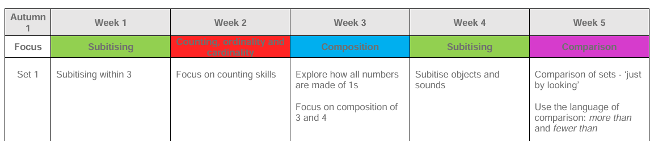
Week 6 | Consolidation
Links to Year 1:
Mathematics – Year 1 National Curriculum: Pupils should be taught to count, read and write numbers, identify one more and one less, represent numbers using objects and pictorial representations, compare and order numbers, and use mathematical language such as more, fewer, less and equal to.

Assessment Checkpoints EYFS:
- Assessment Checkpoints EYFS:
- Subitises quantities to 3.
- Counts objects accurately using one-to-one correspondence.
- Understands that the last number counted tells how many.
- Explores different ways of making 3 and 4.
- Compares groups using more, fewer and the same.
Evaluation of objectives/next steps/Impact:

