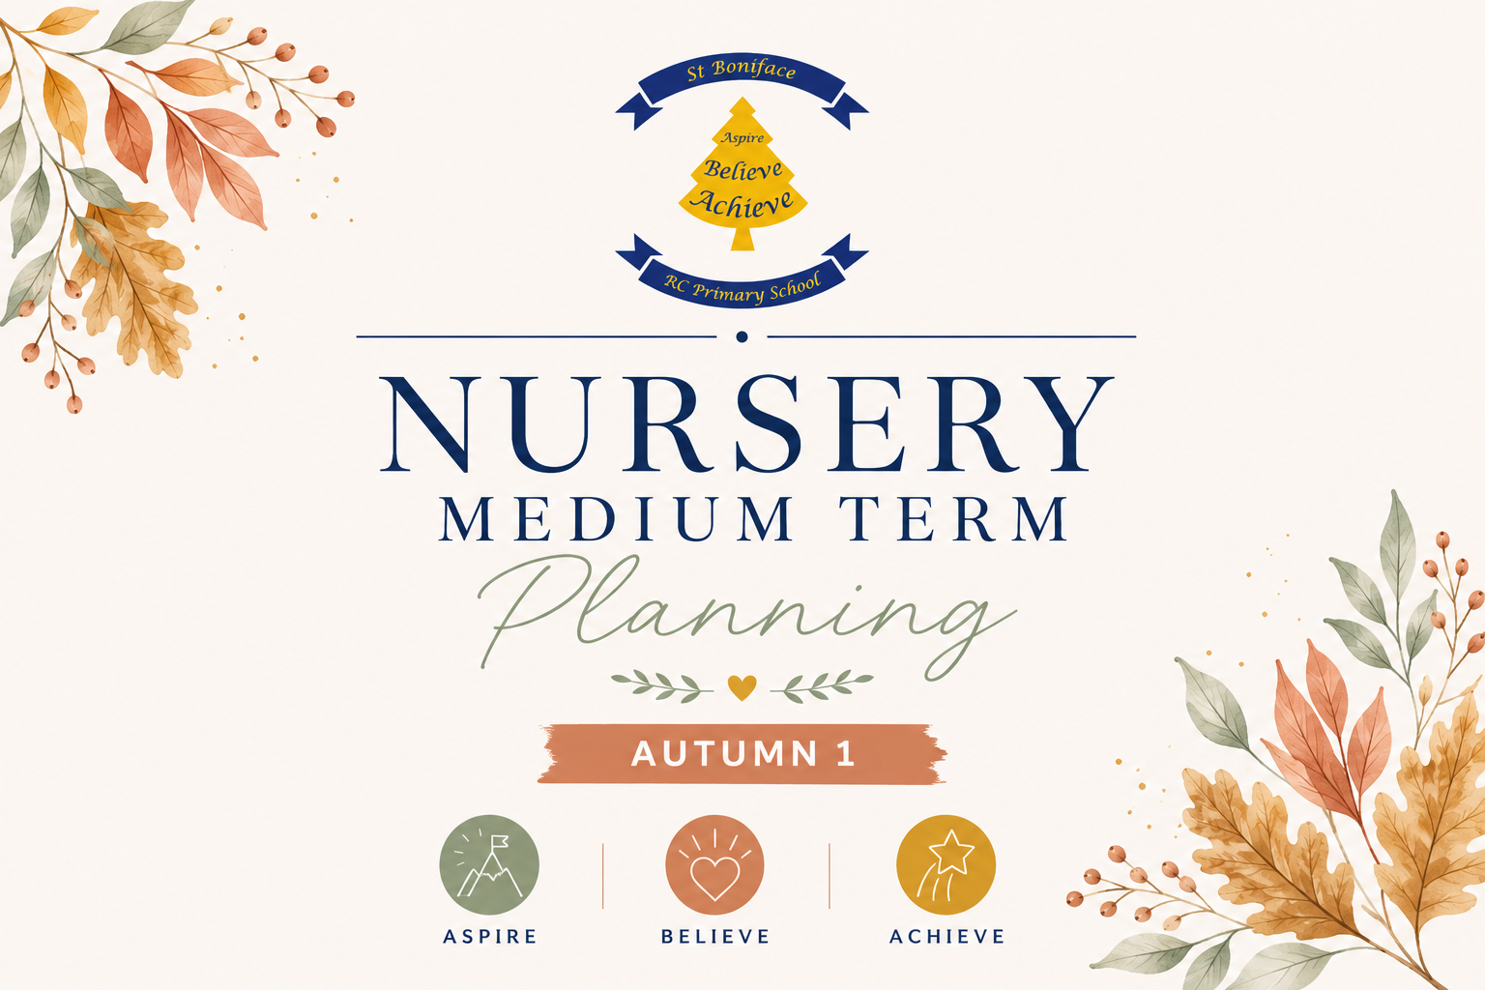
Communication & Language
What do children know now?  Communicate through verbal and non-verbal means, understand simple instructions, say how they are feeling using words as well as actions, listen to simple stories and understand what is happening with the help of pictures, understand longer sentences (3,4 words), understand more words than they can say (between 200-500 words), understand simple questions such as ‘Where’ or ‘What’. |  |  |  |  | Enquiry/Hook:  Introduce a soft toy e.g. Patariki the Penguin (class CST mascot). Place the penguin in a different area each day and encourage the children to locate him (to get used to their surroundings) “Where is Patariki playing today?”  Penguin asks the children questions about themselves throughout the half term:  - What is your name?  - Who is in your family?  - What makes you special?  - What do you like to play with?  - How are you feeling today?
What do children want to find out following the hook (feed into planning)?
Who am I? Who is in my family? What makes everyone different? What do I like? What can I do? How have I changed? Who helps me? Where do I belong?

Suggested Texts:  I’m Starting Nursery, The Family Book, Kipper’s Birthday, Can I Play? Shh Quiet, Only One You, Hello Autumn, The Leaf Thief, Gruffalo Explorers: The Gruffalo Autumn Nature Trail - Julia Donaldson, We’re Going on a Leaf Hunt, Room on the Broom, The Pumpkin who was afraid of the Dark  Resources:  Family photographs  Baby photographs  Mirrors  Class mascot  Emotion cards  Name cards  Family role-play resources |  |  |  |  | Cross Curricular Links:  PSED –  - Talk about themselves and their families.  - Build positive relationships.  - Express feelings.  - Develop confidence to speak in groups.  - Develop independence in routines.  PD –  - Learn body movements through action songs.  - Develop fine motor skills through name mark-making.  - Self-care routines.  Literacy –  - Recognise own name.  - Begin to write own name.  - Enjoy sharing books.  - Develop book handling.  - Hear rhyming words.  - Begin listening to initial sounds.  Maths –  - Count family members.  - Compare heights.  - Explore birthdays and age.  - Notice patterns.  - Use positional language  UTW –  - Learn about family traditions.  - Notice similarities and differences.  - Explore homes.  - Discuss where we live.  - Learn about people who help us.  EAD –  - Self-portraits.  - Family paintings.  - Favourite songs.  - Role play home corner.  - Small world family play.
Objectives/Skills to cover:
Listening: Beginning to listen to stories and nursery rhymes, beginning to listen to instructions given, listens during adult guided activities.
Attention: Focusing on an activity of my own choice for a short period of time, beginning to show attention to the adults in my setting.
Responding: Points to objects upon request, beginning to join in with adult guided activities with support from an adult, follows one key word instructions.
Understanding: Recognises and points to objects that are spoken to me. Understands 1 key word instructions e.g. stop, drink.
Speaking: Links words together when speaking, developing more speech sounds and pronunciation of sounds, use words to begin to communicate my needs.
Communication and Language is developed throughout the year through;
- High quality interactions.
- Daily snack and chat discussions.
- Learning new vocabulary and its meaning.
- Using new vocabulary in a range of contexts.
- Using new vocabulary in conversations and discussions – with teachers and peers.
- Learning new rhymes, poems and songs and repeating these.
- Wellcomm Interventions.
Vocabulary:
Name, Family, Mummy, Daddy, Brother, Sister, Grandma, Grandad, Friend, Home, Nursery
Feelings, Happy, Sad, Excited, Worried, Kind, Because
Sharing, Listening, Talking, Favourite, Same, Different
Body, Face, Eyes
Hair, Hands, Feet, Smile, Help

 | Teaching Knowledge/Modelling | Key Questions | Further lines of enquiry | Focus Activities | Independent Activities /Enhancements
Week 1 | Focus: Myself  Linked books: I’m Starting Nursery by Campbell Big Steps (Author), Marion Cocklico (Illustrator)  All are Welcome.  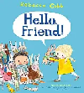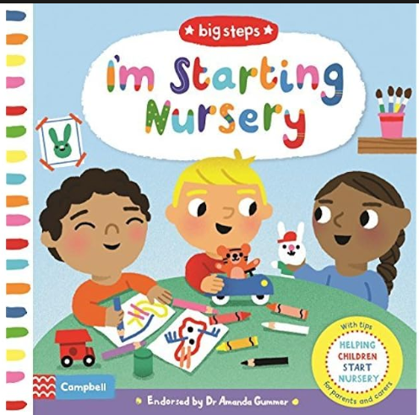  Model introducing yourself.  "I am Miss ____. My favourite colour is..."  (Model answering simple questions)  Introduce visual timetable.  Daily songs:  Hello Song, Heads, Shoulders, Knees and Toes.  Carpet time expectations, listening to others, hands up.  Story time, discussions with adults in nursery.  Asking and encouraging children to answer questions either verbally or physically.  Giving children lots of opportunities to talk during carpet time, group tasks  Observations of children playing in provision every day, encourage more reluctant children to talk. | What is your name?  Can you tell me about yourself?  How are you feeling today?  Where is your peg?  Who is sitting next to you?  What would you like to play with? | Sharing  Friendship  Being brave and kindness  Our daily routine and expectations.  Starting Nursery  Belonging | Sound walks - outside and inside – wind, cars, talking – sound walk.  Look for logos and signs around the Nursery. What do they mean?  Pass the teddy and say your name.  Find your photograph for signing in.  Decorate name card.  Sharing weekend news  Set up a baby clinic. | A range of activities for the children to choose from.  Mirrors,  Photo display  Home corner  Small world families  Mark-making with name cards  Puzzles and board games  Access to water and sand play.  Listening to calming music and nursery rhymes occasionally during play.
Week 2 | Focus: My Family  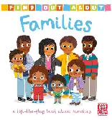  Linked books: The Family Book by Todd Parr, Kipper’s Birthday by Mick Inkpen, Love makes a family.  Talk about different families.  Model respectful language.  Share your own family photograph.  Encourage children to talk about home.  Showing children where things belong, modelling tidying away and listening to instructions  Daily and weekly songs, rhymes, music and stories shared.  Song suggestions: Tommy Thumb, Frere Jacques | Who is special to you?  Who lives in your house?  What makes you unique?  What happens when it is your birthday?  Who helps me at school? Who helps me at home?  What do you like doing together as a family?  How are our families the same/different? | Similarities and differences between each other  People from different cultures  Celebrations. | Introduce Birthday hat for special times and badges.  Sing to the child on their special day.  Family photo discussion  Draw your family  Birthday role play set up.  Home corner conversations  Class photo album. | A range of activities for the children to choose from, adults conversing with children such as:  Draw or paint a picture of your family  Home Corner  Role play clothes & props for children to explore different cultural backgrounds.  Write birthday cards/invitations  Create a cake.
Week 3 | Fucus: Autumn  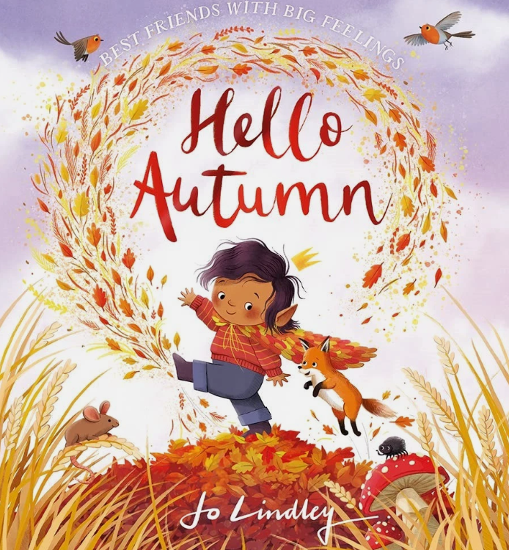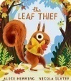  Linked books: Hello Autumn by Jo Lindley  The Leaf Thief by Alice Hemming and Nicola Slater  Discussion points: Seasons, weather, signs of Autumn  Teach days of the week song  Daily and weekly songs, rhymes, music and stories shared. Song suggestions: Incy Wincy Spider, Dingle Dangle Scarecrow | What is Autumn?  What is the weather today?  What day is it today?  What are the signs of Autumn?  What will you choose to play with today? | Wildlife  Harvest | Signs of Autumn Walk and scavenger hunt.  Autumn Leaf Crowns  Make a vocabulary bank for Autumn words  Sorting leaves into colours  Refer the days of the week and sing daily at group times  Children to find teddy amongst the leaves – mark on a simple map where he was found.  Refer to the visual timetable, days of the week  Sharing weekend news | A range of activities for the children to choose from, adults conversing with children such as:  Finger print Autumn tree.  Autumn tuff tray to explore – leaf rubbings, tracing and charcoal  Non- fiction books about Autumn in class library.  Children having access to a variety of texts.  Clipboards, paper, pencils, making marks in mud and finger painting.
Week 4 | Focus: My Senses  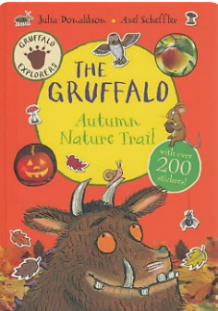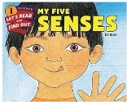  Linked books: Gruffalo Explorers: The Gruffalo Autumn Nature Trail - Julia Donaldson  We’re Going on a Leaf Hunt by Steve Metzger  Introduce -Our 5 senses  Observations/scribing of children on the leave hunt and any comments.  Work for Learning lockers.  Discussion points: Autumn colours  Song suggestion: All the Leaves are Falling | What will we find outside?  What is the weather like?  What can you see/hear/feel/smell/touch?  What colours can you see?  What is today?  What will you choose today?  What did you do at the weekend? | Wildlife  Food in the garden – us or animals?  Minibeasts | Continue to add to the vocabulary bank for Autumn words  Go on a Leaf Hunt.  Collect a range of leaves  Create a large-scale colour leaf rainbow  Reading a selection of Autumn poems  Leaf rubbing.  Tell me one thing you can see, smell, hear, touch and taste. | A range of activities for the children to choose from, adults conversing with children such as:  Autumn tuff tray – leaves to match colour names.  Non- fiction books about Autumn in class library.  Children having access to a variety of texts.  Clipboards, paper, pencils, making marks in mud and finger painting. Colour charts and posters. Organising toys and resources into colours with labels.  Bug boxes, magnifiers, paper.
Week 5 | Focus: My Body  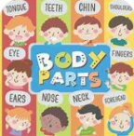  My Amazing Body - by Misio Publishing  Talk about similarities and differences.  Introduce body vocabulary.  Use mirrors.  Model describing appearance respectfully  What makes me unique.  Song suggestions: Miss Polly had a Dolly. | What colour are your eyes?  What colour is your hair?  How tall are you?  Can you find someone the same size as you?  What makes you special?  Can you find someone with the same eye colour? | Body parts  Differences  Respect  Identity  Individuality | Self portraits  Paper plate face  Measure heights  Mirror drawing  Body part songs  Label body parts  Count the number of different body parts.  Name what the function of the body parts. | Access to Mirrors  Paints  Loose parts faces  Playdough faces  Body puzzles  Mark making
Week 6 | Focus: Feelings  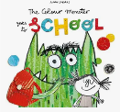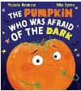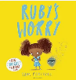  The Colour Monster starts School  The Pumpkin who was afraid of the Dark by Michelle Robinson  Ruby’s Worry  Model naming feelings.  Use emotion cards.  Discuss strategies for calming down.  Role-play emotions.  Giving children lots of opportunities to talk about how the are feeling.  Song suggestion: Hickory, Dickory Dock, 5 Little Ghosts | What do you like/dislike about the story?  Are you afraid of anything?  How are you feeling?  Why do you feel that way?  What makes you happy?  Who can help you? | Light and dark  Feelings  Emotions  Friendship  Kindness  Helping others | Observe/identify children who may require speech/intervention  Make a list of ingredients for a witches’ potion suggest a different ingredient around the circle  Making lanterns to help pumpkin see in the dark.  Sharing weekend news, how did you feel?  Feelings chart  Emotion sorting  Social stories on emotions. | A range of activities for the children to choose from, adults conversing with children such as:  Puppets, bugs, spiders, spooky stories.  Making potions with coloured water and potion bottles.  Exploring pumpkins and seeds.  Make a seed collage.  Listening to calming music and favourite rhymes during play activities – how do you feel listening to this music  Glitter collages and mark making on pumpkins.  Emotion mirrors  Feelings playdough mats  Books  Calming basket
Assessment Checkpoints EYFS:
C+L (3 and 4-year-olds)
Listening: Beginning to listen to stories and nursery rhymes, beginning to listen to instructions given, listens during adult guided activities.
Attention: Focusing on an activity of my own choice for a short period of time, beginning to show attention to the adults in my setting.
Responding: Points to objects upon request, beginning to join in with adult guided activities with support from an adult, follows one key word instructions.
Understanding: Recognises and points to objects that are spoken to me. Understands 1 key word instructions e.g. stop, drink.
Speaking: Links words together when speaking, developing more speech sounds and pronunciation of sounds, use words to begin to communicate my needs.
Reception Expectations:
Listening, Attention and Understanding • Listen attentively and respond to what they hear with relevant questions, comments and actions when being read to and during whole class discussions and small group interactions. • Make comments about what they have heard and ask questions to clarify their understanding. • Hold conversation when engaged in back-and-forth exchanges with their teacher and peers.
Speaking • Participate in small group, class and one-to-one discussions, offering their own ideas, using recently introduced vocabulary. • Offer explanations for why things might happen, making use of recently introduced vocabulary from stories, non-fiction, rhymes and poems when appropriate. • Express their ideas and feelings about their experiences using full sentences, including use of past, present and future tenses and making use of conjunctions, with modelling and support from their teacher.
Evaluation of objectives/next steps/Impact:

PD – Physical Development
What do children know now?  Gross Motor:  Gaining more control of their whole body, fitting themselves into spaces, starting to kick/throw/catch balls, build independently with a range of appropriate resources, sit on a tricycle or riding a scooter, walking/running/jumping/climbing with more confidence.  Fine Motor:  May be able to do own zip and pour drinks with more control, start to dress and undress themselves, start eating independently with a knife and fork. |  |  |  |  | Enquiry/Hook:  Place Patariki the penguin in a different area each day and encourage the children to locate him (to get used to their surroundings) “Where is Patariki playing today?”
What do children want to find out following the hook?

Texts/Resources:  I’m Starting Nursery, The Family Book, Kipper’s Birthday, Can I Play? Shh Quiet, Only One You, Hello Autumn, The Leaf Thief, Gruffalo Explorers: The Gruffalo Autumn Nature Trail - Julia Donaldson, We’re Going on a Leaf Hunt, What do People Do All Day, Room on the Broom, The Pumpkin who was afraid of the Dark |  |  |  |  | Cross Curricular Links:  PSED – Select and use resources with help when needed, play with one or more children, increasingly follow the rules, talk about their feelings, be increasingly independent as they get dressed and undressed.  CLL – Beginning to listen to stories and nursery rhymes, beginning to listen to instructions given, listens during adult guided activities, focusing on an activity of own choice for a short period of time, beginning to show attention to the adults in the setting, points to objects upon request, beginning to join in with adult guided activities with support from an adult, follows one key word instructions, recognises and points to objects that are spoken to them, understands 1 key word instructions e.g. stop, drink, links words together when speaking, developing more speech sounds and pronunciation of sounds, use words to begin to communicate needs.  Literacy – Write some of their name, write some letters accurately, begin to spot and suggest rhymes, begin to count or clap syllables, recognise words with the same initial sound, begin to hold a book correctly.  Maths – Say one number for each item in order, talk about and explore shapes in the environment, begin to understand position through words alone, describe a familiar route, discuss routes and locations, talk about and identify patterns around them, begin to describe a sequence of events  UTW – Using their senses in hands-on exploration of natural materials, begin to talk about what they see using a wider vocabulary, begin to make sense of their own life story and family’s history, begin to understand the need to respect and care for the natural environment and all living things, develop positive attitudes about the differences between people  EAD – Begin to develop more complex stories using small world equipment, listen with increased attention to sounds, respond to what they have heard expressing their thoughts and feelings, remember and sing entire songs.
Objectives/Skills to cover:
Gross Motor:
Walk and crawl confidently, climb using two feet at a time, knowing how to scoop and pour e.g. sand and mud, to run around the setting with some control and direction, clapping and stamping to music, start taking part in some group activities, increasingly be able to use and remember sequences and patterns of movements related to music and rhythm.
Fine Motor: Children using palm grip when mark making tools, children using a spoon and knife and fork to feed themselves correctly, children using spring loaded scissors to make snips into paper with adult support.
Vocabulary:
Walk, crawl, skill, carefully, safe, safely, scoop, use, pour, dig, tools, sand, mud, water, run, careful, clapping, stamping, pencils, tools, spoon, food, feed, safely, hand, scissors, snips.
.

 | Teaching Knowledge/Modelling | Key Questions | Further lines of enquiry | Focus Activities | Independent Activities /Enhancements
Week 1 | Give simple verbal and visual reminders. Talk about group rules  Children playing games that involve walking and crawling, adults modelling good posture when walking and crawling, children supported on a climbing frame physically and verbally, children having access to mud, sand, water, children dancing and clapping during a guided singing time.  Linked books:  Can I Play? and Shhh! Quiet! by Nicola Kinnear  Song suggestions: Heads, Shoulders, Knees and Toes, The Wheels on the Bus | What shall we sing?  What movement shall we do?  How do we move outside and inside Nursery?  How do we hold the jug?  What will happen now and next?  What game shall we play? | What makes us the same/different? What can you do with your hands, feet and fingers? How can we make our bodies strong? What movements can we make to music? | Time to model pouring and sharing drinks and snacks.  Guided Singing group: Action songs: Heads, Shoulders, Knees and Toes, The Wheels on the Bus.  Parachute games: lifting, lowering, walking around and underneath.  Fine motor: threading, playdough and cutting activities. | Nursery rhyme time  Access to water and sand play, pouring, sifting, digging skills  Listening to calming music and nursery rhymes occasionally during play. Encourage movement to music (painting, clapping, waving streamers and dancing)  Pencils available for children at all times, spring loaded scissors available for children to use.
Week 2 | Model talking positively about families and recognising that families can look different.  Encourage children to talk about people who are special to them.  Model caring, kindness, sharing and helping others.  Support children to talk about birthdays and special family occasions.  Continue to encourage independence and making choices.  Linked books: The Family Book by Todd Parr  Song suggestions: Tommy Thumb, Frere Jacques | Who is special to you?  Who lives in your house?  What do you like doing with your family?  What makes you unique?  When is your birthday?  What happens when it is your birthday? Who helps you at home? | Similarities and differences between each other  People from different cultures  How are families the same and different?  Who lives in your home?  What jobs do you do at home? How can we help each other? | Adult sitting at the table with simple threading cards  Adult playing in the home corner modelling pouring and cutting.  Playdough with dinner plate templates for children to create food they like to eat at home  Guided Singing group: Action songs | Draw or paint a picture of your family  Home Corner with real cutlery, plates, bowls, jugs, cups etc.  Role play clothes & props for children to explore different cultural backgrounds  Pictures of different types of housing in construction area to inspire building houses or drawing houses.  Scissors in the dough  Pencils available for children at all times, spring loaded scissors available for children to use.  People puzzle  Home corner with cutlery, plates, bowls, jugs and cups. Playdough dinner plates  Construction materials and pictures of different homes.  Role-play clothes representing different family members and cultures.
Week 3 | Give simple verbal and visual reminders. Talk about group rules  Make a list of movement words to do with Autumn – rustling, swirling, shaking, swaying, falling etc.  Model how to use and hold the scissors to make snips  Introduce movement vocabulary linked to Autumn: rustling, swirling, shaking, swaying, falling, jumping.  Model collecting and handling natural objects safely.  Children supported on a climbing frame physically and verbally.  Song suggestions: Incy Wincy Spider, Dingle Dangle Scarecrow | What can you see in Autumn?  How do the trees and leaves move?  Can you move like a falling leaf? What happens when the wind blows?  How do you hold the scissors?  How can you make snips?  Can you move like a falling leaf? What happens when the wind blows? | Wildlife  Harvest  What happens to trees in Autumn?  What animals can we find outside?  How do leaves feel?  Can we make patterns with Autumn objects?  How can our bodies copy what we see in nature? | Autumn Leaf Crowns  Go on an Autumn Walk use the words created from the movement list to describe walking through the leaves and Autumn weather  Harvest movement songs such as Dingle Dangle Scarecrow  Fine motor: cutting leaves and paper.  Outdoor: climbing, balancing and negotiating natural obstacles. | Finger print Autumn tree.  Making snips in dead leaves and paper.  Natural loose parts in play dough – conkers, leaves, acorns, pine cones etc  Non- fiction books about Autumn in class library  Pencils available for children at all times, spring loaded scissors available for children to use.  Leaf rubbings.  Mud kitchen with leaves and natural ingredients.  Bug exploration.
Week 4 | Model using our senses to explore our environment safely.  Encourage children to describe what they can see, hear, smell, touch and taste.  Model controlled movements and listening carefully to instructions.  Explore how our eyes, ears, nose, mouth and skin help us.  Song suggestion: All the Leaves are Falling | What can you see?  What can you hear? What can you smell?  What does it feel like?  What can you taste?  Which body part helps us?  Can you move quietly/loudly? | Which senses work together? Can you identify something without looking? How can we use our senses outside?  What sounds can our bodies make?  How can we describe what we feel? | Senses walk: explore sounds, textures and smells outdoors. Sound games: copy rhythms, clap patterns and identify sounds.  Texture exploration: wet/dry, rough/smooth, soft/hard.  Movement: move to music and respond to loud/quiet, fast/slow.  Fine motor: mystery-feel bags, tweezers and threading. | Sensory trays.  Feely bags.  Musical instruments.  Scented playdough.  Texture boards.  Water and sand exploration.  Sound-making resources.  Mirrors.  Painting using different tools and textures.  Calm listening area with music and stories.
Week 5 | Model different ways our bodies move and how to move safely.  Talk about healthy bodies, exercise, food, rest and personal care.  Model comfortable pencil grips, scissor control and safe use of equipment.  Model climbing, balancing, crawling, jumping and throwing.  Model hand washing routines. | Can you name this body part?  What can your body do?  How can we keep our bodies healthy? Why do we need exercise?  How can we balance?  Can you jump with two feet?  How do we hold our pencil/scissors? | What happens to our bodies when we exercise?  Why do we need sleep and rest?  What foods help us grow? How do we look after our teeth? What can our hands and fingers do? | Obstacle course: crawl, climb, balance, jump and negotiate spaces.  Body movement: action songs and follow-the-leader.  Healthy living: sorting healthy foods and talking about exercise.  Fine motor: threading, dough, cutting and pencil control. Parachute games: pulling, lifting, lowering and moving around. | Doctor/hospital role play.  Large-scale body outlines.  Playdough people.  Healthy food shop.  Toothbrushes and dental role play.  Construction challenge – build a space for a person to move through.  Outdoor bikes,  climbing and balancing equipment.
Week 6 | Model facial expressions and body language linked to different emotions.  Talk about how our bodies can feel when we are happy, sad, angry, worried or excited.  Model calming strategies such as breathing, stretching, movement and finding a quiet space.  Continue to model pencil and scissor control. | How are you feeling?  How can your face show how you feel? What does your body feel like when you are excited? What can we do when we feel cross or worried?  How can we help a friend?  What movement makes you feel happy? | Can our bodies tell us how we are feeling?  Do different things make people feel differently?  How can movement help us feel calm? How can we recognise how someone else is feeling? | Making lanterns to help pumpkin see in the dark.  Feelings through movement: happy/sad/angry/calm movements.  Mirror work: copy facial expressions. Music and movement: fast/slow, loud/quiet according to emotions.  Calming activities: breathing, stretching and yoga.  Role play: helping a friend who is upset. Fine motor: emotion faces, cutting and collage. | A range of activities for the children to choose from, adults conversing with children such as:  Puppets, bugs, spiders, spooky stories.  Making potions with coloured water and potion bottles.  Exploring pumpkins and seeds.  Glitter collages and mark making on pumpkins.  Pencils available for children at all times, spring loaded scissors available for children to use.
Assessment Checkpoints EYFS:
PD (3 and 4-year-olds)
Gross Motor:
Walk and crawl confidently, climb using two feet at a time, knowing how to scoop and pour e.g. sand and mud, to run around the setting with some control and direction, clapping and stamping to music, start taking part in some group activities, increasingly be able to use and remember sequences and patterns of movements related to music and rhythm.
Fine Motor: Children using palm grip when mark making tools, children using a spoon and knife and fork to feed themselves correctly, children using spring loaded scissors to make snips into paper with adult support.
Reception Expectations

Gross Motor Skills:
- Negotiate space and obstacles safely, with consideration for themselves and others
- Demonstrate strength, balance and co-ordination when playing
- Move energetically, such as running, jumping, dancing, hopping, skipping, and climbing
Fine Motor Skills:
- Hold a pencil effectively in preparation for fluent writing – using the tripod grip in almost all cases
- Use a range of small tools, including scissors, paint brushes and cutlery
- Begin to show accuracy and care when drawing
Evaluation of objectives/next steps/Impact:

Personal, Social and Emotional Development
What do children know now?  Finding ways to calm themselves with key person, establishing a sense of self, expresses preferences and decisions, engaging with others through gestures/gaze/ talk, finding ways to manage transitions, plays with increasing confidence, expressing and talking about a range of emotions, notices and questions differences, develops friendships with other children, learning to use the toilet |  |  |  |  | Enquiry/Hook:  Place Patariki the penguin in a different area each day and encourage the children to locate him (to get used to their surroundings) “Where is Patariki playing today?”  How is Patariki feeling playing here today?  Can you tell Patariki how you are feeling?
What do children want to find out following the hook (feed into planning)?

Suggested Texts/Resources:  I’m Starting Nursery, The Family Book, Kipper’s Birthday, Can I Play? Shh Quiet, Only One You, Hello Autumn, The Leaf Thief, Gruffalo Explorers: The Gruffalo Autumn Nature Trail - Julia Donaldson, We’re Going on a Leaf Hunt, What do People Do All Day, Room on the Broom, The Pumpkin who was afraid of the Dark |  |  |  |  | Cross Curricular Links:  CLL – Beginning to listen to stories and nursery rhymes, beginning to listen to instructions given, listens during adult guided activities, focusing on an activity of own choice for a short period of time, beginning to show attention to the adults in the setting, points to objects upon request, beginning to join in with adult guided activities with support from an adult, follows one key word instructions, recognises and points to objects that are spoken to them, understands 1 key word instructions e.g. stop, drink, links words together when speaking, developing more speech sounds and pronunciation of sounds, use words to begin to communicate needs.  PD – Start taking part in some group activities, increasingly be able to use and remember sequences and patterns of movements related to music and rhythm,  Literacy – Write some of their name, write some letters accurately, begin to spot and suggest rhymes, begin to count or clap syllables, recognise words with the same initial sound, begin to hold a book correctly.  Maths – Say one number for each item in order, talk about and explore shapes in the environment, begin to understand position through words alone, describe a familiar route, discuss routes and locations, talk about and identify patterns around them, begin to describe a sequence of events  UTW – Using their senses in hands-on exploration of natural materials, begin to talk about what they see using a wider vocabulary, begin to make sense of their own life story and family’s history, begin to understand the need to respect and care for the natural environment and all living things, develop positive attitudes about the differences between people  EAD – Begin to develop more complex stories using small world equipment, listen with increased attention to sounds, respond to what they have heard expressing their thoughts and feelings, remember and sing entire songs.
Objectives/Skills to cover:

Self-regulation: I can express when I feel happy, sad, tired or upset. I can find out about emotions through stories and discussions.
Managing self: I can take turns with other children with adult support. I can explore the classroom with adult support. I can use the toilet with adult support.
Building Relationships: I can take turns with other children with support from the adults in my setting. I can separate from my parent/caregiver with adult support.

Vocabulary:
Feelings, emotions, happy, sad, angry, tired, upset, scared, turn taking, children, friends, classroom, explore, areas, toilet, wipe, flush, wash hands, sharing, friends, help, listening, later, worry, parent names.
 | Teaching Knowledge/Modelling | Key Questions | Further lines of enquiry | Focus Activities |  | Independent Activities /Enhancements
Week 1 | Observations of children  Give simple verbal and visual reminders about Nursery routines and expectations.  Model how to separate from parents/carers and reassure children that adults are there to help.  Model naming feelings and talking about how we feel when coming to Nursery.  Introduce children to the zones of regulation.  Encourage children to make choices and begin to become familiar with their peg, coat and personal belongings.  Model turn-taking and sharing during group activities. | What do you think happens in Nursery?  How did you feel when you came to school this morning?  Who are your friends?  Where is your peg?  Where can you put the…?  What is today?  Can you find the…?  Where does your coat go?  Can you tell me about?  What would you like to choose?  How do you feel?  Who can you ask for help? | What makes you special?  What do you like doing?  What are you good at? What makes us all different?  How can we help each other?  How can we be brave when trying something new? | Group time: Storytimes, circle time – happy feelings  Refer to the visual timetable, days of the week  Getting to know you: name games and circle time.  Turn-taking: Pass the Clap, rolling a ball and saying names. Choosing: encourage children to choose activities independently. Routine: practise finding pegs, coats and personal belongings. |  | Mirrors for children to look at themselves.  Family photographs where appropriate.  Name cards and photographs.  Home corner. Opportunities for children to choose resources independently.  Visual timetable available throughout the day.
Week 2 | Linked books: The Family Book by Todd Parr  Only One You by Linda Kranz  Kipper’s Birthday by Mick Inkpen  supported to use the toilet in their setting.  Children supported to separate from care giver – transition settling in sessions to take place before full time nursery is possible, children supported to turn take in a guided group session.  Song suggestions: Tommy Thumb, Frere Jacques | Who is special to you?  Who lives in your house?  What do you like doing with your family?  What makes you unique?  When is your birthday?  What happens when it is your birthday?  Who helps you at home? | How are our families the same and different?  Who helps you?  How can you help at home?  What makes your family special?  Do all families look the same?  How can we show someone we care? | Family circle time: children talk about people who are special to them.  Birthday role play: practise celebrating and sharing.  Caring for others: dolls and babies in the home corner.  Turn-taking games: sharing resources and waiting for a turn.  Friendship: talk about how we can be kind to others. |  | A range of activities for the children to choose from, adults conversing with children such as:  Draw or paint a picture of your family  Home corner with family role-play resources.  Collect family photographs.  Role-play clothes and props representing different families and cultures.  Birthday hats and pretend birthday resources. Family puzzles.  Books about families. Opportunities to draw or paint people who are special to them
Week 3 | Linked books: Hello Autumn by Jo Lindley  The Leaf Thief by Alice Hemming and Nicola Slater  Children supported to separate from care giver – transition settling in sessions to take place before full time nursery is possible.  Model curiosity and enjoyment when exploring the outdoor environment.  Encourage children to notice changes in Autumn and share their ideas with others.  Model working together, sharing resources and taking turns.  Encourage children to become increasingly confident exploring different areas of the setting. | What is the weather today?  What day is it today? Yesterday? Tomorrow?  What are the signs of Autumn?  What will you choose to play with today?  How do you feel?  Who can you ask for help?  What is the weather today?  What are the signs of Autumn? What can you see outside? What can you hear?  What will you choose to play with today? How do you feel? Who can you ask for help? | What has changed outside?  How does Autumn make you feel?  What can we find together?  How can we look after our outdoor environment?  How can we work together?  What can we do if we need help? | Autumn walk: explore the outdoor environment together.  Group exploration: find leaves, conkers and natural objects.  Working together: collect leaves and make an Autumn display.  Circle time: share what children have noticed.  Feelings: talk about how different weather and outdoor experiences make us feel.  Children to find teddy amongst the leaves – mark on a simple map where he was found. |  | A range of activities for the children to choose from, adults conversing with children such as:  Finger print Autumn tree.  Autumn tuff tray to explore – leaf rubbings, tracing and charcoal  Non- fiction books about Autumn in class library.  Children having access to a variety of texts.  Clipboards, paper, pencils, making marks in mud and finger painting.  Puppets to role model feelings  Natural loose parts.  Autumn books.  Leaf collections and sorting.  Small-world Autumn scenes.
Week 4 | Linked books: Gruffalo Explorers: The Gruffalo Autumn Nature Trail - Julia Donaldson  supported to use the toilet in their setting.  Discussion points: Autumn colours  Song suggestion: All the Leaves are Falling  Model how we can use our senses to explore our environment and describe our experiences.  Encourage children to express preferences and recognise that people may like or dislike different things.  Model listening to others and respecting their choices.  Encourage children to communicate when they feel uncomfortable or need help. | What will we find outside?  What is the weather like?  What can you see/hear/feel/smell/touch?  What colours can you see?  What will you choose to play with today?  How do you feel?  Who can you ask for help?  What is today?  What did you do at the weekend?  How do you feel now? | Wildlife  Why do we like different things?  How can we tell someone what we like or dislike?  What can our senses tell us?  How can we respect someone else's choice?  What happens when something feels unfamiliar? | Senses exploration: explore different textures, sounds and smells.  Listening games: take turns making and identifying sounds.  Mystery bags: describe objects without looking.  Preference activities: talk about things children like and dislike. |  | Sensory trays.  Feely bags.  Musical instruments.  Texture boards.  Water and sand play. S  scented playdough.  Books linked to senses and emotions. Opportunities to choose sensory experiences independently.
Week 5 | Model positive language about our bodies and encourage children to recognise that everybody is different.  Talk about looking after ourselves through healthy food, exercise, sleep, hygiene and rest.  Model increasing independence with dressing, toileting, handwashing and tidying belongings.  Encourage children to recognise when they need help. | Can you name this part of your body?  What can your body do?  How can we look after our bodies?  What helps us to stay healthy?  How do you feel after exercise?  When do we need to wash our hands?  Who can help you?  What can you do by yourself? | What makes each of us unique?  How can we look after ourselves?  What can we do independently?  When might we need help?  How can we help a friend? Why do we need rest? | Body awareness: name body parts through songs and games.  Self-care: practise handwashing, dressing and tidying belongings.  Healthy choices: sort foods and talk about healthy routines.  Independence: encourage children to complete familiar routines independently.  Helping others: role-play caring for friends. |  | Doctor/hospital role play.  Home corner with self-care resources.  Body-part puzzles.  Healthy food shop.  Dressing-up resources.  Toothbrush and dental role play.  Visual self-care prompts.  Books about the body and staying healthy.  Calm area for rest and relaxation.
Week 6 | Linked books: Room on the Broom by Julia Donaldson  The Pumpkin who was afraid of the Dark by Michelle Robinson  Model a range of emotions using facial expressions, body language and appropriate vocabulary.  Encourage children to recognise and communicate their own feelings.  Model simple strategies for managing strong feelings, such as talking to an adult, taking deep breaths, finding a quiet space or using a favourite activity.  Model kindness and supporting friends.  Discussion points: Dressing up, Halloween, feelings  Song suggestion: Hickory, Dickory Dock, 5 Little Ghosts | How do you feel?  How can you show how you feel?  What makes you happy?  What makes you sad?  Are you worried or scared about anything?  What can we do when we feel cross?  Who can help you?  How can we help our friends? | Light and dark  Shadows and reflections  Feelings  Can two people feel differently about the same thing?  How does our body feel when we are excited or worried?  What can help us feel calm?  How can we recognise how somebody else is feeling?  How can we show kindness? | Group time: Storytimes, circle time  Making lanterns to help pumpkin see in the dark.  Sharing weekend news or holiday plans  Feelings circle: identify and discuss different emotions.  Mirror activity: make different facial expressions. Puppet role play: explore common Nursery situations and feelings.  Calming strategies: breathing, quiet music and movement.  Stories: discuss characters' feelings and what might help them |  | A range of activities for the children to choose from, adults conversing with children such as:  Puppets, bugs, spiders, spooky stories.  Making potions with coloured water and potion bottles.  Exploring pumpkins and seeds.  Listening to calming music and favourite rhymes during play activities.  Glitter collages and mark making on pumpkins.  Feelings cards and emotion puppets.  sensory room visits.  Playdough faces. Emotion books. Small-world people.  Drawing how we feel.
Assessment Checkpoints EYFS:
PSED (3 and 4-year-olds)
Self-regulation: I can express when I feel happy, sad, tired or upset. I can find out about emotions through stories and discussions.
Managing self: I can take turns with other children with adult support. I can explore the classroom with adult support. I can use the toilet with adult support.
Building Relationships: I can take turns with other children with support from the adults in my setting. I can separate from my parent/caregiver with adult support.

Reception Expectations:
Sustained longer focus at chosen and directed activities, Express their feelings, manage their own personal hygiene, begin to find solutions to conflicts and rivalries and suggest other ideas, remember rules without needing an adult to remind them (most of the time), Be able to share and take turns with minimal adult intervention, Develop confidence in front of larger groups.
Evaluation of objectives/next steps/Impact:

RSE
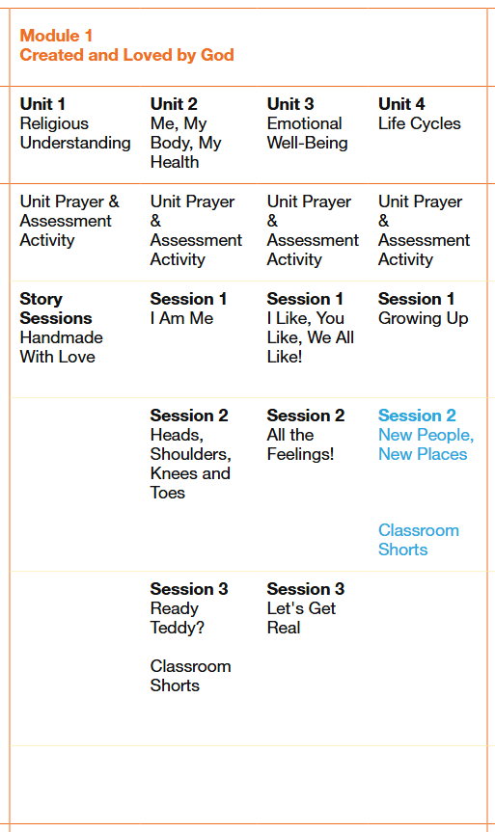
UTW
What do children know now?  • Repeat actions that have an effect.  • Explore materials with different properties.  • Explore natural materials, indoors and outside.  • Explore and respond to different natural phenomena in their setting and on trips.  • Make connections between the features of their family and other families.  • Notice differences between people. |  |  |  |  | Enquiry/Hook:  Introduce a soft toy e.g. bear (class mascot). He is placed in a different area each day or session and the children have to locate him (to get used to their surroundings) “Where is bear playing today?”
What do children want to find out following the hook (feed into planning)?
Texts/Resources:  I’m Starting Nursery, The Family Book, Kipper’s Birthday, Can I Play? Shh Quiet, Only One You, Hello Autumn, The Leaf Thief, Gruffalo Explorers: The Gruffalo Autumn Nature Trail - Julia Donaldson, We’re Going on a Leaf Hunt. Room on the Broom, The Pumpkin who was afraid of the Dark |  |  |  |  | Cross Curricular Links:  CLL – Beginning to listen to stories and nursery rhymes, beginning to listen to instructions given, listens during adult guided activities, focusing on an activity of own choice for a short period of time, beginning to show attention to the adults in the setting, points to objects upon request, beginning to join in with adult guided activities with support from an adult, follows one key word instructions, recognises and points to objects that are spoken to them, understands 1 key word instructions e.g. stop, drink, links words together when speaking, developing more speech sounds and pronunciation of sounds, use words to begin to communicate needs.  PSED – Select and use resources with help when needed, play with one or more children, increasingly follow the rules, talk about their feelings, be increasingly independent as they get dressed and undressed.  PD – Start taking part in some group activities, increasingly be able to use and remember sequences and patterns of movements related to music and rhythm  Literacy – Write some of their name, write some letters accurately, begin to spot and suggest rhymes, begin to count or clap syllables, recognise words with the same initial sound, begin to hold a book correctly.  Maths – Say one number for each item in order, talk about and explore shapes in the environment, begin to understand position through words alone, describe a familiar route, discuss routes and locations, talk about and identify patterns around them, begin to describe a sequence of events  EAD – Recognises colours and chooses them for a purpose. Uses thick paint brushes. Uses playdough to roll, cut, ball, sausage. Builds towers with large construction equipment. Children dancing to music, Children exploring moving to music in different ways, Children showing an interest in the small world and role play areas, children roleplaying their first-hand experiences.
Objectives/Skills to cover:

Development of past and present - begin to make sense of their own life story and family’s history
Development of people, culture and communities - develop positive attitudes about the differences between people
Development of the natural world - Using their senses in hands-on exploration of natural materials, begin to talk about what they see using a wider vocabulary, begin to understand the need to respect and care for the natural environment and all living things
Vocabulary:

Now, next, family, family members names, mum, dad, brother, sister, dog, cat, rabbit, pets, family, family names, special, respect care, look after, home, school, nursery, touch, see, feel, smell, hear, taste.

 | Teaching Knowledge/Modelling | Key Questions | Further lines of enquiry | Focus Activities |  | Independent Activities /Enhancements
Week 1 | Observations of children.  Adults model and talk about the Nursery environment, including different areas, resources and routines.  Encourage children to talk about their experiences of starting Nursery.  Model how to use resources appropriately and where things belong.  Encourage children to explore both indoor and outdoor environments.  Linked books: I’m Starting Nursery by Campbell Big Steps (Author), Marion Cocklico (Illustrator)  Can I Play? and Shhh! Quiet! by Nicola Kinnear  Song suggestions: Heads, Shoulders, Knees and Toes, The Wheels on the Bus | Who are your friends?  What can you see in  Nursery? Where can you find...?  Where does this belong?  What happens at Nursery?  What would you like to choose? | How is Nursery different from home?  What do you like about Nursery?  What is the same and different between Nursery and home?  Who works at Nursery?  What can we find outside? | Explore the Nursery environment together.  Talk about familiar places and people.  Take a walk around the school and identify important areas.  Create simple maps or photographs of familiar areas.  Talk about what happens now and next during the Nursery Day. |  | Small-world Nursery/school.  Photographs of familiar adults and areas.  Construction materials for building Nursery.  Home corner. Dressing-up clothes.  Puzzles showing familiar places.  Books about starting Nursery.  Small-world people and vehicles.  Opportunities to explore indoor and outdoor environments.
Week 2 | Observations of children  Adults prompting children to talk about their families and homes.  Adults asking children at drop off and pick up times who it was/will be today.  Observations of children.  Adults prompt children to talk about their families and homes.  Model that families can be different and that everyone has people who are special to them.  Encourage children to talk about family members, pets, birthdays and familiar routines.  Introduce simple ideas about the past by discussing things they did when they were babies and things they do now.  Linked books: The Family Book by Todd Parr  Only One You by Linda Kranz  Kipper’s Birthday by Mick Inkpen  Song suggestions: Tommy Thumb, Frere Jacques | Who lives in your house?  Who is in your family? What makes your family special?  Do you have any pets?  What did you do when you were a baby?  What do you do now? | What did you look like when you were a baby?  What can you do now that you couldn't do when you were younger?  Where do your family members live?  What special things do your family do together? | Introduce Birthday hat for special times  Children naming their family members.  Family photograph discussion. Talk about then and now using baby photographs where appropriate.  Create family portraits. Discuss family homes and routines.  Explore different types of families and homes through stories, photographs and small-world play.  Talk about birthdays and family celebrations. |  | Family photographs and books.  Home corner.  Small-world family figures. Construction materials for building homes.  Role-play clothes and props representing different cultures and families.  Family puzzles.  Drawing and painting family members.  Books about families
Week 3 | Observations of children  Adults modelling respect and care and encouraging children to do this too,  Adults talking to children about their home environment and school environment, adults setting up activities for children to explore.  Linked books: Hello Autumn by Jo Lindley  The Leaf Thief by Alice Hemming and Nicola Slater  Song suggestions: Incy Wincy Spider, Dingle Dangle Scarecrow | What are the signs of Autumn?  What will you choose to play with today?  Who can you ask for help?  Where can you put the…?  Can you find the…?  Can you tell me about?  How do you use the glue spreader?  What do you need to get? | What happens to leaves in Autumn?  Why do leaves change colour?  What happens to trees? Which animals can we see?  Where do minibeasts live?  What happens when the weather gets colder? | Autumn crowns and sorting leaves  Autumn walk around the school grounds.  Collect natural materials. Sort leaves by colour, size or shape. Observe trees and plants.  Look for signs of wildlife.  Create an Autumn display.  Talk about the weather and seasonal changes.  Explore natural materials using senses.  Adult modelling the Finger print Autumn tree. |  | Autumn tuff tray to explore – leaf rubbings, tracing and charcoal  Non- fiction books about Autumn in class library.  Children having access to a variety of texts.  Clipboards, paper, pencils, making marks in mud and finger painting.  Autumn tuff tray. Leaves, conkers, acorns and pine cones.  Natural loose parts.  Non-fiction Autumn books.  Magnifiers and bug viewers.  Small-world woodland animals.  Autumn-themed construction.  Leaf rubbings.  Natural materials in playdough.
Week 4 | Observations of children  Adults model using the senses to explore the environment.  Encourage children to use vocabulary to describe what they see, hear, smell, touch and taste.  Model that different people may have different preferences and experiences.  Encourage children to explore safely and talk about what they notice.  Discussion points: Autumn colours  Linked books: Gruffalo Explorers: The Gruffalo Autumn Nature Trail - Julia Donaldson  We’re Going on a Leaf Hunt by Steve Metzger  Song suggestion: All the Leaves are Falling | What will we find outside?  What is the weather like?  What can you see/hear/feel/smell/touch?  Where can you put the…?  Can you find the…?  What do you need to get?  What can you touch? What does it feel like?  What can you taste? What does it taste like?  What colours can you see? | Wildlife  Minibeasts  Can you identify something without looking?  Which sense are you using?  Does everyone like the same things?  What can you hear outside?  What different textures can  you find?  How does the weather feel? | A large-scale colour leaf rainbow  Leaf hunt  Minibeast hunt  Sound walks.  Texture exploration. Smell pots.  Explore natural materials using different senses.  Listen to sounds in the environment.  Talk about similarities and differences in children's responses. |  | Autumn tuff tray – leaves to match colour names.  Non- fiction books about Autumn in class library.  Children having access to a variety of texts.  Sensory trays.  Feely bags.  Texture boards.  Natural materials tuff tray. Make a musical instrument.  Sound-making resources. Books about senses and the natural world.
Week 5 | Observations of children.  Adults encourage children to talk about their bodies and how they change as they grow.  Discuss how babies, children and adults are different.  Talk about healthy routines and how we look after ourselves.  Model safe exploration and encourage children to notice what their bodies can do.  Song suggestions: Miss Polly had a Dolly | Can you name this body part?  What can your body do?  How have you changed since you were a baby?  What can you do now?  What helps us stay healthy?  Why do we wash our hands?  What happens when we exercise? | What did you look like when you were a baby?  How have you grown?  What can you do now that you couldn't do before?  What do our bodies need?  How do we look after our bodies?  Who helps us stay healthy? | Baby photograph discussion – then and now.  Create large body outlines.  Talk about body parts. Healthy food exploration.  Discuss exercise, sleep, hygiene and growing.  Explore how our bodies respond to exercise.  Talk about people who help us stay healthy |  | Doctor / baby clinic role play.  Healthy food shop.  Books about the human body. Baby dolls. Dressing-up clothes.  Toothbrush and hygiene resources. Construction opportunities.  Small-world people and community helpers.  Photographs showing children growing and changing.
Week 6 | Encourage children to recognise that people may feel differently about the same experience.  Use stories, puppets and photographs to discuss feelings.  Talk about how feelings can change and how we can respond kindly to others.  Discussion points: Dressing up, Halloween, feelings  Linked books: Room on the Broom by Julia Donaldson  The Pumpkin who was afraid of the Dark by Michelle Robinson  Song suggestion: Hickory, Dickory Dock, 5 Little Ghosts | How do you feel?  What do you like/dislike about the story?  How do you feel?  What makes you happy, sad, feel worried?  What do you like/dislike?  How might someone else feel?  What happens when the light goes off? What can you see in the dark? | Light and dark  How can we help someone who is upset?  What makes you feel safe?  How can shadows change?  What happens when light shines on an object? | Circle time – celebrations linked to events  Making lanterns to help pumpkin see in the dark.  Talk about how different environments can make us feel.  Discuss celebrations and special events in an age-appropriate way. |  | Puppets, bugs, spiders, spooky stories.  Torches and light resources.  Shadow-making resources.  Pumpkins and seeds. Sensory materials.  Fidgets
Assessment Checkpoints EYFS:
UTW (3 and 4-year-olds)
Development of past and present - begin to make sense of their own life story and family’s history
Development of people, culture and communities - develop positive attitudes about the differences between people
Development of the natural world - Using their senses in hands-on exploration of natural materials, begin to talk about what they see using a wider vocabulary, begin to understand the need to respect and care for the natural environment and all living things
Reception Expectations:
- Talk about members of their immediate family and community.
- Name and describe people who are familiar to them.
- Understand that some places are special to members of their community.
- Recognise that people have different beliefs and celebrate special times in different ways.
- Explore the natural world around them.
- Describe what they see, hear and feel whilst outside.

Evaluation of objectives/next steps/Impact:

Mathematics – WRM
Autumn
Objectives covered:
-Exploring colours -Matching colours
- Naming colours -Finding a matching pair
- Exploring same and different
- Sort objects by colour, shape and size
-Identifying sorting rules
- Explaining what they notice
- Identifying the numeral 1 and 2
- Subitising 1 and 2 - Counting 1 and 2
- Developing 1-1 correspondence
- Developing counting skill and technique
- Exploring and extending AB colour patterns
- Copying and creating AB movement patterns
- Fixing patterns
Related Texts:
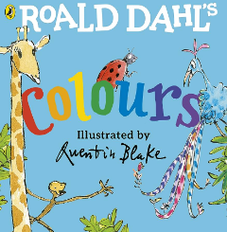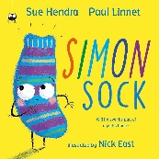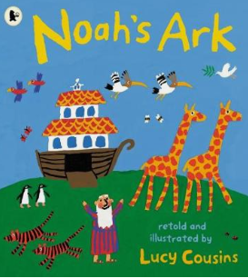

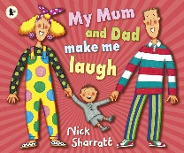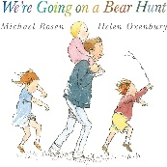
Mathematical Vocabulary:
Colour names, pair, same, match, matching pair, same, different, similar, colour, shape, size, big, small, smooth, shape names, rule, one, two, count, subitise, one at a time, patterns.

EAD – Expressive Art & Design
 | Resources: None
Revisit and Review | Ensure children have met all key adults and know where to put their belongings in the setting. Remind children what they enjoyed on their visit to the setting. Encourage them to explore what resources are on offer.
Week 1  Teach | Sing hello song together while clapping - Hello (child’s name), hello (child’s name) hello everyone it’s time to say hello (wave). Repeat until you have said all the child’s names.  Gather children in a circle and sing ‘Everybody do this, do this, do this, everybody do this, just like me (whilst singing the song think of a movement action for the children to copy such as (wave, clap, tap a body part, wiggle fingers etc).
Practise | As the children become familiar with the activity – 2 or 3 actions can be added/combined repetitively and suggestions from them can be taken. What is your idea/suggestion? How can we make that action? Show me how…
Apply | At the end of the session/day ensure children are said goodbye to. Goodbye song – Goodbye, so long my friends, goodbye, so long, farewell, we’ll see you soon my friends again, so goodbye, so long, farewell.
Success Criteria: Can children join in with repetitive rhymes? Can children listen and move to an instruction? |  | Key vocabulary: clap, tap, move, choice, wave, shake, roll, sound, wiggle, up, down, forwards, backwards, repeat, circle, action, copy, idea, suggestion, hello, welcome, goodbye
 | Resources: None/the setting
Revisit and Review | Key Person to welcome their children. In a group sing hello song together while clapping - Hello (child’s name), hello (child’s name) hello everyone it’s time to say hello (wave). Repeat until you have said all the child’s names.
Teach | Play Simon Says copy this sound. Make a sound and children have to copy it back. Repeat several times. After several times, ask the children to sit as quiet as can be. What can you hear around you?
Practise | Explain to the children they will go on a listening walk. This could be indoors to start with. Model listening and talk about what you can hear. What sounds can we hear? What does it remind you of? Is it quiet or loud? What do you like/not like about that sound?
Apply | Have you heard that before – if so, when? What is it similar to? Why is it different to the last sound? Repeat activity but then venture outside.
Success Criteria: Can children identify different sounds? Can children listen with increased attention to sounds? Can children express their thoughts and feelings? |  | Key vocabulary: listen, sound, hear, similar, different, before, remind, around
 | Resources: None
Revisit and Review | Gather children in a circle and sing ‘Everybody do this, do this, do this, everybody do this, just like me (whilst singing the song think of a movement action for the children to copy such as (wave, clap, tap a body part, wiggle fingers etc). Encourage children to think of ideas for movement.
Teach | Sing ‘Hello song’ but model for the children singing in different voices. Demonstrate a high squeaky voice, a low deep voice, fast, quiet, slow and stretched etc.
Practise | The children can sing back ‘hello’ in a funny voice of their choosing when their name is mentioned.
Apply | Sing a favourite familiar rhyme in a quiet whisper and then louder, or in a way of the children’s choosing. What shall we sing? How shall we sing this? What voice shall we use?
Success Criteria: Can children explore using their voices and enjoy making different sounds? |  | Key vocabulary: Sing, fast, slow, loud, quiet, stretched, slow motion, funny, voice, low, deep, high, squeaky, song, nursery rhyme, hello, goodbye

 | Resources: Pencils, pens, crayons, mirrors to help if needed
Revisit and Review | Sing Heads, Shoulders, Knees and Toes – encourage pointing to body and moving to music.
Week 2  Teach | Model first how to draw a simple potato person. Model holding the pencil incorrectly at first. Include head, body, arms and legs. Ask the children to think about how they hold the pencil and get them to practise. Redraw yourself – compare the 2 versions. Which looks better? What else can I add to myself now? (pay attention to the face). Model drawing and selecting the appropriate colours for features and skin.
Practise | Explain to the children when they are drawing themselves – check how they hold their pencil. Can you hold your pencil in a better way that makes it more comfortable?
Apply | What else can you add? What colour do you need for your eyes?
Success Criteria: Can children draw simple shapes needed for their self-portrait?  Can children hold the pencil with the correct grip? |  | Key vocabulary: Heads, shoulders, knees, toes, eyes, ears, mouth, nose, hair, colour names, lines, circles, shape, round, self-portrait, picture
 | Resources: Junk modelling resources, lids, boxes, scissors, tape, glue, spreaders, glue sticks, corks, ribbon, wool, collage shapes etc, different textured materials, sequins
Revisit and Review | Sing Heads, Shoulders, Knees and Toes – encourage pointing to body and moving to music. Sing slow then get faster.
Teach | Model first and show different ways of joining such as using Sellotape and cutting off the correct amounts of tape needed. Model using types of glue – dab onto the glue pot so it does not drip/spill over. Encourage children to create themselves out of junk and collage materials. Model What could I use to stick this piece on?
Practise | Children can have a go at joining and sticking – practise first then incorporate into making themselves out of junk - What features will you include? How will you attach these pieces to the body etc?  Take photos of these models to compare against at the end of the year.
Apply | Sing and move to ‘Shake your sillies out’. When we dance what can we make move?
Success Criteria: Can children choose a range of materials to join together and express their ideas? |  | Key vocabulary: Head, hair, eyes, ears, mouth, nose, hair, colour names, straight, curved, materials, join, attach, stick, glue, shapes, round, long, short curly, sing, move, dance

 | Resources: We’re Going on a Leaf Hunt by Steve Metzger, brown/re/orange/yellow paint or colours to make, brushes, paper
Revisit and Review | As children come into the setting talk about the weather and changes such as changes to leaves.
Week 3  Teach | Share the story We’re Going on a Leaf Hunt by Steve Metzger whilst outside.
Practise | Gather different types of leaves and sort them into piles of different colours. Where does this leaf go? Why?
Apply | Back inside do some leaf printing or paint the leaves the relevant Autumn colours if not yet changed. Leave out colours to explore – how can we make orange and what can we add to make it brown and darker?
Success Criteria: Can children mix coloured paint to create new ones? |  | Key vocabulary: Positional language, hunt, leaves, Autumn, story words, colourful, black, white, skunk, colours, mix, brush, add, more, less, light, dark
 | Resources: Water, small world people, natural materials, wooden blocks, Autumn leaves
Revisit and Review | Revisit the colours that we used to make orange. Talk about the 3 colours we have that cannot be made (yellow, red, blue).
Teach | Re-read the story We’re Going on a Leaf Hunt by Steve Metzger. Ask children to think about movements we could do that match the story. How can we show we are going up a mountain? etc
Practise | Act out with the children going over the mountain, forest, create a waterfall etc. What could happen? Why did you make it using...? What did you use? How did you make it? What could we use that for...?
Apply | What else could we add from the story? Can you make the little people go on a leaf hunt?
Success Criteria: Can children act out a story using available materials and props?  Can children use their imagination to represent objects as other items? |  | Key vocabulary: Positional language, hunt, leaves, Autumn, story words, colourful, black, white, skunk, colours, mix, brush
 | Resources: (Teach this session on a rainy day) brushes, buckets
Revisit and Review | As children come into the setting talk about the weather. Today it is raining. It often rains in the Autumn. What happens to the leaves? What will they feel like under our feet or in our hands?
Teach | Sing the song (fast or slow depending on how the rain is falling) ‘Rain Rain’  “Rain, rain  go away,  Come again another day!”  The rain is coming down fast. What did you notice about the way the song was sung?
Practise | Repeat but this time varying the tone and pitch of the song. Encourage children to ‘pitch-match’ the song how you sing it. High, low, fast, slow.
Apply | Water painting outside, find ways to collect the rainwater and jumping in puddles with our wellies on!
Success Criteria: Can children follow the pitch of a tone? |  | Key vocabulary: quiet, loud, slow, fast, high, low, rain, wellies, puddles, paint, water, pitch, match, copy, sing, tone

 | Resources: Home corner and resources from the setting including workshop
Revisit and Review | Sing Heads, Shoulders, Knees and Toes – encourage pointing to body and moving to music. Move and dance to other familiar songs
Week 4  Teach | Show the children the home corner and the resources there. Talk about if they have anything similar at home. What could be missing in our home corner that you have in your family home?
Practise and Apply | Children can practise adding materials to make the home corner more like their family home. Encourage children to make and join materials to make things that they have. Encourage pretend play – having a meal, reading a story etc- being someone else in the family (baby, Dad, Mum etc). Model being a different ‘character’.
Success Criteria: Can children develop their ideas with a range of materials and consider how to use them to make representations? |  | Key vocabulary: Show, glue, stick, tape, works best, try, help, home, family and members, play, imagine, pretend, make, join, meal, bedtime
 | Resources: Home corner and resources, teddies, dolls, puppets or small world
Revisit and Review | Revisit what we did yesterday in the home corner. We acted out families and made other items. What did we make or add?
Teach | Show the children the home corner and invite small groups to play, spend time listening to how the children play and interact with them offering some ideas to get them started/engaged. Take teddies, dolls or paper plate faces to make simple pretend play.
Practise | Ask the children what we could use as a phone, item of food etc. What could we pretend this is? What could we use?
Apply | Take a step back and see what they do/how they manage on their own in the home corner. Do they carry on the theme? Do they seek out others? Do they find other objects to add to their play?
Success Criteria: Can children take part in pretend play, pretending that one object represents another |  | Key vocabulary: Home, play, imagine, pretend, who, what, when, how, appropriate vocabulary for play theme
 | Resources: Paper, pencils, crayons, black paper strips the lengths of the paper given, tape or glue
Revisit and Review | Sing ‘Put your finger on your nose on your nose…’
Teach | Revisit how to draw a simple potato person. Model holding the pencil incorrectly at first. Include head, body, arms and legs. Ask the children to think about how they hold the pencil and get them to practise. Explain that you are going to draw your family members. Model drawing and selecting the appropriate colours for features and skin.
Practise | Explain to the children when they are drawing their family – check how they hold their pencil. Can you hold your pencil in a better way that makes it more comfortable?
Apply | Who is in your family? Who have you drawn? How many people? What else can you add? What colour do you need for their hair? This could be made into a portrait with black strips of paper added around the edge to finish it off.
Success Criteria: Can children draw simple shapes needed for their family portrait?  Can children hold the pencil with the correct grip? |  | Key vocabulary: Heads, shoulders, knees, toes, eyes, ears, mouth, nose, hair, colour names, lines, circles, shape, round, family portrait, picture

 | Resources: Chalk
Revisit and Review | Sing Heads, Shoulders, Knees and Toes – encourage pointing to body and moving to music. Move and dance to other familiar songs
Week 5  Teach | Show the children that we can draw around our bodies outside with some chalk. Ask an adult to help. Point out the features (head, shoulders, arms, knees, legs, feet, toes. “This is my arm; this is my leg…” Show the blank face. Model adding in your features (eyes, nose, mouth) encourage children to tell you what else to add. What do I need to add to my face? What is missing?
Practise | Children can have a go with adult support drawing bodies with chalk. Ask the children to point out main body parts. Can you add the features of your face, so we know it is you?
Apply | Can we work out who is who?
Success Criteria: Can children talk about their features and make marks to represent these? |  | Key vocabulary: Body, body parts, move, draw, mark, add, play, head, hair, eyes, ears, mouth, nose, hair, colour names, look, see, point, song, sing, how many? curly, short, long
 | Resources: Cut out body parts, glue and tape, pencils, pens, wool
Revisit and Review | Sing ‘Heads, Shoulders, Knees and Toes’. Talk about body parts familiarising with key parts
Teach | Show the children a range of shapes that have been pre-cut. Start with the oval. This could be my head. Next find the body shape and model attaching it. What is missing? How many arm pieces do I need? Continue until the body is complete. How can I make this look like me? I need to add my face/hair.
Practise | Encourage children to make themselves out of the cut-out shapes. What do you need to add next?
Apply | These could be all joined together to form a display about ourselves. Look we are altogether in the same room and on the wall!
Success Criteria: Can children join materials together and explore different textures? |  | Key vocabulary: Join, stick, attach, body part names, glue, make, together, add
 | Resources: Music player with children’s songs, instruments and dance scarves, natural materials such as conkers, stones, pebbles, moss, sticks, logs etc.
Revisit and Review | Sing the Hokey Cokey and encourage children to copy the movements to the words of the song. Vary the song by singing in slow motion or faster.
Teach | Whilst outside, encourage children to use natural materials to create a person or themselves. Model making yourself and show the children what materials could be used for different features.
Practise | What could you use for the head, body, legs, eyes etc? Why have you chosen the…? What does the moss look like? What shape does this stone look like? Where can we find some more sticks?
Apply | Play Hide and Seek outside. How can we tell that is ___ hiding? What can we see?
Success Criteria: Can children create themselves using a range of natural materials? Can children talk about the features they have included? |  | Key vocabulary: Names of body parts and natural materials, place, position, hide, make, shape

 | Resources: Emotion cards
Revisit and Review | Sing the Hokey Pokey and encourage children to copy the movements to the words of the song. Vary the song by singing in slow motion or faster.
Week 6  Teach | Teach the song ‘If you’re happy and you know it’.
Practise | Show children emotions cards (these could be made or photographs of the children showing these emotions). Can you copy the face? What happens to your eyes and mouth? This means your feel…
Apply | Take the cards into different play areas throughout the day and if a child feels like any of the cards – draw attention to it and recognise those reassuring them it is ok to have those feelings. Encourage them to say the word that makes them feel in that way.
Success Criteria: Can children explore their voices through song? Can children express their thoughts and feelings? |  | Key vocabulary: Happy, sad, angry, shy, scared, feelings, action, copy, slow, fast
 | Resources: Paints, brushes, paper or large roll of paper, classical relaxing music
Revisit and Review | Sing and dance to ‘Shake your Sillies out’ How do you feel after dancing?
Teach | Put on some classical music. Talk to the children about how it makes you feel (calm, relaxed, rested etc). Place paints, brushes and paper or a large roll outside for space for all paint. Ask the children to listen to the music and paint along to it.
Practise | Tell me about your painting. How did the music make you feel when you were painting? What did the paintbrush do? What colours did you choose and why? Did you end up painting fast or slow – why?
Apply | Dance to some happy, lively music of children’s choosing. How did that make you feel? Was it the same or different to the music we listened to when painting?
Success Criteria: Can children express their thoughts and feelings through music? Can children move and dance to music, explore their voices and enjoy making sounds? |  | Key vocabulary: Silly, dance, dancing, move, hand, up, down, big, small, marks, colours, why, feel, emotions, speed -fast and slow, relaxed, steady, loud, quiet, happy, lively
 | Resources: Coloured spot markers, emotion cards if choose to use, ‘Today I feel Silly and other Moods that make my day’ by Jamie Lee Curtis, instruments.
Revisit and Review | Sing ‘If you’re happy and you know it’. How do you feel today?
Week 6  Teach | Teach some movements where the children move on the spot. Give out spot markers. Show a happy, glad face and jump up and down in excitement to the emotion of happiness (happy lively music can be played). Next show a sad face and this time stomp on the spot to show sadness (louder music or lower tone can be played). This could be escalated my moving arms in a brisk way with the legs to show anger when cross.
Practise | Encourage the children to join in and express their feelings in a safe way through physical movement/play. Have you ever felt like this? How can you calm yourself to feel happy again? Sounds can be accompanied through voice or instruments.
Apply | Explore other moods and feelings through the story ‘Today I feel Silly and other Moods that make my day’ by Jamie Lee Curtis. Look at the mood wheel on the last page with small groups of children throughout the day. How do you feel at the end of the day – home time?
Success Criteria: Can children express their ideas and feelings in different ways? |  | Key vocabulary: Silly, dance, mood, mood wheel, dancing, move, hand, up, down, glad, sad, happy, frown, join in, feelings, feel, better, music, instrument names

Literacy

