Catholic Social Teaching
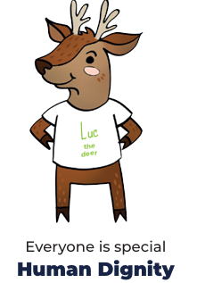

In the name of the Father, and of the Son and of the Holy Spirit.
Amen’.

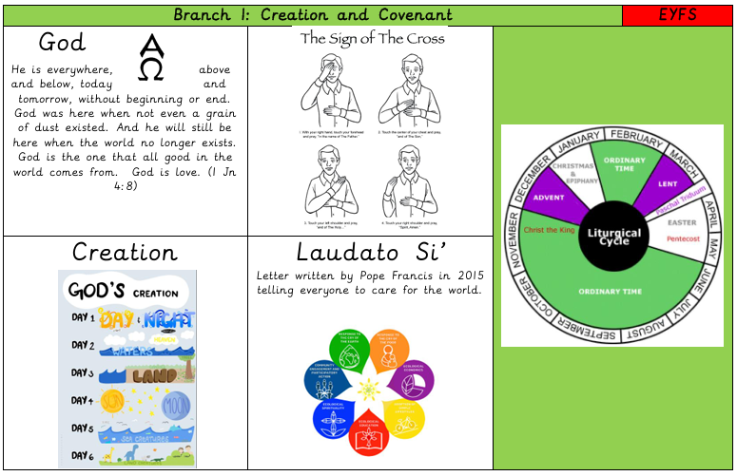

Big Question: Who made me?

