Catholic Social Teaching
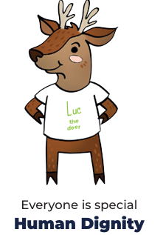
Our Father, who art in heaven,
hallowed be thy name.
Thy kingdom come.
Thy will be done on earth as it is in heaven.
Give us this day our daily bread,
and forgive us our trespasses,
as we forgive those who trespass against us.
And lead us not into temptation,
but deliver us from evil. Amen.

Celebrate
- Praying is a way people draw close to God.
- As a community, the Church prays the Creed and the Our Father to pray to God and worship him.
Live
- God wants us to love and care for the world because the world is God’s gift to us.
- Caring for the world is one of the ways we love and care for each other.
- A community in another part of the world cares for Creation.

Hear
- The Creation story in Genesis 1:1-4, 24-26
- The opening of the Nicene Creed ‘I believe in one God, the Father almighty, maker of heaven and earth, of all things visible and invisible’.

Believe
- All that is comes from God.
- God is our Father.
- God’s love and care for humanity is experienced through the beauty and order of Creation.
- Prayer is a way we draw closer to God.

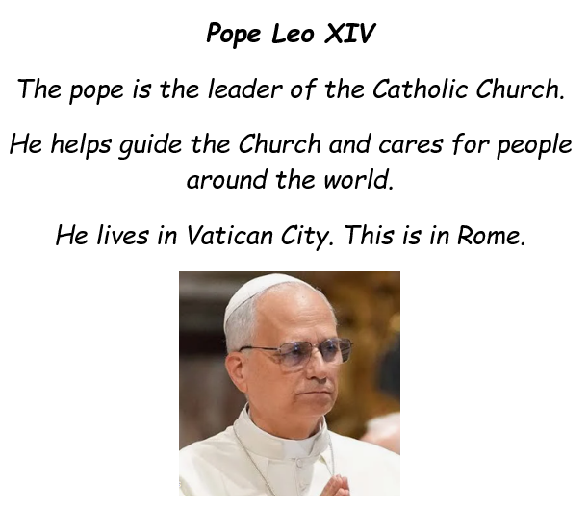
Big Question: Why is it important to take care of the world God made?



