Catholic Social Teaching
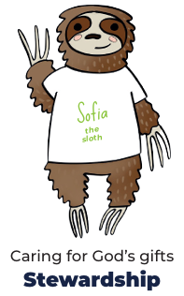

Hear
- The story of Noah, focusing on God’s covenant (promise) with Noah and all living beings in the sign of the rainbow (Gen 9:7-17).145
- Through Noah, God decided to open a path of salvation. In this way he gave humanity the chance of a new beginning. All it takes is one good person to restore hope!’
- Psalm 139146 in praise of God’s Creation of each of us and his love for us.
Believe
- God makes a covenant (promise) with Noah to save all living things.
- People in the story of Noah turned away from God and chose to act badly; this is behaviour called sin.
- The Sacrament of Baptism is when a person becomes part of the Christian family and promises to love God.
- The Christian Bible is split into two parts, the Old Testament, and the New Testament.

Celebrate
- Psalms are prayers to praise God.
- Sacraments are living signs of Jesus’ love for all people.
- Baptism is the first sacrament which welcomes people into the Christian family.
Live
- We can show care for God’s world (stewardship) as part of our care for each other.
- To know how a baby is baptised in the Catholic Church.
Big Question: How does the story of Noah and God’s promise help us understand why it’s important to take care of the world?

Our Father, who art in heaven,
hallowed be thy name.
Thy kingdom come.
Thy will be done on earth as it is in heaven.
Give us this day our daily bread,
and forgive us our trespasses,
as we forgive those who trespass against us.
And lead us not into temptation,
but deliver us from evil. Amen.



