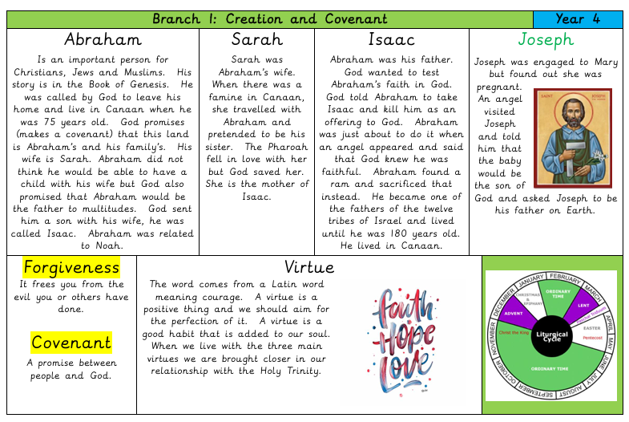
Catholic Social Teaching


Celebrate
- Prayers of faith in God from the Catholic tradition. (For example, Ps 40:1, the St Therese prayer, ‘May today there be peace within’, St John Henry Newman’s ‘Mission of my Life’.

Live

- The virtues of faith, hope, and love.
- The life and work of a person who was an example of faith made active in love, e.g., the intervention of Cardinal Manning in the London dockworker’s strike.

Hear
- The story of Abraham, focusing on the following key texts:
- The call of Abram (Gen 12:1-5) The Abrahamic covenant (Gen 15:1-6)
- Abraham and Sarah (Gen 18:1-15) Abraham and Isaac (Gen 22:1-18
Believe
- A God’s covenant with Abraham is the foundation of the faith of the people of the Old and New Testaments: Judaism and Christianity
- Faith is believing in God, trusting what God reveals, and following God’s loving purpose to live a good life.
- Through living out virtues of faith, hope, and love (sometimes referred to as charity), Christians are drawn into a closer relationship with the Holy Trinity.
Abraham is a model of how to pray.

Big Question: How Does Abraham inspire my Faith?

Our Father, who art in heaven,
hallowed be thy name.
Thy kingdom come.
Thy will be done on earth as it is in heaven.
Give us this day our daily bread,
and forgive us our trespasses,
as we forgive those who trespass against us.
And lead us not into temptation,
but deliver us from evil. Amen.

