Believe
- John the Baptist helped people follow God. Baptism shows God forgives.
- When we do wrong, we turn away from God. Jesus teaches that God loves us and forgives us. Saying sorry helps us do better.
- Jesus’ miracles show he is God’s special one.
- Jesus tells simple stories to help us learn about God.
- Jesus helps and heals people.

Celebrate- Water in Baptism is a sign of a new start. - Catholics say sorry to God in prayers, for example:
  - The Act of Sorrow
  - Asking forgiveness in the ‘Our Father’

Live- Saying sorry to God and others is important. - We can show we are sorry by being kind and helping others.

Hear
- John the Baptist preaching to people (Luke 3:2-6, 10-17)
- Jesus being baptised (Luke 3:21-22)
- Jesus being tempted in the wilderness and starting to teach (Luke 4:1-15)
- Jesus healing a paralyzed man (Luke 5:17-26)
- Jesus choosing his twelve special friends (Luke 6:12-16)
- Jesus calming a storm (Luke 8:22-25)
- The parable of the lost sheep (Luke 15:4-7)
- The visit of the Magi for the Feast of the Epiphany (Matthew 2:1-12

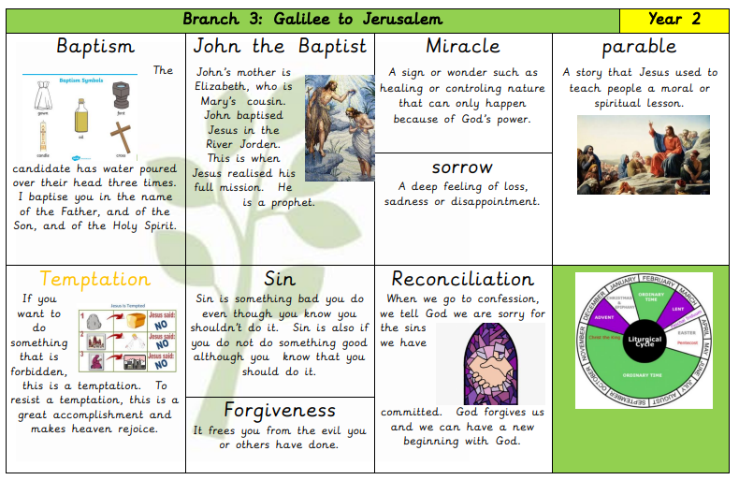
Catholic Social Teaching

Our Father, who art in heaven,
hallowed be thy name.
Thy kingdom come.
Thy will be done on earth as it is in heaven.
Give us this day our daily bread,
and forgive us our trespasses,
as we forgive those who trespass against us.
And lead us not into temptation,
but deliver us from evil.
Amen.

