Catholic Social Teaching

Our Father, who art in heaven,
hallowed be thy name.
Thy kingdom come.
Thy will be done on earth as it is in heaven.
Give us this day our daily bread,
and forgive us our trespasses,
as we forgive those who trespass against us.
And lead us not into temptation,
but deliver us from evil.
Amen.

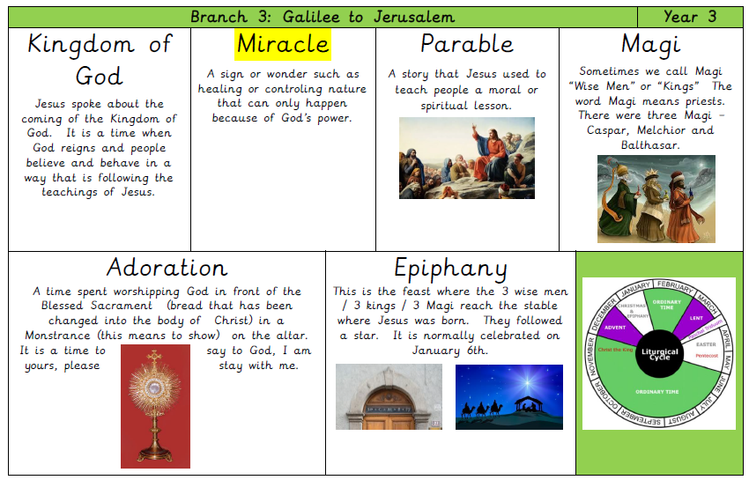

Hear
- Cure of the Paralytic (Matthew 9:1–8)
- Parable of the Sower (Matthew 13:4–9)
- Parable of the Yeast (Matthew 13:33)
- Parable of the Treasure and the Pearl (Matthew 13:44–46)
For Epiphany: The Visit of the Magi (Matthew 2:1–12)

Believe
- The Adoration of the Magi shows that all people are seeking Jesus and that he comes for the whole world.
- The Kingdom of God begins in all who open their hearts to God’s love.
- The miracles Jesus worked expressed his love for all people and were signs that the Kingdom of God was beginning.
- Jesus used parables to show the choices people must make to accept his invitation to the Kingdom.

Celebrate- Praying the Our Father helps Christians to continue building the Kingdom begun with Jesus.

Live- Learning about the life of a saint who worked to build the Kingdom of God.

