CELEBRATE
- Psalm 23 – The Lord is My Shepherd
- Advent prayers
- O Come, O Come Emmanuel
- The Joyful Mysteries of the Rosary

LIVE
- Praying the Psalms
- Trusting God's plan
- Preparing for Christmas
- Welcoming Jesus

HEAR
- David is chosen by God
- David and Goliath
- David becomes King
- God's promise to David
- Jesus – the promised King

BELIEVE
- God chooses us
- David – a great King
- Trusting in God
- Jesus fulfils God's promises
- Psalms – prayers to God

The Our Father
Our Father, who art in heaven,
hallowed be thy name;
thy kingdom come;
thy will be done
on earth as it is in heaven.
Give us this day our daily bread,
and forgive us our trespasses,
as we forgive those who trespass against us;
and lead us not into temptation,
but deliver us from evil. Amen
Amen.

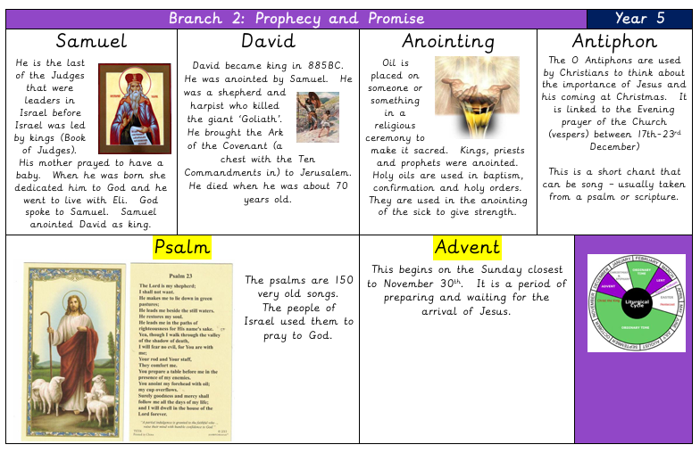
Big Question: How does the life and kingship of David, as well as Jesus' fulfilment of God’s promise, teach us about true leadership and service to others?

Catholic Social Teaching


