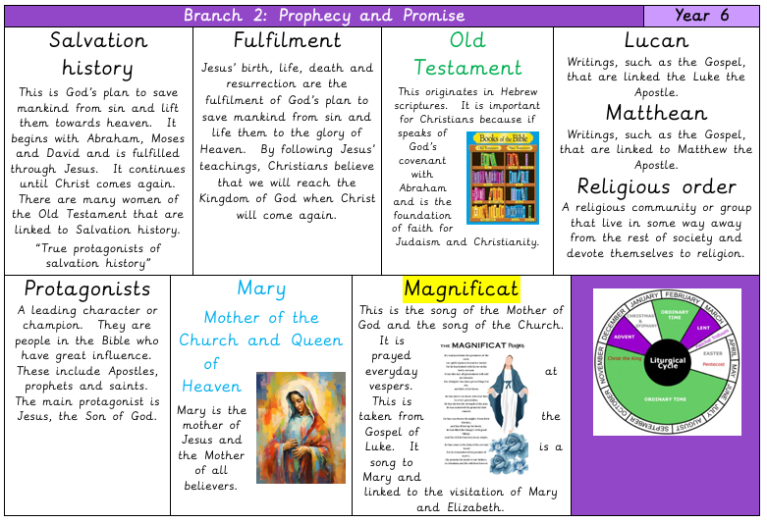
Big Question: How have women played a significant role in God's plan of salvation, and what can we learn from their faith and actions today?

HEAR
- Women in the Bible
- Sarah, Miriam, Deborah, Hannah and Esther
- Mary says ‘Yes’ to God
- The birth of Jesus

BELIEVE
- God's plan
- God's promises
- Mary – Mother of God
- Faith and trust

The Our Father
Our Father, who art in heaven,
hallowed be thy name;
thy kingdom come;
thy will be done
on earth as it is in heaven.
Give us this day our daily bread,
and forgive us our trespasses,
as we forgive those who trespass against us;
and lead us not into temptation,
but deliver us from evil.
Amen.

Catholic Social Teaching


CELEBRATE
- Mary's song – Magnificat
- Praise and thanks
- Evening prayer

LIVE
- Following God's call
- Courage and kindness
- Helping others
- Women serving God

